PROFORMA FOR ANNUAL REPORT 2016 (April 2016 to March 2017)

1. GENERAL INFORMATION ABOUT THE KVK

1.1. Name and address of KVK with phone, fax and e-mail

|  |  |  |  |
| --- | --- | --- | --- |
| Address | Telephone | | E mail |
|  | Office | FAX |  |
| Darjeeling KVK  Uttar Banga Krishi Viswavidyalaya  Kalimpong, Darjeeling, West Bengal - 734301 | 03552 256283 | 03552 256283 | [djkvk@yahoo.com](mailto:djkvk@yahoo.com)  djkvk93@gmail.com |

1.2 .Name and address of host organization with phone, fax and e-mail

|  |  |  |  |
| --- | --- | --- | --- |
| Address | Telephone | | E mail |
| Office | FAX |  |
| Dr. Satyan Chandra Sarkar  Uttar Banga Krishi Viswavidyalaya  P.O Pundibari, Cooch Behar | 03582-270141/986 | 03582-270249/986 | dee_ubkv@gmail.com |

1.3. Name of the Programme Coordinator with phone & mobile No.

|  |  |  |  |
| --- | --- | --- | --- |
| Name | Telephone / Contact | | |
|  | Residence | Mobile | Email |
| Dr. Mendel Wangchuk Moktan |  | 9635105595 | mendelmw@gmail.com |

1.4. Year of sanction of KVK: 1993

1.5. Staff Position (as on 1st April, 2017)

|  |  |  |  |  |  |  |  |  |
| --- | --- | --- | --- | --- | --- | --- | --- | --- |
| **Sl.**  **No.** | **Sanctioned post** | **Name of the incumbent** | **Designation** | **Discipline** | **Pay**  **Scale with present basic** | **Date of joining** | **Permanent**  **/Temporary** | **Category (SC/ST/**  **OBC/**  **Others)** |
| 1 | Senior Scientist- cum- Head | Dr. Mendel Wangchuk Moktan | Senior Scientist- cum- Head | Agril. Extension | PB-4  47800 | 10.12.2001 | Permanent | ST |
| 2 | Subject Matter  Specialist | Dr. Rakesh Roy | SMS | Animal Science | PB-3  30440 | 29.06.2010 | Permanent | SC |
| 3 | Subject Matter  Specialist | Miss Akriti Pradhan | SMS | Home Science | PB – 3  21630 | 14/07/2014 | Permanent | OBC |
| 4 | Subject Matter  Specialist | Dr. Pranab Barma | SMS | Plant Protection | PB – 3  21630 | 21/07/2014 | Permanent | SC |
| 5 | Subject Matter  Specialist | Mrs. Snehlata Lama | SMS | Horticulture | PB – 3  21630 | 25/11/2014 | Permanent | ST |
| 6 | Subject Matter  Specialist | Vacant | SMS | Soil Science |  |  |  |  |
| 7 | Subject Matter  Specialist | Vacant | SMS | Agril Extension |  |  |  |  |
| 8 | Computer  Programmer | Sri. Subrata Manna | Programme Assistant (Comp) | M.C.A | PB – 2  18870 | 30.01.2006 | Permanent | OBC |
| 9 | Programme Assistant | Dr. Basu Deo Kharga | Programme Assistant (Training) | Agril. Extension | PB-2  18320 | 20.06.2007 | Permanent | General |
| 10 | Farm Manager | Akash Deep Thapa | Farm Manager | Agril. Extension | PB-2  18320 | 02.07.2007 | Permanent | OBC |
| 11 | Assistant | Dinesh Kr.Diyali | Assistant | M.com. | PB – 2  18870 | 30.01.2006 | Permanent | SC |
| 12 | Stenographer | Vacant |  |  |  |  |  |  |
| 13 | Driver | Ashok Tamang | Driver | HS | PB – 1  10730 | 12.09.2007 | Permanent | ST |
| 14 | Driver | Harish Kr.Chhetri | Driver | HS | PB – 1  10730 | 13.09.2007 | Permanent | General |
| 15 | Supporting staff | Mrs. Mingma Lhamu Lama | Supporting staff | HS | PB-1  7210 | 31/10/2014 | Permanent | ST |
| 16 | Supporting staff | Sri Sandeep Thapa | Supporting staff | B.A. | PB-1  7210 | 03/11/2014 | Permanent | OBC |

1.6. Total land with KVK (in ha) : 22 ha

|  |  |  |
| --- | --- | --- |
| **S. No.** | **Item** | **Area (ha)** |
| 1 | Under Buildings | 0.25 |
| 2. | Under Demonstration Units | 1.00 |
| 3. | Under Crops | 2.50 |
| 4. | Orchard/Agro-forestry | 1.88 |
| 5. | Others with details | 16.77 |
|  | **Total** | **22.4** |

*Total area should be matched with breakup*

1.7. Infrastructure Development:

A) Buildings and others

|  |  |  |  |  |  |  |  |  |  |
| --- | --- | --- | --- | --- | --- | --- | --- | --- | --- |
| **S. No.** | **Name of infrastructure** | **Not yet started** | **Completed up to plinth level** | **Completed up to lintel level** | **Completed up to roof level** | **Totally completed** | **Plinth area (sq.m)** | **Under use or not\*** | **Source of funding** |
| 1. | Administrative  Building |  |  |  |  | April 2004 | 293 | Yes | ICAR |
| 2. | Farmers Hostel |  |  |  |  | 31/03/2006 | 293 | Yes | ICAR |
| 3. | Staff Quarters (6) |  |  |  |  | 31/03/2009 | 400 | 4 out of 6 | ICAR |
| 4. | Piggery unit |  |  |  |  | 31/03/2012 | 14 | Yes | RKVY Project |
| 5 | Fencing |  |  |  |  |  |  |  |  |
| 6 | Rain Water harvesting structure |  |  |  |  | 31/03/2009 | 75000 L | Yes | ICAR |
| 7 | Threshing floor |  |  |  |  | 31/03/2012 | 400 sq ft | Yes | RKVY Project |
| 8 | Farm godown |  |  |  |  | 31/03/2010 | 800 Sq ft | Yes | ICAR |
| 9. | Dairy unit |  |  |  |  |  |  |  |  |
| 10. | Poultry unit |  |  |  |  | 31/03/2012 | 450 Sq ft | Yes | RKVY Project |
| 11. | Goatary unit |  |  |  |  | 31/03/2012 | 120 Sq ft | Yes | RKVY Project |
| 12. | Mushroom Lab |  |  |  |  |  |  |  |  |
| 13. | Mushroom production unit | Under construction | | | | | | | |
| 14. | Shade house |  |  |  |  | 31/03/2012 | 800 Sq ft | No | RKVY Project |
| 15. | Soil test Lab |  |  |  |  | University’s building | 180 Sq ft | Yes | University |
| 16 | Others, Please Specify |  |  |  |  | 31/03/2012 | 300 sq ft | No | RKVY Project |
|  |  |  |  |  |  | April 2004 | 293 | Yes | ICAR |
|  |  |  |  |  |  | 31/03/2006 | 293 | Yes | ICAR |

* If not in use then since when and reason for non-use

B) Vehicles

|  |  |  |  |  |
| --- | --- | --- | --- | --- |
| **Type of vehicle** | **Year of purchase** | **Cost (Rs.)** | **Total km. Run** | **Present status** |
| Mahendra Max (4 wheel drive) | 2006 | 5.0 lacks | **1,79,519** | Poor |

C) Equipment & AV aids

|  |  |  |  |  |
| --- | --- | --- | --- | --- |
| **Name of equipment** | **Year of purchase** | **Cost (Rs.)** | **Present status** | **Source of fund** |
| **a. Lab equipment** | | | | |
| Spectrophotometer |  | 0.60 |  | ICAR |
| Flame Photometer |  | 0.50 |  | ICAR |
| PH Meter |  | 0.10 |  | ICAR |
| Conductivity bridge |  | 0.10 |  | ICAR |
| Physical balance |  | 0.10 |  | ICAR |
| Chemical balance |  | 1.00 |  | ICAR |
| Digestion unit |  |  |  | ICAR |
| Kjeldhal Distillation set |  | 0.60 |  | ICAR |
| Mechanical shaker |  | 0.50 |  | ICAR |
| Refrigerator |  | 0.20 |  | ICAR |
| Hot air oven |  | 0.15 |  | ICAR |
| Hot plate |  | 0.25 |  | ICAR |
| Grinder |  | 0.30 |  | ICAR |
| Water distillation unit (double) |  | 1.00 |  | ICAR |
| Chemical and Glass wares |  | 2.50 |  | ICAR |
| Soxlet Apparatus (Big &Small) |  | 0.50 |  | ICAR |
| Laboratory set up |  | 3.30 |  | ICAR |
| Soil and plant sample processing and storage facility |  | 0.50 |  | ICAR |
| **b. Farm machinery** | | | | |
| Power tiller | (2 nos) one from RRS, Hill Zone & another from Khoribari | One is in working condition another working but need some repairing | |  |
| Rotary power tiller | 2011 | 68500 | working | RKVY |
| Weed cutter | 2011 | 32800 | Working | RKVY |
| Mobile sprayer | 2011 | 32600 | Working | RKVY |
| Rocker sprayer | 2011 | 4800 | Working | RKVY |
| Branch cutter | 2011 | 61000 (2nos) | Working | RKVY |
| Paddy cutter | 2011 | 36000 | working | RKVY |
| Weigh machine | 2011 | 16640(2nos) | Working | RKVY |
| P.A. System | 2011 | 2860 | working | RKVY |
| **C. AV Aids** | | | | |
| Over Head Projector | 1995 | 9042 | Not good |  |
| Television | 2004 | 13500 | Good |  |
| DVD | 2006 | 4050 | Good |  |
| Camera | 1994 | 2350 | Not good |  |
| Digital Camera Sony F217 | 2004 | 64990 | Not good |  |
| LCD Projector | 2008 | 78000 | Good |  |
| LCD Projector | 2009 | 56000 | Not Good |  |
| Nikon SLR Camera | 2009 | 30000 | Not Good |  |
| Handy Cam | 2009 | 25000 | Not Good |  |
| Laptop | 2009 | 30000 | outdated |  |
| Laptop | 2011 | 30000 | Not Good |  |
| Netbook | 2011 | 25000 | Not Good |  |
| Ahuja Sound system for Conference Hall |  |  | Not Good |  |
| Canon Photo copier |  |  | Good |  |
| FAX Machine |  |  | Good |  |
| Laptop | 2011 | 44780 | Working |  |
| Desktop | 2011 | 40980 | Not Working |  |
| LCD Projector | 2011 | 54000 | Working |  |
| Printer | 2011 | 10900 | Not Working |  |
| UPS | 2011 | 1750 | Not working |  |

D) Farm implements

|  |  |  |  |  |
| --- | --- | --- | --- | --- |
| **Name of equipment** | **Year of purchase** | **Cost (Rs.)** | **Present status** | **Source of fund** |
| Maize Sheller | 2011 | 1500 (10 pcs) | Working | ICAR |
| Secateurs | 2011 | 2100 (6pcs) | Working | RKVY |
| Tree pruner | 2011 | 1645 (1pc) | Working | RKVY |
| Hedge shear | 2011 | 1000 (1pc) | Working | RKVY |
| Pruning saw | 2011 | 400 (2pcs) | Working | RKVY |
| Garden tools | 2011 | 1200 (3 pcs) | Working | RKVY |
| Spade | 2011 | 3750 (12 pcs) | Working | RKVY |
| Rake | 2011 | 1344 (6 pcs) | Working | RKVY |
| Khurpa | 2011 | 900 (8 pcs) | Working | RKVY |
| Datri | 2011 | 375 (3pcs) | Working | RKVY |
| Knapsack sprayer | 2011 | 5100 (2 pcs) | Working | RKVY |
| Turmeric cutter machine | 2016 | 14000 ( 1 Pcs) | Working | TSP |
| Honey Extractor | 2016 | 6600 (2 pcs) | Working | TSP |
| Bee Hives | 2016 | 5400 ( 3 Pcs) | Working | TSP |

1.8. Details SAC meeting* conducted in the year

|  |  |  |  |  |  |
| --- | --- | --- | --- | --- | --- |
| Sl.No. | Date | Number of Participants | Salient Recommendations | Action taken | If not conducted, state reason |
| 1. |  |  |  |  |  |
|  |  |  |  |  |  |
|  |  |  |  |  |  |
|  |  |  |  |  |  |
|  |  |  |  |  |  |
|  |  |  |  |  |  |
|  |  |  |  |  |  |
|  |  |  |  |  |  |

*\* Salient recommendation of SAC in bullet form*

*Attach a copy of SAC proceedings along with list of participants*

2.a. District level data on agriculture, livestock and farming situation (2016-17)

|  |  |  |  |  |
| --- | --- | --- | --- | --- |
| **Sl. no.** | **Item** | **Information** | | |
| 1 | Major Farming system/enterprise | Hill and mountain farming system with horticulture base crop enterprise | | |
| 2 | Agro-climatic Zone | | | |
|  | Hill Zone | 1. Sloppy land – high soil erosion, shallow depth 2. Acidity problem 3. Low soil fertility – due to NPK and micro nutrient 4. Low Nitrogen release from organic matter due to soil acidity and low temperature | | |
|  | Tarai Zone | 1. High leaching loss of nutrient due to light texture soil 2. Low availability of P due to soil acidity 3. Bo and Mo deficiency | | |
| 3 | Agro ecological situation | 1. Due to sub-humid climate organic matter content moderate to high (2%) but decrease with depth 2. The eastern Himalayan region acidic to neutral range pH found | | |
| 4 | Soil type |  | | |
|  | Brown forest soil | 1. Slow release nutrients from organic matter due to acidity and low temperature 2. Micro nutrient deficiency 3. Leaching loss of nutrients due to high rainfall | | |
| 5 | Productivity of major 2-3 crops under cereals, pulses, oilseeds, vegetables, fruits and others | Crop | Productivity (q/ha) | |
| Rice | 16.98 | |
| Wheat | 13.18 | |
| Maize | 20.42 | |
| Gram | 10.65 | |
| Other Pulses | 6.19 | |
| Mustard | 3.01 | |
| Linseed | 2.05 | |
| Potato | 164.40 | |
| Tea | 18.89 | |
| Chilli (dry) | 7.5 | |
| Ginger | 35 | |
| Mandarin Orange | 92 | |
| Tomato | 160.79 | |
| Cabbage | 340.21 | |
| Cauliflower | 343.55 | |
| Radish | 135.04 | |
| Gladiolus | 146733 spikes | |
| 6 | Mean yearly temperature, rainfall, humidity of the district | |  |  |  |  |  | | --- | --- | --- | --- | --- | | Month | Rainfall (mm) | Temperature 0 C | | Relative Humidity (%) | | Maximum | Minimum | | April 16 | 9.4 | 22.7 | 22.2 | 82 | | May 16 | 20.1 | 23.3 | 22.5 | 95 | | June 16 | 214.5 | 22.4 | 18.6 | 92 | | July 16 | 318.5 | 23.7 | 21.4 | 91 | | Aug 16 | 331.0 | 21.6 | 20.3 | 88 | | Sept 16 | 237.0 | 20.6 | 19.3 | 82 | | Oct 16 | 35.0 | 16.4 | 16.3 | 76 | | Nov 16 | 7.4 | 15.4 | 15.6 | 72 | | Dec 16 | 0 | 12.5 | 7.1 | 61 | | Jan 17 | 0 | 11.5 | 7.4 | 60 | | Feb 17 | 8.0 | 12.8 | 9.7 | 67 | | Mar 17 | 23.7 | 17.6 | 14.8 | 75 | | | |
| 7 | Production of major livestock products like milk, egg, meat etc. | **Category** | | **Population** |
| **Cattle** | |  |
| *Crossbred* | | **277057** |
| *Indigenous* | |  |
| **Buffalo** | | **5520** |
| **Sheep** | |  |
| Crossbred | | **2649** |
| *Indigenous* | |  |
| **Goats** | | **187975** |
| **Pigs** | | **53875** |
| *Crossbred* | |  |
| *Indigenous* | |  |
| **Rabbits** | |  |
| **Poultry** | | **673026** |
| Hen | |  |
| *Desi* | |  |
| *Improved* | |  |
| Duck | |  |
| others | | **71593** |

2.b. Details of operational area / villages (2016-17)

| **Sl.**  **No.** | **Name of Taluk** | **Name of the block** | **Name of the villages** | **Major crops**  **& enterprises** | **Major problems identified (crop-wise)** | **Identified Thrust Areas** |
| --- | --- | --- | --- | --- | --- | --- |
| 1 | Kalimpong | Kalimpong I | Bong Busty | Paddy, Vegetables, Maize, Ginger | Ginger Rhizome rot, low productivity of paddy and vegetables | Rhizome rot disease of ginger |
| 2 |  | Kalimpong II | Bidyang | Large Cardamom, Maize Potato Vegetables | Blight in Large cardamom, potato, low market price for vegetables | Blight in Large cardamom |
| 3 |  | Algarah | Sangsey | Ginger, Maize, Vegetables, Darjeeling Orange | Fruit drop in orange, Rhizome rot in ginger | Fruit drop in orange, Rhizome rot in ginger |
| 4 |  | Mirik | Chenga Pani | Ginger, Maize, Vegetables, Animal Husbandary, Black pepper & Betal Nut | Fruit drop of Betal Nut, Rhizome rot in ginger | Fruit drop of Betal Nut, Rhizome rot in ginger |
| 5 | Kurseong | Mirik | Sittong | Ginger, Darjeeling Orange, Vegetables | Rhizome rot in ginger, fruit drop and trunk borer in orange and low market rate for vegetables | Fruit drop in orange, Rhizome rot in ginger |
| 8 | Siliguri | Phansidewa | Phansidewa | Animal husbandry | Diseases Problem | Vaccination |

2. c. Details of village adoption programme:

Name of the villages adopted by PC and SMS in 2016-17) for its development and action plan

|  |  |  |
| --- | --- | --- |
| **Name of village** | **Block** | **Action taken for development** |
| Bidyang | Kalimpong II | Training, Demonstration, OFT, Field day |
| Sangsey | Kalimpong II |
| Sittong | Kurseong |
| Chenga | Mirik |
| Bong Busty | Kalimpong I |

2. d. Sansad Adarsh Gram Yojona

1. Name of the village under Sansad Adarsha Gram Yojona: Hatighisa, Siliguri

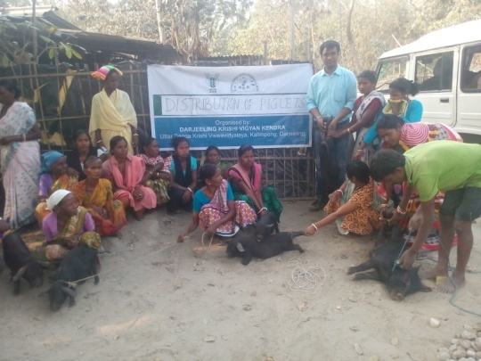 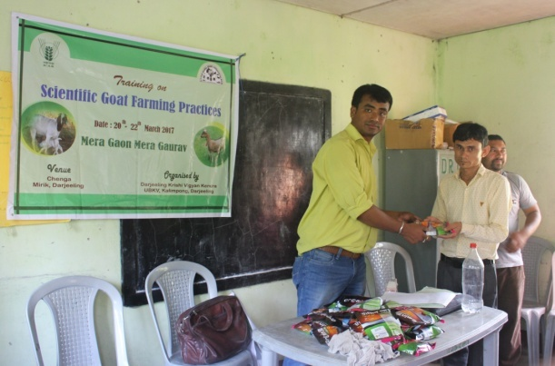

1. Contribution of KVK in the programme:

Swacha Bharat Abhiyan, PPV&FRA, Pradhan Mantri Fasal Beema Yozana, Training and Demonstration.

**2.1 Priority thrust areas**

|  |  |
| --- | --- |
| **S. No** | **Thrust area** |
| 1. | Management of declination of Darjeeling Mandarin orange. |
| 2. | Mulching in Citrus orchard (to conserve soil moisture). |
| 3. | Management of Gerbera (cut flowers) & Marigold |
| 4. | Production management of Rice. |
| 5. | Production management of Potato. |
| 6. | Promotion of I.P.M. in Rice and Potato. |
| 7. | Introduction of off season vegetables under plastic house. |
| 8. | Socio-Economic empowerment of women through Preservation, Mushroom production, Backyard Poultry and Goatery. |
| 9. | Entrepreneurship development of rural youth through floriculture, small scale piggery and production of vermi compost. |
| 10. | Production & Management of Large Cardamom and Ginger |
| 11. | Production & Management of Maize. |

3. TECHNICAL ACHIEVEMENTS

3. A. Details of target and achievement of mandatory activities by KVK during 2016-17

|  |  |  |  |  |  |  |  |
| --- | --- | --- | --- | --- | --- | --- | --- |
| **OFT** | | | | **FLD** | | | |
|  | | | |  | | | |
| **Number of OFTs** | | **Number of farmers** | | **Number of FLDs** | | **Number of farmers** | |
| **Target** | **Achievement** | **Target** | **Achievement** | **Target** | **Achievement** | **Target** | **Achievement** |
| 8 | 6 | 65 | 52 | 8 | 7 | 125 | 112 |

|  |  |  |  |  |  |  |  |
| --- | --- | --- | --- | --- | --- | --- | --- |
| **Training** | | | | **Extension activities** | | | |
|  | | | |  | | | |
| **Number of Courses** | | **Number of Participants** | | **Number of activities** | | **Number of participants** | |
| **Target** | **Achievement** | **Target** | **Achievement** | **Target** | **Achievement** | **Target** | **Achievement** |
| 70 | 72 | 2500 | 2498 | 30 | 21 | 1575 | 1227 |

|  |  |  |  |
| --- | --- | --- | --- |
| **Seed production (q)** | | **Planting material (Nos.)** | |
|  | |  | |
| **Target** | **Achievement** | **Target** | **Achievement** |
| 30 | 33.5 | 5000 | 8659 |

3.1 Achievements on technologies assessed and refined

OFT-1: **Cultivation and study of growth of oyster mushroom on different agricultural waste substrate**

|  |  |  |
| --- | --- | --- |
| 1. | Title of On farm Trial | Cultivation and study of growth of oyster mushroom on different agricultural waste substrate |
| 2. | Problem area | Reduced yield of mushroom through traditional practices |
| 3. | Important cause | Use of paddy straw only for growing mushroom |
| 4. | Technology for testing | Use of various agricultural wastes as a substrate for growing mushroom |
| 5. | Existing practise | Use of chemical treated paddy straw for growing mushroom |
| 6. | Objectives | * To know the most potential substrate for mushroom growth and yield * Minimize usage of chemical for the treatment of substrate * Modify the traditional practises followed by the farmers |
| 7. | Hypothesis | Farmers are using chemically treated paddy straw alone for growing mushrooms. Therefore, a trial on usage of different substrates and treatment methods is scheduled for a better and safe yield of mushrooms. |
| 8. | Treatment details | Farmers practice- use of chemically treated paddy straw  T1- Technology assessed- paddy straw + maize  T2- Technology assessed- paddy straw + saw dust + hot water treatment  T3- Technology assessed- hot water treated paddy straw |
| 9. | Source of Technology | Department of Plant Science and Biotechnology, Imo State University, P.M.B 2000 Owerri, Nigeria |
| 10 | Critical inputs | Paddy straw, saw dust, mushroom spawn, chemicals |
| 11 | Unit size | 10 (No. of Cylinder) |
| 12 | No. of replications | 4 |
| 13 | Unit cost | Rs. 900/- |
| 14 | Total cost | Rs. 3,600/- |
| 15 | Monitoring indicators | Crop yield- quality and quantity of mushroom, its nutrient content could also be assessed |

*Thematic area:*

Problem definition: Reduced yield of mushroom through traditional practices

Technology assessed: Growth of oyster mushroom on different agricultural waste substrate

Table:

|  |  |  |  |  |  |  |  |  |  |
| --- | --- | --- | --- | --- | --- | --- | --- | --- | --- |
| Technology option | No. of trials | Yield component | | | Disease/ insect pest incidence (%) | Cost of cultivation  (Rs./cylinder) | Gross return (Rs/cylinder) | Net return  (Rs./Cylinder) | B C ratio |
| No. of effective bunch | Weight per bunch (g) | Yield of 1st harvest (Kg) |
| Farmers Practice | 4 | 3 | 150 | 0.5 | 5% | 40 | 60 | 20 | 1.5:1 |
| T1 | 4 | 5 | 200 | 0.75 | 8% | 30 | 90 | 60 | 3:1 |
| T2 | 4 | 3 | 150 | 0.35 | 12% | 30 | 30 | 12 | 1:1 |
| T3 | 4 | 8 | 250 | 1.0 | 5% | 30 | 120 | 90 | 4:1 |

OFT-2: Assessment of Integrated Nutrient Management of cauliflower (*Brassica oleraceae var botrytis*) in Darjeeling Hills..

|  |  |  |
| --- | --- | --- |
| 1. | Title of On farm Trial | Integrated Nutrient Management of cauliflower (*Brassica oleraceae var botrytis*) |
| 2. | Problem area | Decline in yield and poor quality curds |
| 3. | Important cause | Use of only FYM no use of balance chemical fertilizer |
| 4. | Technology for testing | Integrated nutrient management |
| 5. | Existing practice | User of only FYM @ 20 tons per ha |
| 6. | Objectives | To improve the quality of curds and also to increase the yield per ha |
| 7. | Hypothesis | Farmers of Darjeeling district are using only FYM and unaware about the balance dose of fertilizer. So the yield as well as the quality of the curds are low. So an OFT on the Integrated Nutrient Management of cauliflower has been conducted |
| 8. | Treatment details | **Farmers’ practice:** Application of FYM @20 t/ha  **Tech. option I:** Application of 50% NPK i.e (75:50:50)(BasalFullP+K+1/2N,30DAS1/4N,60DAS1/4N) +50% FYM ie 5t/ha +Azospirillium @2kg/ha  **Tech. option II:** Application of 50% NPK i.e (75:50:50) : Application of 50% NPK i.e (75:50:50)+50% FYM ie 5t/ha +Azospirillium @2kg/ha +50% pigmanureie 10t/ha +Azospirillium @2kg/ha  **Tech. option III:** Application of 50% NPK i.e (75:50:50) : Application of 50% NPK i.e (75:50:50)+50% FYM ie 5t/ha +Azospirillium @2kg/ha +50% pigmanureie 10t/ha +Azospirillium @2kg/ha |
| 9. | Source of Technology | Nagaland University, Medziphema |
| 10 | Critical inputs | FYM, Urea, SSP, MOP, Azospirillium, Pig manure |
| 11 | Unit size | 5 Decimal |
| 12 | No. of replications | 4 |
| 13 | Unit cost | Rs. 1500/- |
| 14 | Total cost | Rs. 6000/- |
| 15 | Monitoring indicators | Average weight of curds, yield per ha |

*Thematic area:*

Problem definition:

Technology assessed:

Table:

|  |  |  |  |  |  |  |  |  |  |  |
| --- | --- | --- | --- | --- | --- | --- | --- | --- | --- | --- |
| Technology option | No. of trials | Yield component | | | Disease/ insect pest incidence (%) | Yield  (Kg/unit) | Cost of cultivation  (Rs./unit) | Gross return (Rs/unit) | Net return  (Rs./Unit) | BC ratio |
| No. of effective bunch | Weight per curd (g) | Yield of 1st harvest (Kg) |
| T1 | 4 |  |  |  |  |  |  |  |  |  |
| T2 | 4 |  |  |  |  |  |  |  |  |  |
| T3 | 4 |  |  |  |  |  |  |  |  |  |
| T4 | 4 |  |  |  |  |  |  |  |  |  |

Crop is not yet harvested

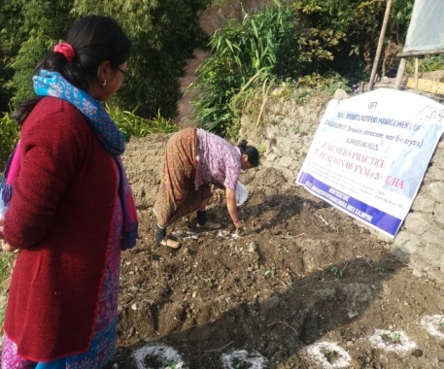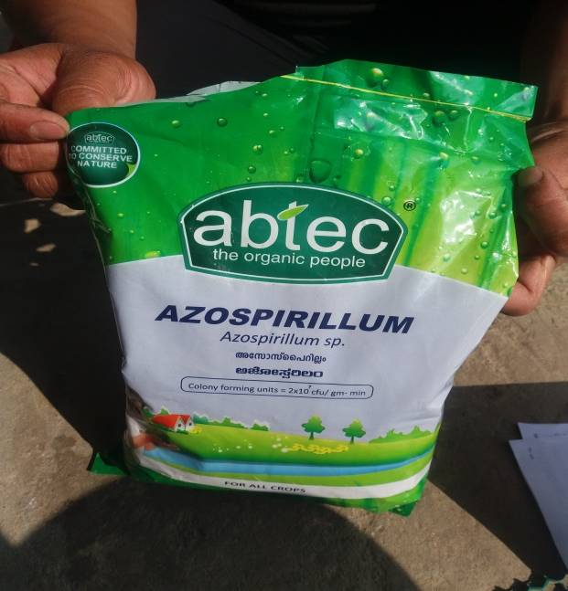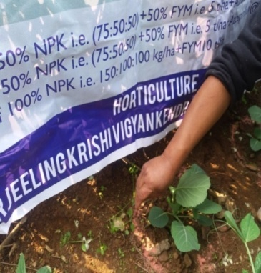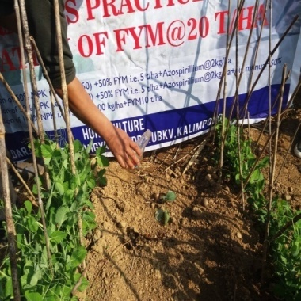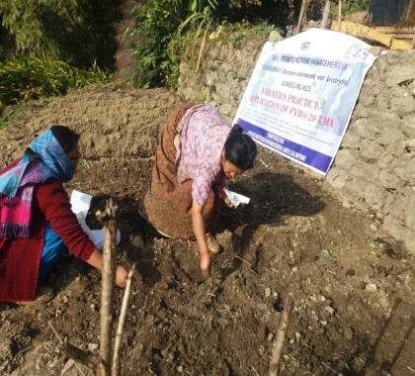

OFT-3: **Varietal assessment of potato under Hill Agro-climatic situation**

|  |  |  |
| --- | --- | --- |
| 1. | Title of On farm Trial | **Varietal assessment of potato under Hill Agro-climatic situation** |
| 2. | Problem area | Poor quality potato tuber, low yields. |
| 3. | Important cause | Use of local variety |
| 4. | Technology for testing | Varietal assessment with FYM @ 20tonnes/ha and NPK @ 150:100:150 kg/ha (RDF) |
| 5. | Existing practice | use of local varieties (Darjeeling Red Round) with FYM 15 tonnes/ha |
| 6. | Objectives | To improve the quality of tubers and also to increase the yield per ha |
| 7. | Hypothesis | Farmers of Darjeeling district local variety of poor quality low yield |
| 8. | Treatment details | **Farmers’ practice:** use of seed tubers (Darjeeling Red Round) with FYM 15 tonnes/ha  **Tech. option I:** Cultivation of Kufri Himalini with FYM @ 20tonnes/ha and NPK @ 150:100:150 kg/ha (RDF)  **Tech. option II:** Cultivation of Kufri Kanchanwith FYM @ 20tonnes/ha and NPK @ 150:100:150 kg/ha (RDF)  **Tech. option III:** Cultivation of Kufri Shailjia with FYM @ 20 tonnes/ha and NPK @ 150:100:150 kg/ha(RDF) |
| 9. | Source of Technology | BCKV |
| 10 | Critical inputs | Seed Tuber, FYM, Urea, SSP, MOP |
| 11 | Unit size | 8 |
| 12 | No. of replications | 4 |
| 13 | Unit cost | 3,700/- |
| 14 | Total cost | 14,800/- |
| 15 | Monitoring indicators | Average weight of tubers, yield |

*Thematic area:* Vegetable based cropping system*.*

Technology assessed: Varietal assessment of potato.

Table:

|  |  |  |  |  |  |  |  |  |  |
| --- | --- | --- | --- | --- | --- | --- | --- | --- | --- |
| Technology option | No. of trials | Yield component | | Disease/ insect pest incidence (%) | Total Yield  (q/ha) | Cost of cultivation  (Rs./unit) | Gross return (Rs/unit) | Net return  (Rs./Unit) | BC ratio |
| Avg. wt. of tuber (g) | Yield per Unit (Kg) |
| Farmers practice | 4 | 40.10 | 537 | -- | 167.84 | 3,217 | 4027 | 810 | 1.2:1 |
| T1 | 4 | 111.30 | 774 | -- | 242.88 | 3,700 | 5805 | 2105 | 1.5:1 |
| T2 | 4 | 108.85 | 726 | -- | 227.01 | 3,700 | 5445 | 1745 | 1.4:1 |
| T3 | 4 | 153.64 | 823 | -- | 167.84 | 3,700 | 6172 | 2427 | 1.6:1 |

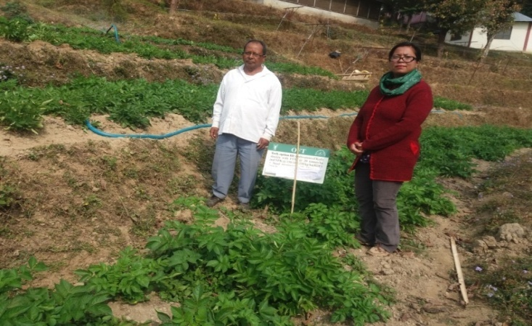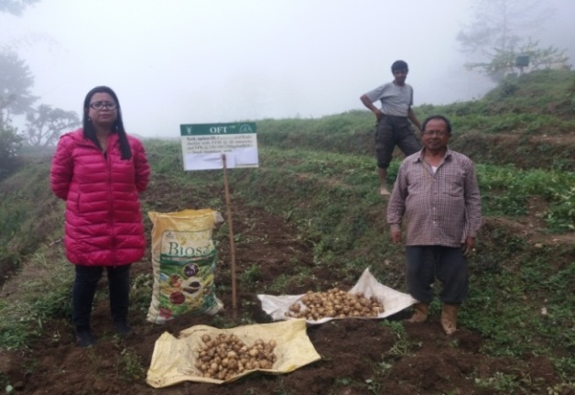

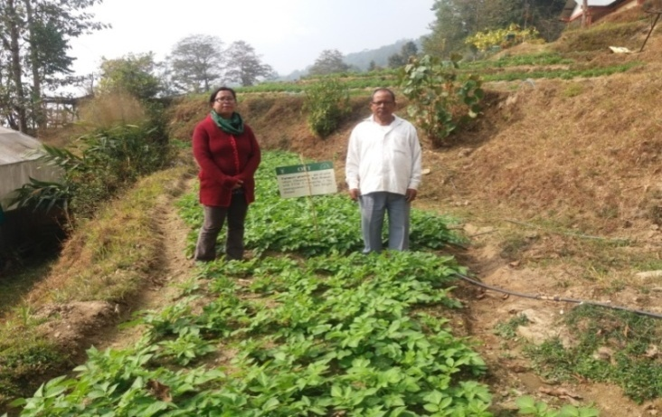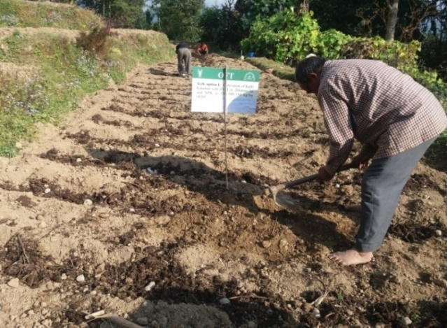

OFT-4: **Assessment of** **Integrated management of rhizome rot in Ginger (*Zingiber officinale*) grown in Darjeeling Hills.**

|  |  |  |
| --- | --- | --- |
| 1. | Title of On farm Trial | **Integrated management of rhizome rot of Ginger (*Zingiber officinale*) grown in Darjeeling Hills.** |
| 2. | Problem area | Decline in yield. |
| 3. | Important cause | Rhizome rot complex |
| 4. | Technology for testing | Integrated diseases management |
| 5. | Existing practice | Application of FYM @20 t/ha and no management practices for Rhizome rot diseases complex |
| 6. | Objectives | To reduce the Rhizome rot diseases complex intensity and increase the yield. |
| 7. | Hypothesis | In Darjeeling district the ginger crop is severely affected with Rhizome rot diseases complex and farmers do not aware for the management of this diseases |
| 8. | Treatment details | **Farmers’ practice:** Application of FYM @20 t/ha  **Tech. option I:**Rhizome treated with Metalaxil + Mancozeb for 20 minutes and covered with black polythene mulch  **Tech. option II:**Furrow application of Bleaching powder (2.5 kg/bigha) followed by irrigation + Neem cake + Metalaxil MZ 1 g/l of water in 3 times.  **Tech. option III:**T. O. I + T. O. II |
| 9. | Source of Technology | BCKV |
| 10 | Critical inputs | Metalaxil + Mancozeb, black polythene, Bleaching powder, Neem cake, Metalaxil MZ |
| 11 | Unit size | 0.05 ha |
| 12 | No. of replications | 2 |
| 13 | Unit cost | 2500/- |
| 14 | Total cost | 5000/- |
| 15 | Monitoring indicators | PDI, Yield |

*Thematic area:* Vegetable based cropping system*.*

Technology assessed:. **Management of rhizome rot of Ginger**

Table:

|  |  |  |  |  |  |  |  |  |  |  |  |  |
| --- | --- | --- | --- | --- | --- | --- | --- | --- | --- | --- | --- | --- |
| Technology option | No. of trials | Yield component | | | Disease/ insect pest incidence (%) | | | Total Yield  (q/ha) | Cost of cultivation  (Rs./unit) | Gross return (Rs/unit) | Net return  (Rs./Unit) | BC ratio |
| Avg. wt. (g) | Weight per curd (g) | Yield per Unit (Kg) | Soft rot | | Bacterial wilt |
| Farmers practice | 2 |  |  | 129 | 31.19 | 44.35 | | 25.90 | 88,433 | 1,34,680 | 46,247 | 1.52 |
| T1 | 2 |  |  | 133 | 24.07 | 32.33 | | 26.61 | 89,400 | 1,38,355 | 48,954.7 | 1.54 |
| T2 | 2 |  |  | 205 | 9.27 | 13.23 | | 40.97 | 1,00,185 | 2,13,044 | 1,12,859 | 2.13 |
| T3 | 2 |  |  | 168 | 23.43 | 27.64 | | 33.64 | 1,04,904 | 1,74,928 | 70,024 | 1.66 |

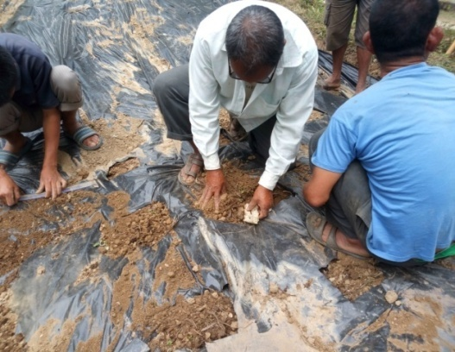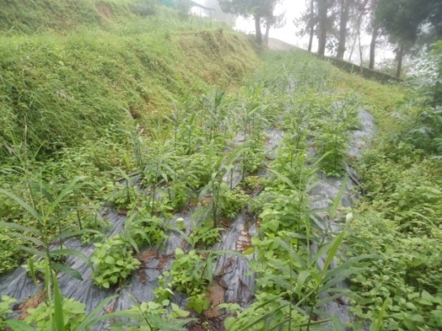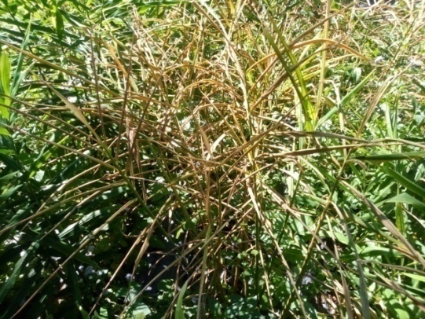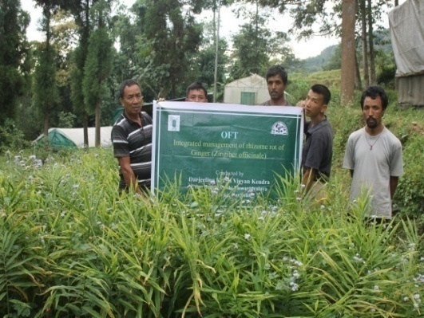

**OFT-5: Production performance of Srinidhi poultry breed under backyard poultry farming system in hills.**

|  |  |  |
| --- | --- | --- |
| 1. | Title of On farm Trial | Production performance of Srinidhi poultry breed under backyard poultry farming system in hills. |
| 2. | Problem diagnosed | Low production of local poultry under backyard farming |
| 3. | Details of technologies selected for assessment/refinement | **Farmers’ practice:** Indigenous breed under backyard farming system  **Tech. option I:** Vanaraja poultry breed under backyard farmingsystem  **Tech. option II:** Srinidhi poultry breed under backyard farmingsystem |
| 4. | Source of Technology | Project Directorate on Poultry, Hyderabad |
| 5. | Production system and thematic area | Backyard farming system in hills and production performance |
| 6. | Performance of the Technology with performance indicators | Vanaraja shows higher production in terms of both body weight and egg production |
| 7. | Final recommendation for micro level situation | Vanaraja shows higher performance than Srinidhi |
| 8. | Constraints identified and feedback for research | Srinidhi had higher mortality rate than Vanaraja. Sustainability of Srinidhi was found poor for 1stand 2ndyear. Mortality rate of Vanaraja and Srinidhi poultry breeds needs to be done for consecutive 3-5 years. |
| 9. | Process of farmers participation and their reaction | Initial response of the farmers is good on Vanaraja than Srinidhi poultry breed. |

**Thematic area:** Backyard poultry farming system

**Problem definition:** Low production of local poultry under backyard farming system

**Technology assessed:** Sustainability and production of Srinidhi Poultry birds under backyard farming system in hill agro climatic zone.

**Table: Data on parameter in relation to Technology demonstrated**

|  |  |  |  |  |  |  |  |  |  |  |
| --- | --- | --- | --- | --- | --- | --- | --- | --- | --- | --- |
| **Technology option** | **Growth rate**  **(@8 weeks)** | | **Growth rate**  **(@20 weeks)** | | **Growth rate (@40weeks)** | | **Egg Production** | | **Mortality rate (%)** | **C:B ratio** |
| **Male (Mean±SD)** | **Female (Mean±SD)** | **Male (Mean±SD)** | **Female (Mean±SD)** | **Male (Mean±SD)** | **Female (Mean±SD)** | **Sexual Maturity (week)** | **No. of eggs / hen / annum**  **(Mean±SD)** |
| **Farmers’ practice** | 1.29±0.69 | 1.18±0.26 | 2.02±0.35 | 1.76±0.46 | 2.90±0.91 | 2.56±0.12 | 26 | 80.82±25.67 | 15.13 | 1:2.6 |
| **Tech. option I** | 1.59±0.63 | 1.36±0.77 | 2.61±0.32 | 2.20±0.37 | 3.70±01.07 | 3.02±01.25 | 25 | 133.07±42.36 | 12.10 | 1:4.1 |
| **Tech. option II** | 1.61±0.21 | 1.32±0.36 | 2.76±0.46 | 2.26±0.96 | 3.76±11.03 | 3.15±01.17 | 23 | 121.82±36.71 | 16.40 | 1:3.2 |

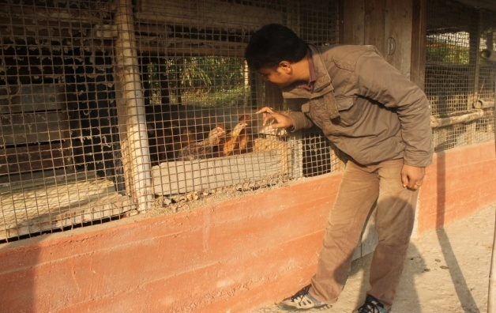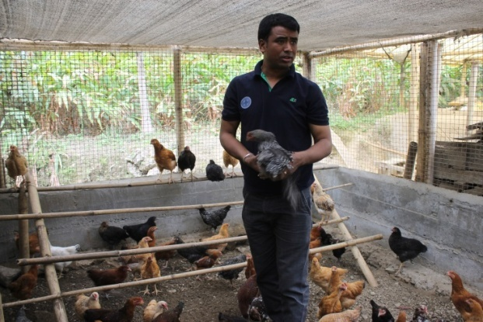**Results:** Technology Option II shows early sexual maturity than Technology Option I and Farmers Practice but Technology Option I shows more numbers of egg production per hen per annum and low mortality rate in backyard farming system in hill climatic situation and thereby higher C:B ratio than Technology Option II and Farmers Practice. Therefore, it can be concluded that Technology Option I is better than Technology option II and farmers’ practice.

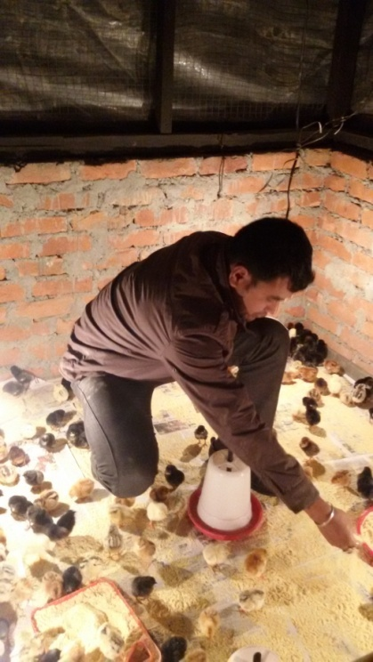

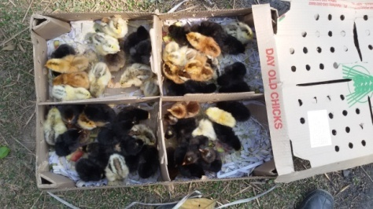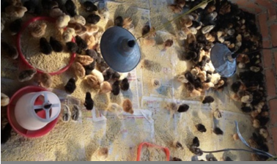

**OFT-6: Preparation of low cost feed using local feed ingredients for pig**

|  |  |  |
| --- | --- | --- |
| 1. | Title of On farm Trial | Preparation of low cost feed using local feed ingredients for pig |
| 2. | Problem diagnosed | Low growth rate of pig and high mortality of piglet when fed with kitchen waste only under backyard farming system |
| 3. | Details of technologies selected for assessment/refinement | **Farmers’ practice:** Feeding with kitchen waste only under backyard farming system  **Tech. option I:** Feeding with commercial feed available at the market  **Tech. option II:** Feeding of Corn + Oilcake + Vitamin + Minerals  **Tech. option III:** Tech. option II + Feed additives + antibiotics |
| 4. | Source of Technology | Indian Veterinary Research Institute |
| 5. | Production system and thematic area | Backyard farming system in hills and production performance |
| 6. | Performance of the Technology with performance indicators | Tech. Option III shows higher production in terms of body weight and low mortality rate |
| 7. | Final recommendation for micro level situation | Tech. Option III shows higher production performance which can be taken for frontline demonstration. |
| 8. | Constraints identified and feedback for research | Low knowledge level of the farmers about scientific feeding management practices |
| 9. | Process of farmers participation and their reaction | Active participation by the farmers and response of the farmers was good. |

**Thematic area:** Backyard piggery farming system

**Problem definition:** Low growth rate of pig and high mortality of piglet when fed with kitchen waste only under backyard farming system

**Technology assessed:** Preparation of low cost feed using local feed ingredients for pig which will increase growth rate and reduce disease incidence rate and mortality rate.

**Table: Data on parameter in relation to Technology demonstrated**

|  |  |  |  |  |  |  |  |
| --- | --- | --- | --- | --- | --- | --- | --- |
| **Technology option** | **Growth rate (@3 months)** | | **Growth rate (@6 months)** | | **Disease incidence (%)** | **Mortality rate (%)** | **C:B ratio** |
| **Male (Mean±SD)** | **Female (Mean±SD)** | **Male (Mean±SD)** | **Female (Mean±SD)** |
| **Farmers’ practice** | 15.83±8.30 | 13.36±6.71 | 68.17±12.14 | 64.39±13.61 | 22.6 | 13.3 | 1:23 |
| **Tech. option I** | 20.33±9.05 | 19.41±6.07 | 78.45±11.92 | 73.30±16.10 | 15.1 | 10.2 | 1:2.9 |
| **Tech. option II** | 21.12±2.32 | 19.15±9.55 | 81.33±14.76 | 77.59±13.13 | 14.4 | 11.5 | 1:3.2 |
| **Tech. option III** | 22.38±3.72 | 20.58±4.27 | 86.60±18.30 | 79.63±18.18 | 11.7 | 4.5 | 1:3.8 |

**Results:** Technology Option III shows increase growth rate and reduce disease incidence rate and mortality rate among other Technology Options and thereby it has higher C:B ratio. Therefore, it can be concluded that Technology Option III is better than the other two options and farmers’ practices. So, it can be recommended to the farmers of this region.

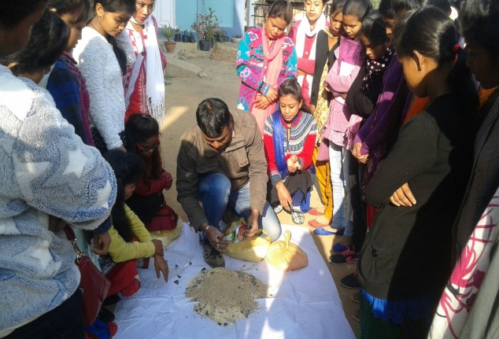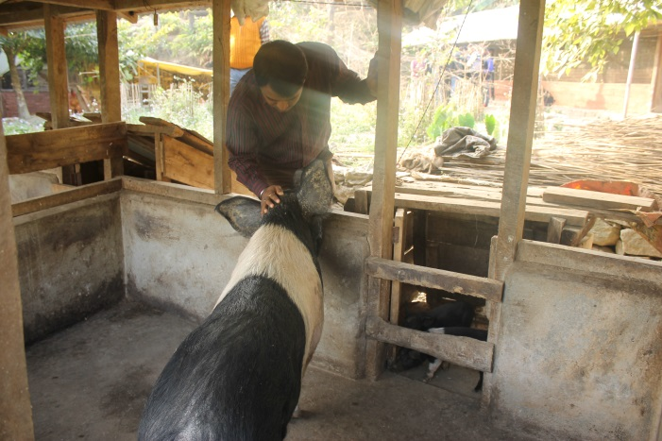

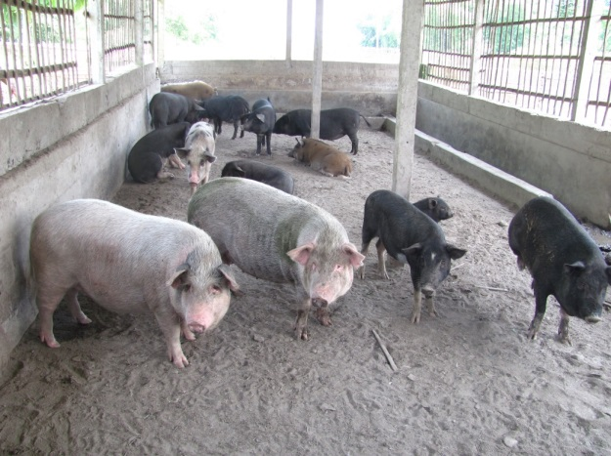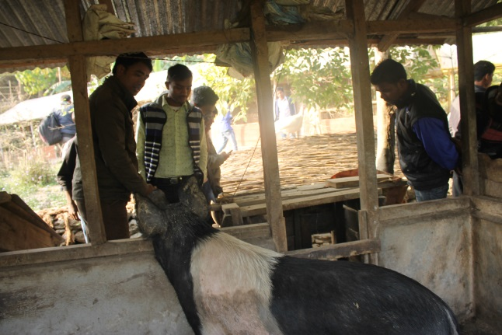

3.2 Achievements of Frontline Demonstrations

A. Details of FLDs conducted during 2016-17

Cereals

|  |  |  |  |  |  |  |  |  |  |
| --- | --- | --- | --- | --- | --- | --- | --- | --- | --- |
| Sl.  No. | Crop | Thematic area | Technology Demonstrated with detailed treatments | Area (ha) | | No. of farmers/  demonstration | | | Reasons for shortfall in achievement |
| Proposed | Actual | SC/ST | Others | Total |  |
| 1. | Darjeeling Mandarin | Crop production | Nutritional Management of Darjeeling Mandarin  NPK300:250:300g/pt B(250g),50%FYM,25%PM | 1 | 1 | 0 | 1 | 1 |  |
| 2. | Kitchen Garden | Nutritional and Food Security | Use of Kitchen waste in Kitchen Garden | 4 Unit each of 100 sq ft | 4 Unit each of 100 sq ft | 1 | 3 | 4 |
| 3. | Formulation of Low cost nutrition rich supplements | Nutrition Security of Rural Children | Enhancement and availability of Nutrients | 2 Units each of 20 children | 2 Units each of 20 children | 22 | 18 | 40 |  |
| 4. |  |  |  |  |  |  |  |  |

Details of farming situation

|  |  |  |  |  |  |  |  |  |  |  |  |
| --- | --- | --- | --- | --- | --- | --- | --- | --- | --- | --- | --- |
| Crop | Season | Farming situation (RF/Irrigated) | Soil type | Status of soil  (Kg/ha) | | | Previous crop | Sowing date | Harvest date | Seasonal rainfall (mm) | No. of rainy days |
| N | P2O5 | K2O |
| Darjeeling Mandarin | Rabi | Rainfed | Acidic | - | - | - | Perennial | April 16  Oct 16 | January 17 | - | - |
| Kitchen Garden | Round the year | Irrigated | Acidic | -- | -- | -- | -- | Round the year | Round the year | -- | - |

In both the Tables, information of same crop should be provided. For example, if in Table 3.2A crops are mentioned as a,b,c,d etc., in the table for Details of farming situation, the same crop should be mentioned in the identical sequence.

|  |  |  |  |  |  |  |  |  |  |  |  |  |  |  |
| --- | --- | --- | --- | --- | --- | --- | --- | --- | --- | --- | --- | --- | --- | --- |
| Crop | Thematic area | Name of the technology demonstrated | No. of Farmer | Area  (ha) | Yield (q/ha) | | *Economics of demonstration (Rs./ha) | | | | *Economics of check  (Rs./ha) | | | |
| Demons  ration | Check | Gross  Cost | Gross  Return | Net Return | **  BCR | Gross  Cost | Gross  Return | Net Return | **  BCR |
| Darjeeling Mandarin | Crop production | Nutritional Management of Darjeeling Mandarin  NPK300:250:300g/pt B(250g),50%FYM,25%PM | 1 | 1 | 370 | 180 | 184149 | 548340 | 364191 | 2.9:1 | 105940 | 266760 | 160820 | 2.5:1 |
| Ginger | Crop protection | Disease management in ginger with Hot water treatment and application of bio agent | 2 | 0.1 | 47.5 | 27.4 | 102450 | 247000 | 144550 | 2.41 | 88433 | 142480 | 54047 | 1.61 |
| Large Cardamom | Crop protection | Management of blight disease of Large Cardamom with 1% Bordeaux mixture | 4 | 0.14 | 4.32 | 3.66 | 60366 | 250260 | 189894 | 4.15 | 57,672 | 212280 | 154608 | 3.68 |

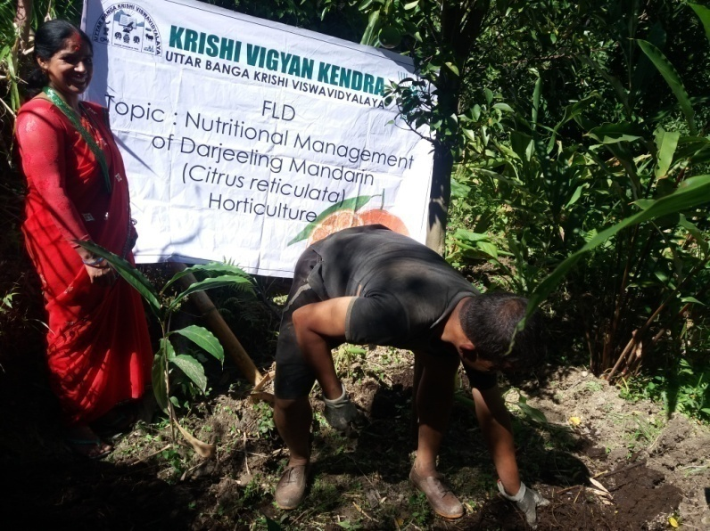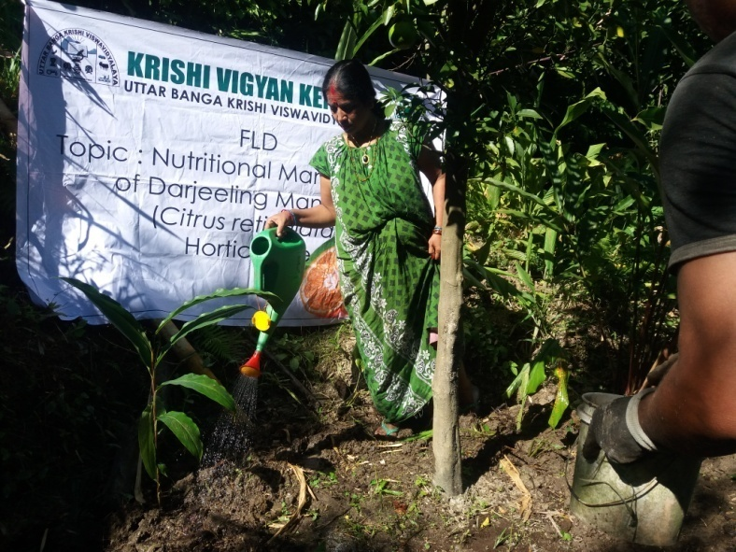

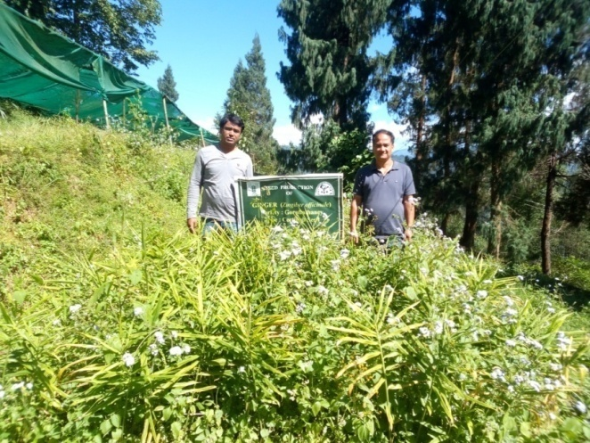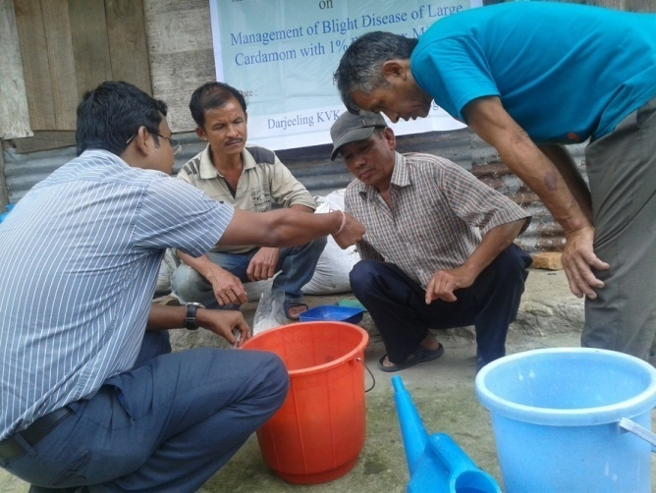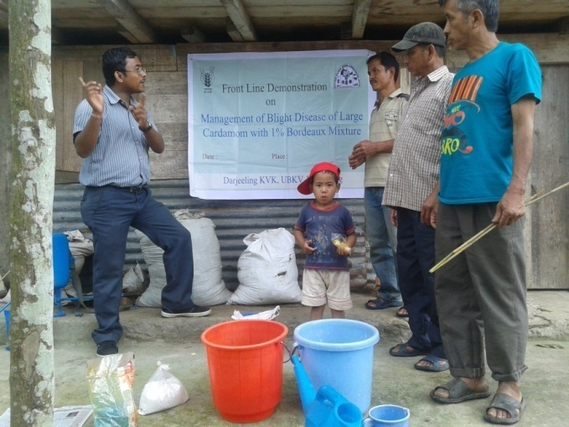

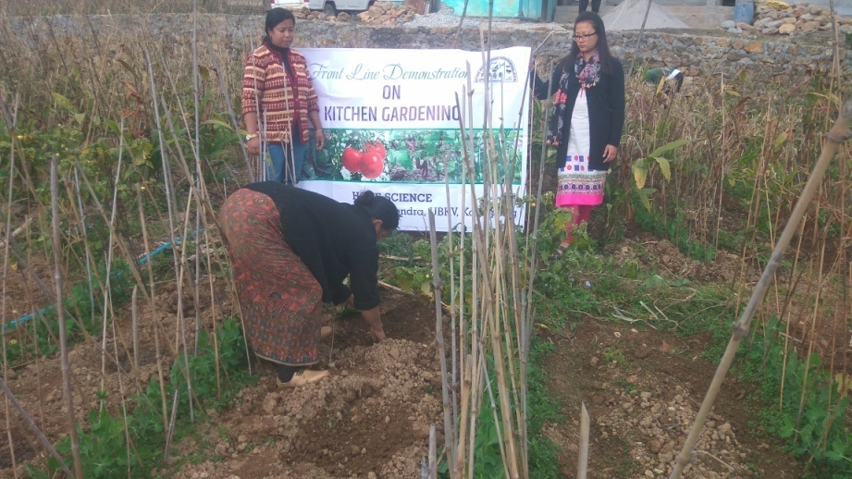 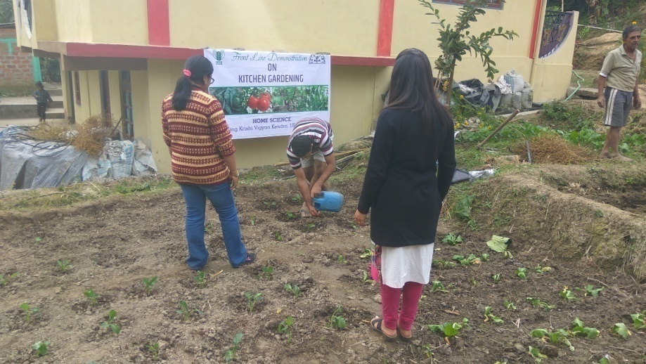

FLD (Home Science)

|  |  |  |  |  |  |  |  |  |  |  |  |  |  |  |
| --- | --- | --- | --- | --- | --- | --- | --- | --- | --- | --- | --- | --- | --- | --- |
| Beneficiary | Thematic area | Name of the technology demonstrated | No. of children | Area | Weight (Kg)  Initial | | Weight (Kg)  Final | | Height (cm)  Initial | | Height (cm)  Final | | *Economics of demonstration (Rs./head/month) | *Economics of check  (Rs./head/month) |
| Demo | Check | Demo | Check | Demons  ration | Check | Demons  ration | Check |
| Pre-school children | Nutrition | Formulation of low cost nutrition rich supplements | 40 | 2 | 14.0 | 14.58 | 14.16 | 14.66 | 116.6 | 119.4 | 116.6 | 119.4 | 375/- | 350/- |

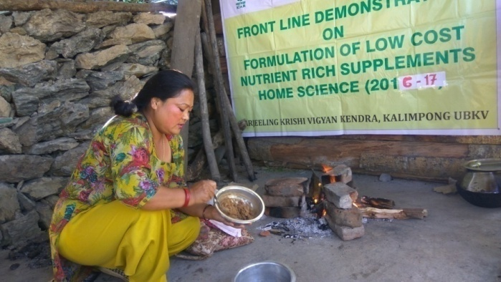 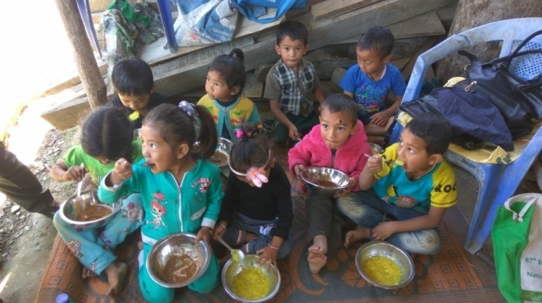

Performance of FLD

Oilseeds:

Frontline demonstrations on oilseed crops

|  |  |  |  |  |  |  |  |  |  |  |  |  |  |  |  |
| --- | --- | --- | --- | --- | --- | --- | --- | --- | --- | --- | --- | --- | --- | --- | --- |
| Crop | Thematic Area | Name of the technology demonstrated | No. of Farmers | Area  (ha) | Yield (q/ha) | | % Increase | *Economics of demonstration (Rs./ha) | | | | *Economics of check  (Rs./ha) | | | |
| Demo | Check | Gross  Cost | Gross  Return | Net Return | **  BCR | Gross  Cost | Gross  Return | Net Return | **  BCR |
|  |  |  |  |  |  |  |  |  |  |  |  |  |  |  |  |
|  |  |  |  |  |  |  |  |  |  |  |  |  |  |  |  |
| Total |  |  |  |  |  |  |  |  |  |  |  |  |  |  |  |

* Economics to be worked out based on total cost of production per unit area and not on critical inputs alone.

** BCR= GROSS RETURN/GROSS COST

Pulses   
Frontline demonstration on pulse crops

|  |  |  |  |  |  |  |  |  |  |  |  |  |  |  |  |
| --- | --- | --- | --- | --- | --- | --- | --- | --- | --- | --- | --- | --- | --- | --- | --- |
| Crop | Thematic Area | Name of the technology demonstrated | No. of Farmers | Area  (ha) | Yield (q/ha) | | % Increase | *Economics of demonstration (Rs./ha) | | | | *Economics of check  (Rs./ha) | | | |
| Demo | Check | Gross  Cost | Gross  Return | Net Return | **  BCR | Gross  Cost | Gross  Return | Net Return | **  BCR |
|  |  |  |  |  |  |  |  |  |  |  |  |  |  |  |  |
|  |  |  |  |  |  | | | | | | | | | | |
|  | Total |  |  |  |  |  |  |  |  |  |  |  |  |  |  |

* Economics to be worked out based on total cost of production per unit area and not on critical inputs alone.

** BCR= GROSS RETURN/GROSS COST

Other crops

|  |  |  |  |  |  |  |  |  |  |  |  |  |  |  |  |  |  |
| --- | --- | --- | --- | --- | --- | --- | --- | --- | --- | --- | --- | --- | --- | --- | --- | --- | --- |
| Crop | Thematic area | Name of the technology demonstrated | No. of Farmer | Area  (ha) | Yield (q/ha) | | % change in yield | Other parameters | | *Economics of demonstration (Rs./ha) | | | | *Economics of check  (Rs./ha) | | | |
| Demons  ration | Check | Demo | Check | Gross  Cost | Gross  Return | Net Return | **  BCR | Gross  Cost | Gross  Return | Net Return | **  BCR |
|  |  |  |  |  |  |  |  |  |  |  |  |  |  |  |  |  |  |
|  |  |  |  |  |  |  |  |  |  |  |  |  |  |  |  |  |  |
|  |  |  |  |  |  | | | | | | | | | | | | |
|  |  |  |  |  |  |  |  |  |  |  |  |  |  |  |  |  |  |
|  |  |  |  |  |  |  |  |  |  |  |  |  |  |  |  |  |  |
|  |  |  |  |  |  |  |  |  |  |  |  |  |  |  |  |  |  |
|  |  |  |  |  |  |  |  |  |  |  |  |  |  |  |  |  |  |
|  |  |  |  |  |  |  |  |  |  |  |  |  |  |  |  |  |  |
|  |  |  |  |  |  |  |  |  |  |  |  |  |  |  |  |  |  |
|  |  |  |  |  |  |  |  |  |  |  |  |  |  |  |  |  |  |
|  |  |  |  |  |  |  |  |  |  |  |  |  |  |  |  |  |  |
|  | Total | |  |  |  | | | | | | | | | | | | |

Livestock

|  |  |  |  |  |  |  |  |  |  |  |  |  |  |  |  |  |  |
| --- | --- | --- | --- | --- | --- | --- | --- | --- | --- | --- | --- | --- | --- | --- | --- | --- | --- |
| Category | Thematic  area | Name of the technology demonstrated | No. of Farmer | No.of units | Major parameters | | % change in major parameter | Other parameter | | *Economics of demonstration (Rs.) | | | | *Economics of check  (Rs.) | | | |
| Demons  tration | Check | Demons  ration | Check | Gross  Cost | Gross  Return | Net Return | **  BCR | Gross  Cost | Gross  Return | Net Return | **  BCR |
| Dairy |  |  |  |  |  |  |  |  |  |  |  |  |  |  |  |  |  |
| Cow |  |  |  |  |  |  |  |  |  |  |  |  |  |  |  |  |  |
| Buffalo |  |  |  |  |  |  |  |  |  |  |  |  |  |  |  |  |  |
| Poultry | Production performance | Vanaraja | 30 | 30 | Egg production | Egg production | 19 | Weight gain | Weight gain | 6540 | 34700 | 28160 | 1:5.30 | 5560 | 21750 | 16190 | 1:3.91 |
| Rabbitry |  |  |  |  |  |  |  |  |  |  |  |  |  |  |  |  |  |
| Pigerry | Production performance | Hampshire | 30 | 30 | Growth rate | Growth rate | 15 | Litter size | Litter size | 7650 | 15500 | 7850 | 1:2.03 | 6350 | 12200 | 7850 | 1:1.92 |

* Economics to be worked out based on total cost of production per unit area and not on critical inputs alone.

** BCR= GROSS RETURN/GROSS COST

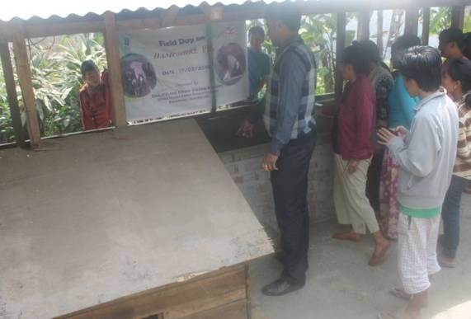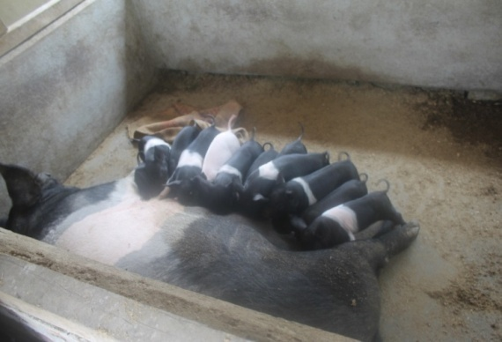

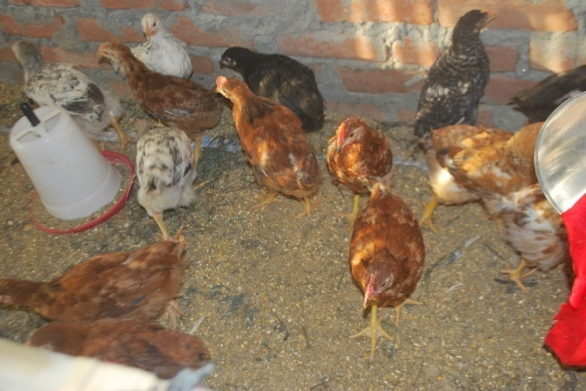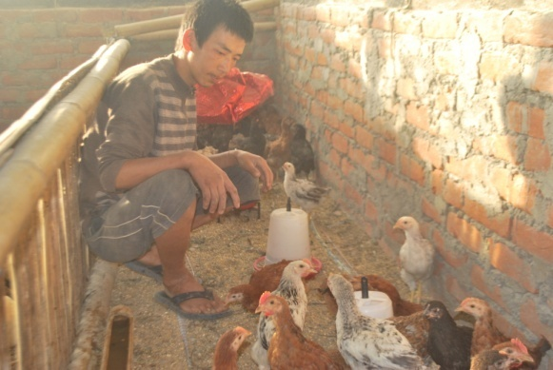

Fisheries

|  |  |  |  |  |  |  |  |  |  |  |  |  |  |  |  |  |  |  |
| --- | --- | --- | --- | --- | --- | --- | --- | --- | --- | --- | --- | --- | --- | --- | --- | --- | --- | --- |
| Category | Thematic area | | Name of the technology demonstrated | No. of Farmer | No.of units | Major parameters | | % change in major parameter | Other parameter | | *Economics of demonstration (Rs.) | | | | *Economics of check  (Rs.) | | | |
| Demons  ration | Check | Demons  ration | Check | Gross  Cost | Gross  Return | Net Return | **  BCR | Gross  Cost | Gross  Return | Net Return | **  BCR |
| Common carps |  | |  |  |  |  |  |  |  |  |  |  |  |  |  |  |  |  |
| Mussels |  | |  |  |  |  |  |  |  |  |  |  |  |  |  |  |  |  |
|  |  | |  |  |  |  |  |  |  |  |  |  |  |  |  |  |  |  |
| Ornamental fishes |  | |  |  |  |  |  |  |  |  |  |  |  |  |  |  |  |  |
| Others (pl.specify) |  | |  |  |  |  |  |  |  |  |  |  |  |  |  |  |  |  |
|  |  | |  |  |  |  |  |  |  |  |  |  |  |  |  |  |  |  |
|  | | Total | |  |  |  | | | | | | | | | | | | |

* Economics to be worked out based on total cost of production per unit area and not on critical inputs alone.

** BCR= GROSS RETURN/GROSS COST

Other enterprises

|  |  |  |  |  |  |  |  |  |  |  |  |  |  |  |  |  |
| --- | --- | --- | --- | --- | --- | --- | --- | --- | --- | --- | --- | --- | --- | --- | --- | --- |
| Category | Name of the technology demonstrated | No. of Farmer | No.of units | Major parameters | | % change in major parameter | Other parameter | | *Economics of demonstration (Rs.) or Rs./unit | | | | *Economics of check  (Rs.) or Rs./unit | | | |
| Demons  ration | Check | Demons  ration | Check | Gross  Cost | Gross  Return | Net Return | **  BCR | Gross  Cost | Gross  Return | Net Return | **  BCR |
| Oyster mushroom | Enterprise development |  |  |  |  |  |  |  |  |  |  |  |  |  |  |  |
| Button mushroom |  |  |  |  |  |  |  |  |  |  |  |  |  |  |  |  |
| Vermicompost |  |  |  |  |  |  |  |  |  |  |  |  |  |  |  |  |
| Sericulture |  |  |  |  |  |  |  |  |  |  |  |  |  |  |  |  |
| Apiculture |  |  |  |  |  |  |  |  |  |  |  |  |  |  |  |  |
| Others (pl.specify) |  |  |  |  |  |  |  |  |  |  |  |  |  |  |  |  |
| Total | |  |  |  | | | | | | | | | | | | |

* Economics to be worked out based on total cost of production per unit area and not on critical inputs alone.

** BCR= GROSS RETURN/GROSS COST

Women empowerment

|  |  |  |  |  |  |
| --- | --- | --- | --- | --- | --- |
| Category | Name of technology | No. of demonstrations | Observations | | Remarks |
| Demonstration | Check |
| Farm Women | Cultivation of Oyster Mushroom | 6 |  |  |  |
| Pregnant women | Low cost nutritional supplements | 3 |  |  |  |
| Adolescent Girl | Preservation and Value addition | 2 |  |  |  |
| Other women | Kitchen Gardening for nutrition and food security | 4 |  |  |  |
| Children | Nutrition, health and sanitation | 1 |  |  |  |
| Neonatal |  |  |  |  |  |
| Infants | Preparation of low cost Malted Supplements | 2 |  |  |  |

Farm implements and machinery

|  |  |  |  |  |  |  |  |  |  |  |  |  |  |  |  |
| --- | --- | --- | --- | --- | --- | --- | --- | --- | --- | --- | --- | --- | --- | --- | --- |
| Name of the implement | Crop | Name of the technology demonstrated | No. of Farmer | Area (ha) | Filed observation (output/man hour) | | % change in major parameter | Labor reduction (man days) | | | | Cost reduction (Rs./ha or Rs./Unit) | | | |
| Demons  ration | Check |  |  |  |  |  |  |  |  |
| -- | -- | -- | -- | -- | -- | -- | -- | -- | -- | -- | -- | -- | -- | -- | -- |

**\* Economics to be worked out based on total cost of production per unit area and not on critical inputs alone.**

**\*\* BCR= GROSS RETURN/GROSS COST**

Demonstration details on crop hybrids

|  |  |  |  |  |  |  |  |  |  |  |
| --- | --- | --- | --- | --- | --- | --- | --- | --- | --- | --- |
| Crop | Name of the Hybrid | No. of  farmers | Area  (ha) | Yield (kg/ha) / major parameter | | | Economics (Rs./ha) | | | |
| Cereals |  |  |  | Demo | Local check | % change | Gross  Cost | Gross  Return | Net  Return | BCR |
|  |  |  |  |  |  |  |  |  |  |  |
| Bajra |  |  |  |  |  |  |  |  |  |  |
| Maize | F7001 | 9 | 0.6 | 26.4 | 20.8 | 21.2 | 21500 | 39600 | 18100 | 1.84 |
| Paddy | PS -5 | 8 | 0.1 | 17.8 | 12.7 | 28.6 | 25334 | 62300 | 36966 | 2.45 |
| Sorghum |  |  |  |  |  |  |  |  |  |  |
| Wheat |  |  |  |  |  |  |  |  |  |  |
| Others (pl.specify) |  |  |  |  |  |  |  |  |  |  |
| Total |  |  |  |  |  |  |  |  |  |  |
| Oilseeds |  |  |  |  |  |  |  |  |  |  |
| Castor |  |  |  |  |  |  |  |  |  |  |
| Mustard |  |  |  |  |  |  |  |  |  |  |
| Safflower |  |  |  |  |  |  |  |  |  |  |
| Sesame |  |  |  |  |  |  |  |  |  |  |
| Sunflower |  |  |  |  |  |  |  |  |  |  |
| Groundnut |  |  |  |  |  |  |  |  |  |  |
| Soybean |  |  |  |  |  |  |  |  |  |  |
| Others (pl.specify) |  |  |  |  |  |  |  |  |  |  |
| Total |  |  |  |  |  |  |  |  |  |  |
| Pulses |  |  |  |  |  |  |  |  |  |  |
| Greengram |  |  |  |  |  |  |  |  |  |  |
| Blackgram |  |  |  |  |  |  |  |  |  |  |
| Bengalgram |  |  |  |  |  |  |  |  |  |  |
| Redgram |  |  |  |  |  |  |  |  |  |  |
| Others (pl.specify) |  |  |  |  |  |  |  |  |  |  |
| Total |  |  |  |  |  |  |  |  |  |  |
| Vegetable crops |  |  |  |  |  |  |  |  |  |  |
| Bottle gourd |  |  |  |  |  |  |  |  |  |  |
| Capsicum |  |  |  |  |  |  |  |  |  |  |
| Cucumber |  |  |  |  |  |  |  |  |  |  |
| Tomato |  |  |  |  |  |  |  |  |  |  |
| Brinjal |  |  |  |  |  |  |  |  |  |  |
| Okra |  |  |  |  |  |  |  |  |  |  |
| Onion |  |  |  |  |  |  |  |  |  |  |
| Potato |  |  |  |  |  |  |  |  |  |  |
| Field bean |  |  |  |  |  |  |  |  |  |  |
| Others (pl.specify) |  |  |  |  |  |  |  |  |  |  |
| Total |  |  |  |  |  |  |  |  |  |  |
| Commercial crops |  |  |  |  |  |  |  |  |  |  |
| Cotton |  |  |  |  |  |  |  |  |  |  |
| Coconut |  |  |  |  |  |  |  |  |  |  |
| Others (pl.specify) |  |  |  |  |  |  |  |  |  |  |
|  |  |  |  |  |  |  |  |  |  |  |
| Total |  |  |  |  |  |  |  |  |  |  |
| Fodder crops |  |  |  |  |  |  |  |  |  |  |
| Napier (Fodder) |  |  |  |  |  |  |  |  |  |  |
| Maize (Fodder) |  |  |  |  |  |  |  |  |  |  |
| Sorghum (Fodder) |  |  |  |  |  |  |  |  |  |  |
| Others (pl.specify) |  |  |  |  |  |  |  |  |  |  |
| Total |  |  |  |  |  |  |  |  |  |  |

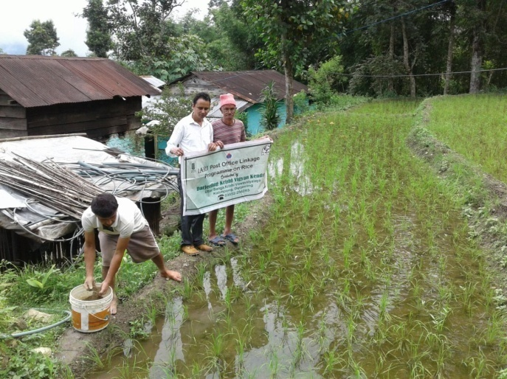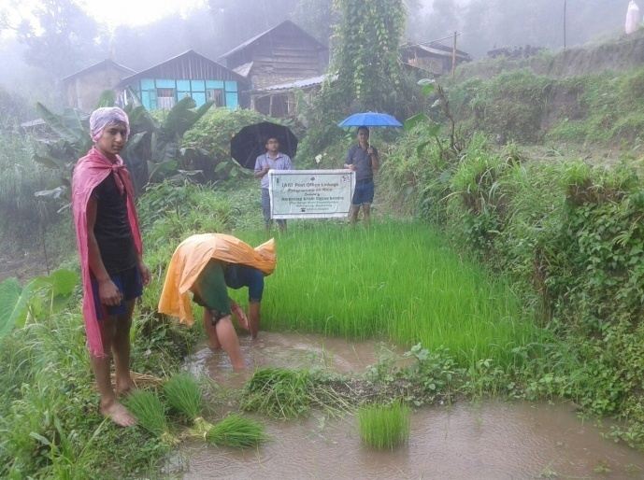

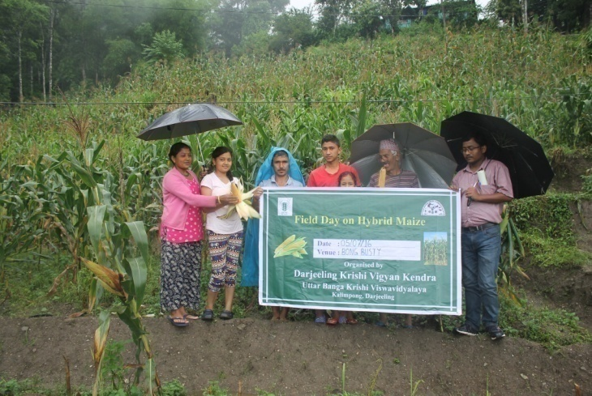

Technical Feedback on the demonstrated technologies

|  |  |  |
| --- | --- | --- |
| S. No | Crop | Feed Back |
| 1 | Mandarin Orange | After nutritional management size and yield of fruits were increased. |
| 2 | Maize – F7001 | The performance of this Hybrid variety is good in terms of corn size and yield. |
| 3 | Paddy –PS5 | Production of this scented rice is satisfactory, but the milling performance is not at per due to the long grain |
| 4 | Ginger | Rhizome rot was effectively managed and yield was good. |
| 5 | Large Cardamom | Blight diseases was effectively managed. |
| 6 | Kitchen Garden | It is well accepted among rural family with horizontal expansion |
| 7 | Low cost malted supplements | For effective acceptability more awareness is required. |
| 8 | Hampshire pig | Hampshire pig have good litter size and growth rate compared to desi pig |
| 9 | Vanaraja poultry | Vanaraja poultry have high growth rate and egg laying efficiency compared to desi poultry birds |

Extension and Training activities under FLD

|  |  |  |  |  |  |
| --- | --- | --- | --- | --- | --- |
| SL.No. | Activity | Date | No. of activities organized | Number of participants | Remarks |
| 1. | Field days | 05/07/2016  11/07/2016  09/06/2016  15/03/2017 | 1  1  1  1 | 9  8  18  7 | Hybrid Maize  PS-5 Paddy  Kiwi fruit  Potato |
| 2. | Farmers Training | 24/11/2016 | 1 | 36 | Low cost Malted supplements |
| 3. | Media coverage |  |  |  |  |
| 4. | Training for extension functionaries |  |  |  |  |

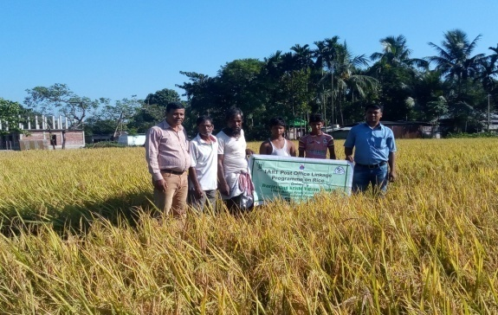 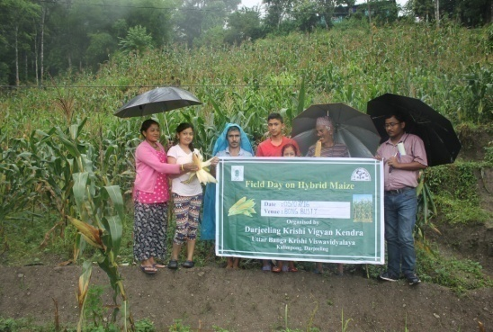

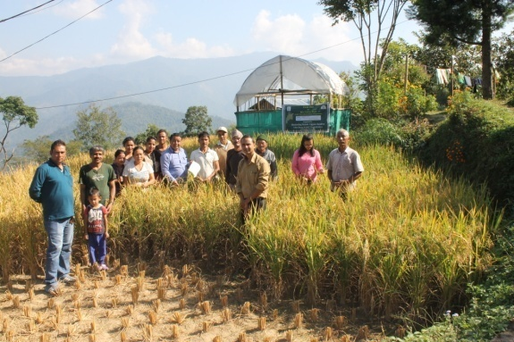 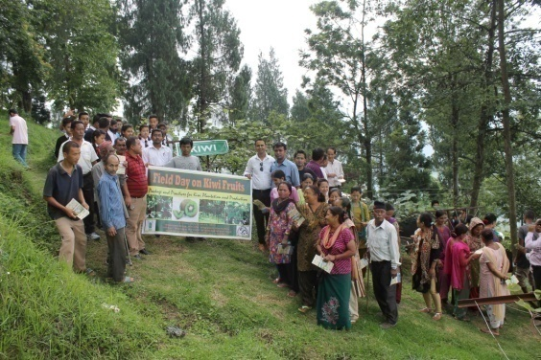

**Performance of the demonstration under CFLD on Pulse and Oilseed Crops during Kharif 2016 and Rabi 2016-17:**

1. **Technical Parameters:**

|  |  |  |  |  |  |  |  |  |  |  |  |  |  |  |  |
| --- | --- | --- | --- | --- | --- | --- | --- | --- | --- | --- | --- | --- | --- | --- | --- |
| Sl.  No. | Crop demonstrated | Existing (Farmer's) variety name | Existing yield  (q/ha) | Yield gap (Kg/ha)  w.r.to | | | Name of Variety + Technology  demonstrated | Number of farmers | Area in ha | Yield obtained (q/ha) | | | Yield gap minimized  (%) | | |
| District  yield (D) | State  yield (S) | Potential  yield (P) |
| Max. | Min. | Av. | D | S | P |
| 1 | Blackgram  Sarada  WBU108 | Local | 4.6 | 482 | 580 |  | Sarada  (WBU 108) | 153 | 20 | 7.9 | 3.8 | 6.01 | 19.8 | 3.49 |  |
| 2 | Mustard  B9  (Yellow) | PT303 | 11.61 | 330 | 764 | 1400 | Variety  Bio fertilizer  PSB  Nutrient  Mngt. | 60 | 15 | 11.20  11.78  12.68 | 9.28  10.23  10.58 | 10.02  10.62  11.08 | 67.1  68.9  70.02 | 23.7  28.1  31.1 |  |
| 3 | Mustard  Garima  (Black) | NS212 | 10.32 | 330 | 764 | 1400 | Variety  Bio fertilizer  PSB  Nutrient Mngt. | 60 | 15 | 9.52  9.83  10.36 | 7.65  8.24  8.65 | 8.12  8.91  9.33 | 59.3  62.9  67.5 | 5.9  14.2  18.1 |  |
| 4* | Green Gram  Sukumar |  |  |  |  |  |  |  |  |  |  |  |  |  |  |

**\* Green Gram in field**

1. **Economic parameters**

|  |  |  |  |  |  |  |  |  |  |
| --- | --- | --- | --- | --- | --- | --- | --- | --- | --- |
| Sl.  No. | Variety demonstrated & Technology demonstrated | Farmer’s Existing plot | | | | Demonstration plot | | | |
| Gross Cost  (Rs/ha) | Gross return  (Rs/ha) | Net Return  (Rs/ha) | B:C  ratio | Gross Cost  (Rs/ha) | Gross return  (Rs/ha) | Net Return  (Rs/ha) | B:C  ratio |
| 1 | Blackgram | 17456 | 20700 | 3244 | 1.18 | 18732 | 27045 | 8313 | 1.44 |
| 2 | Mustard  B9  (Yellow) | 4048 | 14362 | 10314 | 3.54 | 3868 | 17048 | 13180 | 4.40 |
| 3 | Mustard  Garima  (Black) | 4048 | 12216 | 8168 | 3.01 | 3868 | 14628 | 10760 | 3.78 |
| 4 | Green Gram  Sukumar |  |  |  |  |  |  |  |  |

1. **Socio-economic impact parameters**

|  |  |  |  |  |  |  |  |  |
| --- | --- | --- | --- | --- | --- | --- | --- | --- |
| Sl.  No. | Crop and variety  Demonstrated | Total Produce  Obtained (kg) | Produce sold  (Kg/household) | Selling  Rate  (Rs/Kg) | Produce used for own sowing (Kg) | Produce distributed to other farmers (Kg) | Purpose for which income gained was utilized | Employment Generated (Mandays/house hold) |
| 1 | Blackgram  Sarada    WBU 108 | 12020 | 200 | 45 | 17 | 8 | Household Activity  & Child Edu. | 6 |
| 2 | Mustard  B9  (Yellow) | 7515 |  |  |  |  |  |  |
| 3 | Mustard  Garima  (Black) | 6090 |  |  |  |  |  |  |
| 4 | Green Gram  Sukumar |  |  |  |  |  |  |  |

1. **Oilseed Farmers’ perception of the intervention demonstrated**

|  |  |  |  |  |  |  |  |
| --- | --- | --- | --- | --- | --- | --- | --- |
| Sl.  No. | Technologies demonstrated  (with name) | Farmers' Perception parameters | | | | | |
| Suitability to their farming system | Likings  (Preference) | Affordability | Any negative effect | Is Technology acceptable to all in the group/village | Suggestions, for change/improvement, if any |
| 1 | Blackgram | Yes | Yield | Yes | No | Yes | -- |
| 2 | Variety  Bio ferz  PSB  Nutrient Mgnt | Yes | Good | Affordable | No | Yes | -- |
| 3 | Variety  Bio ferz  PSB  Nutrient Mgnt | Yes | Good | Affordable | No | Yes | -- |
| 4 | Green gram |  |  |  |  |  |  |

1. **Specific Characteristics of Technology and Performance**

|  |  |  |  |
| --- | --- | --- | --- |
| Specific Characteristic | Performance | Performance of Technology vis-a vis Local Check | Farmers Feedback |
| Blackgram  Sarada    WBU 108 | Pod formation per plant is higher | Line sowing with application of Bio fertilizer (Rhizobium) performed well than the local practice | Produce higher yield than the local one. Infestation of pest and diseases was lower. |
| Mustard  B9  (Yellow) | Height of the crop is shorter with higher number of branches and resistant to lodging  Pod formation is higher  Seed per pod is higher  Survive well in low moisture in soil | Line sowing with application of Bio fertilizer (PSB) performed well than the local practice | Produce higher yield than the local check with the application of Bio fertilizer and nutrient management.  Duration of the crop is shorter |
| Mustard  Garima  (Black) |  |  |  |
| Green Gram  Sukumar |  |  |  |

1. **Extension activities under FLD conducted till dates:**

|  |  |  |  |
| --- | --- | --- | --- |
| Sl. No. | Extension Activities organized | Date and place of activity | Number of farmer attended |
|  | Training | 26/08/16, Sumbuk | 34 |
|  |  | 29/08/16, Sindebong | 30 |
|  |  | 31/08/16, Sittong | 44 |
|  |  | 31/08/16, Bong Busty | 22 |
|  |  | 01/09/16, Bidyang | 15 |
|  |  | 01/09/16, Khamdong | 8 |
|  | Demonstration | 26/08/16, Sumbuk | 34 |
|  |  | 29/08/16, Sindebong | 30 |
|  |  | 31/08/16, Sittong | 44 |
|  |  | 31/08/16, Bong Busty | 22 |
|  |  | 01/09/16, Bidyang | 15 |
|  |  | 01/09/16, Khamdong | 8 |
|  | Field Visit | 31/10/16, Sumbuk | 7 |
|  |  | 28/10/16, Sindebong | 12 |
|  |  | 27/10/16, Sittong | 7 |
|  |  | 31/10/16, Bong Busty | 8 |
|  |  | 27/10/16, Bidyang | 10 |
|  |  | 28/10/16, Khamdong | 2 |

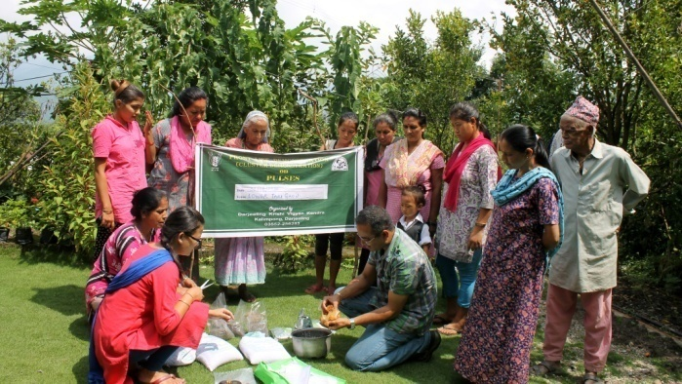 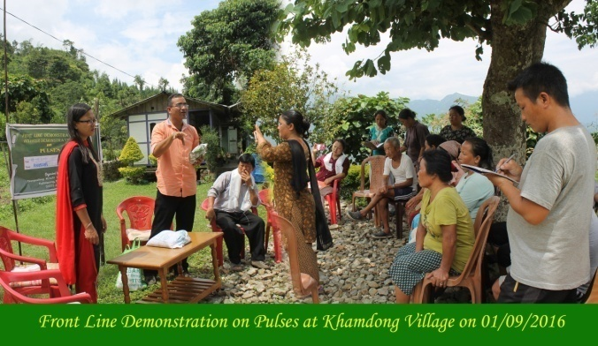

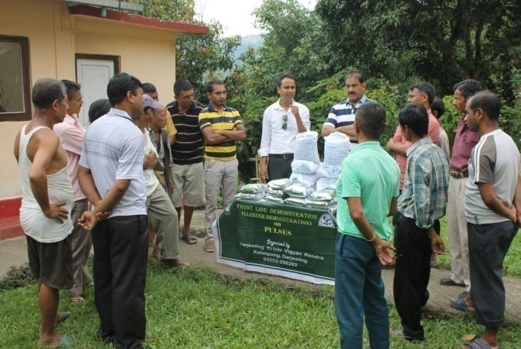 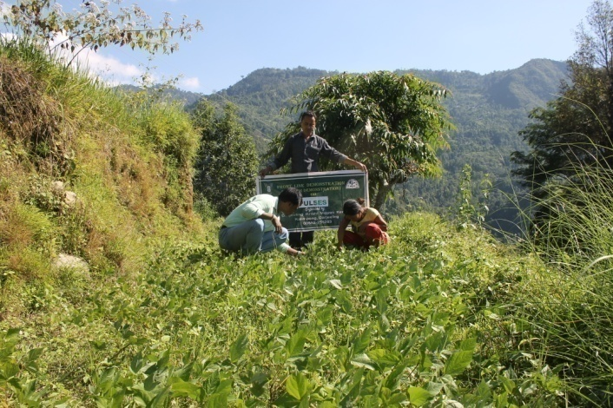

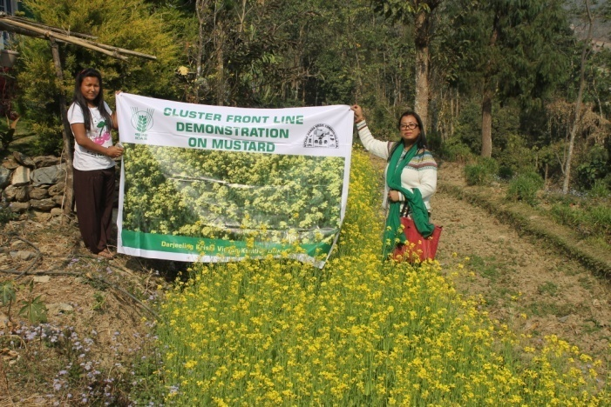 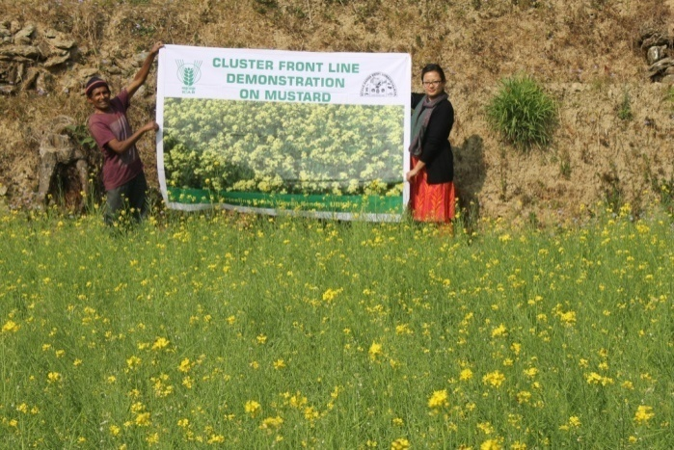

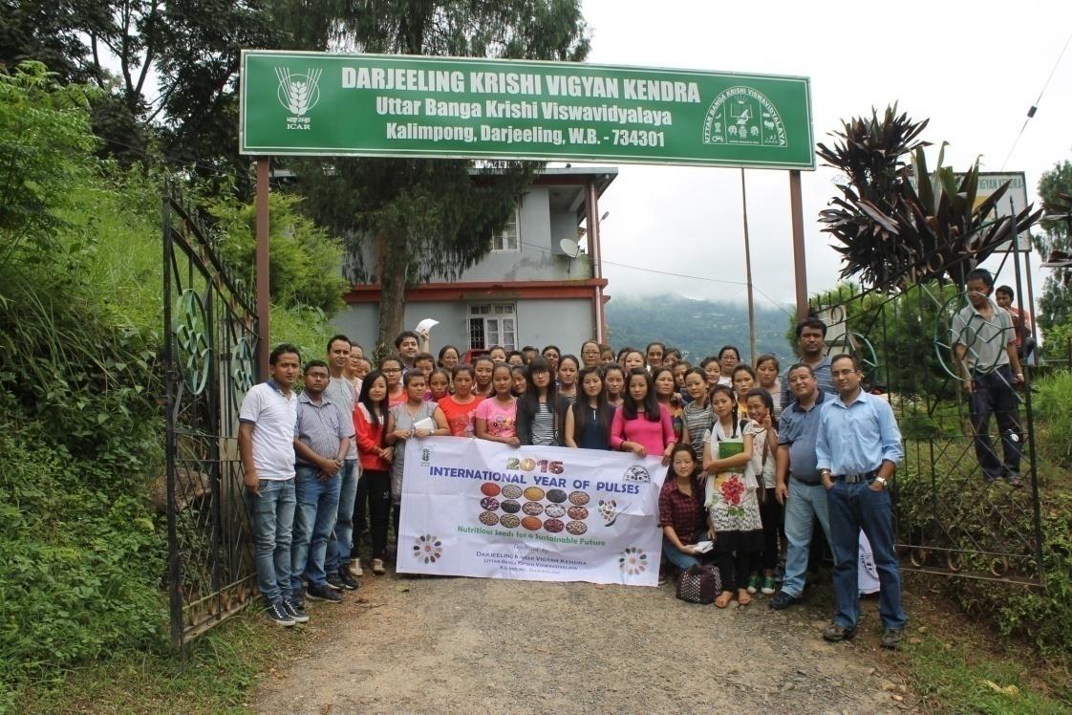

1. **Sequential good quality photographs (as per crop stages i.e. growth & development)**
2. **Farmers' training photographs**
3. **Quality Photographs of field visits/field days and technology demonstrated.**

**J. Details of budget utilization**

|  |  |  |  |  |
| --- | --- | --- | --- | --- |
| Crop  (provide crop wise information ) | Items | Budget  Received  (Rs.) | Budget  Utilization  (Rs.) | Balance  (Rs.) |
|  | i) Critical input |  |  |  |
| ii) TA/DA/POL etc. for monitoring |  |  |  |
| iii) Extension Activities (Field day) |  |  |  |
| iv)Publication of literature |  |  |  |
|  | Total |  |  |  |

**K. List of Farmer under FLD (Crop wise)**

1. **Crop 1**

|  |  |  |  |  |  |  |  |  |  |  |  |  |  |  |  |  |  |
| --- | --- | --- | --- | --- | --- | --- | --- | --- | --- | --- | --- | --- | --- | --- | --- | --- | --- |
| Name of farmer | Father’s name | Village | Block | Mobile No. | Email ID | GPS Coordinates (DDMMSS format) | | Soil testing done (Yes/No) | Recommendations based on soil test value | Brief technology intervention | Variety | Seed quantity used | Demo. Yield (q/ha) | | | Yield of local check q/ha | % increase |
|  |  |  |  |  |  | Latitude | Longitude |  |  |  |  |  | H | L | A |  |  |
|  |  |  |  |  |  |  |  |  |  |  |  |  |  |  |  |  |  |
|  |  |  |  |  |  |  |  |  |  |  |  |  |  |  |  |  |  |

1. **Crop2**

|  |  |  |  |  |  |  |  |  |  |  |  |  |  |  |  |  |  |
| --- | --- | --- | --- | --- | --- | --- | --- | --- | --- | --- | --- | --- | --- | --- | --- | --- | --- |
| Name of farmer | Father’s name | Village | Block | Mobile No. | Email ID | GPS Coordinates (DDMMSS format) | | Soil testing done (Yes/No) | Recommendations based on soil test value | Brief technology intervention | Variety | Seed quantity used | Demo. Yield (q/ha) | | | Yield of local check q/ha | % increase |
|  |  |  |  |  |  | Latitude | Longitude |  |  |  |  |  | H | L | A |  |  |
|  |  |  |  |  |  |  |  |  |  |  |  |  |  |  |  |  |  |
|  |  |  |  |  |  |  |  |  |  |  |  |  |  |  |  |  |  |

* 1. **Achievements on Training (Including the sponsored and FLD training programmes):**

1. **Farmers and farm women (on campus)**

| Thematic Area | No. of Courses | No. of Participants | | | | | | | | | | Grand Total | | |
| --- | --- | --- | --- | --- | --- | --- | --- | --- | --- | --- | --- | --- | --- | --- |
| Other | | | SC | | | | ST | | |
|  | M | F | T | M | F | | T | M | F | T | M | F | T |
| **I. Crop Production** |  |  |  |  |  |  | |  |  |  |  |  |  |  |
| Weed Management |  |  |  |  |  |  | |  |  |  |  |  |  |  |
| Resource Conservation Technologies |  |  |  |  |  |  | |  |  |  |  |  |  |  |
| Cropping Systems |  |  |  |  |  |  | |  |  |  |  |  |  |  |
| Crop Diversification |  |  |  |  |  |  | |  |  |  |  |  |  |  |
| Integrated Farming |  |  |  |  |  |  | |  |  |  |  |  |  |  |
| Water management |  |  |  |  |  |  | |  |  |  |  |  |  |  |
| Seed production |  |  |  |  |  |  | |  |  |  |  |  |  |  |
| Nursery management |  |  |  |  |  |  | |  |  |  |  |  |  |  |
| Integrated Crop Management |  |  |  |  |  |  | |  |  |  |  |  |  |  |
| Fodder production | 1 | 0 | 1 | 1 | 0 | 0 | | 0 | 2 | 27 | 29 | 2 | 28 | 30 |
| Production of organic inputs |  |  |  |  |  |  | |  |  |  |  |  |  |  |
| Others, (cultivation of crops ) |  |  |  |  |  |  | |  |  |  |  |  |  |  |
| **II. Horticulture** |  |  |  |  |  |  | |  |  |  |  |  |  |  |
| **a) Vegetable Crops** |  |  |  |  |  |  | |  |  |  |  |  |  |  |
| Integrated nutrient management |  |  |  |  |  |  | |  |  |  |  |  |  |  |
| Water management |  |  |  |  |  |  | |  |  |  |  |  |  |  |
| Enterprise development |  |  |  |  |  |  | |  |  |  |  |  |  |  |
| Skill development |  |  |  |  |  |  | |  |  |  |  |  |  |  |
| Yield increment |  |  |  |  |  |  | |  |  |  |  |  |  |  |
| Production of low volume and high value crops |  |  |  |  |  |  | |  |  |  |  |  |  |  |
| Off-season vegetables | 1 | 24 | 38 | 62 | 2 | 0 | | 2 | 7 | 6 | 13 | 33 | 44 | 77 |
| Nursery raising |  |  |  |  |  |  | |  |  |  |  |  |  |  |
| Export potential vegetables |  |  |  |  |  |  | |  |  |  |  |  |  |  |
| Grading and standardization |  |  |  |  |  |  | |  |  |  |  |  |  |  |
| Protective cultivation (Green Houses, Shade Net etc.) | 1 | 18 | 12 | 30 | 0 | 1 | | 1 | 6 | 8 | 14 | 24 | 21 | 45 |
| Others, if any (Cultivation of Vegetable) | 1 | 20 | 16 | 36 | 1 | 0 | | 1 | 8 | 9 | 17 | 29 | 25 | 54 |
| Training and Pruning |  |  |  |  |  |  | |  |  |  |  |  |  |  |
| **b) Fruits** |  |  |  |  |  |  | |  |  |  |  |  |  |  |
| Layout and Management of Orchards |  |  |  |  |  |  | |  |  |  |  |  |  |  |
| Cultivation of Fruit | 1 | 9 | 25 | 34 | 0 | 0 | | 0 | 3 | 1 | 4 | 0 | 0 | 38 |
| Management of young plants/orchards |  |  |  |  |  |  | |  |  |  |  |  |  |  |
| Rejuvenation of old orchards |  |  |  |  |  |  | |  |  |  |  |  |  |  |
| Export potential fruits |  |  |  |  |  |  | |  |  |  |  |  |  |  |
| Micro irrigation systems of orchards |  |  |  |  |  |  | |  |  |  |  |  |  |  |
| Plant propagation techniques |  |  |  |  |  |  | |  |  |  |  |  |  |  |
| Others, if any(INM) |  |  |  |  |  |  | |  |  |  |  |  |  |  |
| **c) Ornamental Plants** |  |  |  |  |  |  | |  |  |  |  |  |  |  |
| Nursery Management |  |  |  |  |  |  | |  |  |  |  |  |  |  |
| Management of potted plants |  |  |  |  |  |  | |  |  |  |  |  |  |  |
| Export potential of ornamental plants | 1 | 0 | 0 | 0 | 0 | 0 | | 0 | 0 | 63 | 63 | 0 | 63 | 63 |
| Propagation techniques of Ornamental Plants |  |  |  |  |  |  | |  |  |  |  |  |  |  |
| Others, if any |  |  |  |  |  |  | |  |  |  |  |  |  |  |
| **d) Plantation crops** |  |  |  |  |  |  | |  |  |  |  |  |  |  |
| Production and Management technology |  |  |  |  |  |  | |  |  |  |  |  |  |  |
| Processing and value addition | 1 | 0 | 5 | 5 | 0 | 1 | | 1 | 0 | 1 | 1 | 0 | 7 | 7 |
| Others, if any |  |  |  |  |  |  | |  |  |  |  |  |  |  |
| **e) Tuber crops** |  |  |  |  |  |  | |  |  |  |  |  |  |  |
| Production and Management technology |  |  |  |  |  |  | |  |  |  |  |  |  |  |
| Processing and value addition |  |  |  |  |  |  | |  |  |  |  |  |  |  |
| Others, if any |  |  |  |  |  |  | |  |  |  |  |  |  |  |
| **f) Spices** |  |  |  |  |  |  | |  |  |  |  |  |  |  |
| Production and Management technology |  |  |  |  |  |  | |  |  |  |  |  |  |  |
| Processing and value addition |  |  |  |  |  |  | |  |  |  |  |  |  |  |
| Others, if any |  |  |  |  |  |  | |  |  |  |  |  |  |  |
| **g) Medicinal and Aromatic Plants** |  |  |  |  |  |  | |  |  |  |  |  |  |  |
| Nursery management |  |  |  |  |  |  | |  |  |  |  |  |  |  |
| Production and management technology |  |  |  |  |  |  | |  |  |  |  |  |  |  |
| Post harvest technology and value addition |  |  |  |  |  |  | |  |  |  |  |  |  |  |
| Others, if any |  |  |  |  |  |  | |  |  |  |  |  |  |  |
| **III. Soil Health and Fertility Management** |  |  |  |  |  |  | |  |  |  |  |  |  |  |
| Soil fertility management |  |  |  |  |  |  | |  |  |  |  |  |  |  |
| Soil and Water Conservation |  |  |  |  |  |  | |  |  |  |  |  |  |  |
| Integrated Nutrient Management |  |  |  |  |  |  | |  |  |  |  |  |  |  |
| Production and use of organic inputs |  |  |  |  |  |  | |  |  |  |  |  |  |  |
| Management of Problematic soils |  |  |  |  |  |  | |  |  |  |  |  |  |  |
| Micro nutrient deficiency in crops |  |  |  |  |  |  | |  |  |  |  |  |  |  |
| Nutrient Use Efficiency |  |  |  |  |  |  | |  |  |  |  |  |  |  |
| Soil and Water Testing |  |  |  |  |  |  | |  |  |  |  |  |  |  |
| Others, if any |  |  |  |  |  |  | |  |  |  |  |  |  |  |
| **IV. Livestock Production and Management** |  |  |  |  |  |  | |  |  |  |  |  |  |  |
| Dairy Management | 1 | 8 | 2 | 10 | 0 | 0 | | 0 | 23 | 4 | 27 | 31 | 6 | 37 |
| Poultry Management | 1 | 13 | 0 | 13 | 7 | 0 | | 7 | 1 | 1 | 2 | 21 | 1 | 22 |
| Piggery Management |  |  |  |  |  |  | |  |  |  |  |  |  |  |
| Rabbit Management |  |  |  |  |  |  | |  |  |  |  |  |  |  |
| Disease Management | 1 | 9 | 3 | 12 | 7 | 0 | | 7 | 0 | 0 | 0 | 16 | 3 | 19 |
| Feed management |  |  |  |  |  |  | |  |  |  |  |  |  |  |
| Production of quality animal products | 1 | 16 | 19 | 35 | 0 | 1 | | 1 | 12 | 6 | 18 | 28 | 26 | 54 |
| Others, if any Goat farming | 1 | 16 | 0 | 16 | 3 | 0 | | 3 | 0 | 0 | 0 | 19 | 0 | 19 |
| **V. Home Science/Women empowerment** |  |  |  |  |  |  | |  |  |  |  |  |  |  |
| Household food security by kitchen gardening and nutrition gardening |  |  |  |  |  |  | |  |  |  |  |  |  |  |
| Design and development of low/minimum cost diet | 1 | 0 | 3 | 3 | 0 | 21 | | 21 | 0 | 6 | 6 | 0 | 30 | 30 |
| Designing and development for high nutrient efficiency diet |  |  |  |  |  |  | |  |  |  |  |  |  |  |
| Minimization of nutrient loss in processing |  |  |  |  |  |  | |  |  |  |  |  |  |  |
| Gender mainstreaming through SHGs |  |  |  |  |  |  | |  |  |  |  |  |  |  |
| Storage loss minimization techniques |  |  |  |  |  |  | |  |  |  |  |  |  |  |
| Enterprise development |  |  |  |  |  |  | |  |  |  |  |  |  |  |
| Value addition | 4 | 0 | 27 | 27 | 0 | 5 | | 5 | 0 | 28 | 28 | 0 | 14 | 60 |
| Income generation activities for empowerment of rural Women | 2 | 15 | 18 | 33 | 0 | 24 | | 24 | 4 | 13 | 17 | 19 | 55 | 74 |
| Location specific drudgery reduction technologies |  |  |  |  |  |  | |  |  |  |  |  |  |  |
| Rural Crafts |  |  |  |  |  |  | |  |  |  |  |  |  |  |
| Capacity building | 1 | 2 | 3 | 5 | 5 | 9 | | 14 | 2 | 3 | 5 | 9 | 15 | 24 |
| Women and child care |  |  |  |  |  |  | |  |  |  |  |  |  |  |
| Others, if any |  |  |  |  |  |  | |  |  |  |  |  |  |  |
| **VI. Agril. Engineering** |  |  |  |  |  |  | |  |  |  |  |  |  |  |
| Installation and maintenance of micro irrigation systems |  |  |  |  |  |  | |  |  |  |  |  |  |  |
| Use of Plastics in farming practices |  |  |  |  |  |  | |  |  |  |  |  |  |  |
| Production of small tools and implements |  |  |  |  |  |  | |  |  |  |  |  |  |  |
| Repair and maintenance of farm machinery and implements |  |  |  |  |  |  | |  |  |  |  |  |  |  |
| Small scale processing and value addition |  |  |  |  |  |  | |  |  |  |  |  |  |  |
| Post Harvest Technology |  |  |  |  |  |  | |  |  |  |  |  |  |  |
| Others, if any |  |  |  |  |  |  | |  |  |  |  |  |  |  |
| **VII. Plant Protection** |  |  |  |  |  |  | |  |  |  |  |  |  |  |
| Integrated Pest Management | 6 | 67 | 29 | 67 | 61 | 29 | | 61 | 39 | 61 | 69 | 109 | 59 | 139 |
| Integrated Disease Management | 2 | 21 | 17 | 38 | 10 | 2 | | 12 | 16 | 11 | 27 | 47 | 30 | 77 |
| Bio-control of pests and diseases | 1 | 20 | 0 | 20 | 26 | 13 | | 39 | 1 | 0 | 1 | 0 | 0 | 60 |
| Production of bio control agents and bio pesticides |  |  |  |  |  | |  |  |  |  |  |  |  |  |
| Others, if any |  |  |  |  |  | |  |  |  |  |  |  |  |  |
| **VIII. Fisheries** |  |  |  |  |  | |  |  |  |  |  |  |  |  |
| Integrated fish farming |  |  |  |  |  | |  |  |  |  |  |  |  |  |
| Carp breeding and hatchery management |  |  |  |  |  | |  |  |  |  |  |  |  |  |
| Carp fry and fingerling rearing |  |  |  |  |  | |  |  |  |  |  |  |  |  |
| Composite fish culture & fish disease |  |  |  |  |  | |  |  |  |  |  |  |  |  |
| Fish feed preparation & its application to fish pond, like nursery, rearing & stocking pond |  |  |  |  |  | |  |  |  |  |  |  |  |  |
| Hatchery management and culture of freshwater prawn |  |  |  |  |  | |  |  |  |  |  |  |  |  |
| Breeding and culture of ornamental fishes |  |  |  |  |  | |  |  |  |  |  |  |  |  |
| Portable plastic carp hatchery |  |  |  |  |  | |  |  |  |  |  |  |  |  |
| Pen culture of fish and prawn |  |  |  |  |  | |  |  |  |  |  |  |  |  |
| Shrimp farming |  |  |  |  |  | |  |  |  |  |  |  |  |  |
| Edible oyster farming |  |  |  |  |  | |  |  |  |  |  |  |  |  |
| Pearl culture |  |  |  |  |  | |  |  |  |  |  |  |  |  |
| Fish processing and value addition |  |  |  |  |  | |  |  |  |  |  |  |  |  |
| Others, if any |  |  |  |  |  | |  |  |  |  |  |  |  |  |
| **IX. Production of Inputs at site** |  |  |  |  |  | |  |  |  |  |  |  |  |  |
| Seed Production |  |  |  |  |  | |  |  |  |  |  |  |  |  |
| Planting material production |  |  |  |  |  | |  |  |  |  |  |  |  |  |
| Bio-agents production |  |  |  |  |  | |  |  |  |  |  |  |  |  |
| Bio-pesticides production |  |  |  |  |  | |  |  |  |  |  |  |  |  |
| Bio-fertilizer production |  |  |  |  |  | |  |  |  |  |  |  |  |  |
| Vermi-compost production |  |  |  |  |  | |  |  |  |  |  |  |  |  |
| Organic manures production |  |  |  |  |  | |  |  |  |  |  |  |  |  |
| Production of fry and fingerlings |  |  |  |  |  | |  |  |  |  |  |  |  |  |
| Production of Bee-colonies and wax sheets |  |  |  |  |  | |  |  |  |  |  |  |  |  |
| Small tools and implements |  |  |  |  |  | |  |  |  |  |  |  |  |  |
| Production of livestock feed and fodder |  |  |  |  |  | |  |  |  |  |  |  |  |  |
| Production of Fish feed |  |  |  |  |  | |  |  |  |  |  |  |  |  |
| Others, if any |  |  |  |  |  | |  |  |  |  |  |  |  |  |
| **X. Capacity Building and Group Dynamics** |  |  |  |  |  | |  |  |  |  |  |  |  |  |
| Leadership development |  |  |  |  |  | |  |  |  |  |  |  |  |  |
| Group dynamics |  |  |  |  |  | |  |  |  |  |  |  |  |  |
| Formation and Management of SHGs |  |  |  |  |  | |  |  |  |  |  |  |  |  |
| Mobilization of social capital |  |  |  |  |  | |  |  |  |  |  |  |  |  |
| Entrepreneurial development of farmers/youths |  |  |  |  |  | |  |  |  |  |  |  |  |  |
| WTO and IPR issues |  |  |  |  |  | |  |  |  |  |  |  |  |  |
| Others, if any |  |  |  |  |  | |  |  |  |  |  |  |  |  |
| XI Agro-forestry |  |  |  |  |  | |  |  |  |  |  |  |  |  |
| Production technologies |  |  |  |  |  | |  |  |  |  |  |  |  |  |
| Nursery management |  |  |  |  |  | |  |  |  |  |  |  |  |  |
| Integrated Farming Systems |  |  |  |  |  | |  |  |  |  |  |  |  |  |
| **XII. Others (Pl. Specify)** |  |  |  |  |  | |  |  |  |  |  |  |  |  |
| **TOTAL** | **29** | **258** | **218** | **447** | **122** | | **106** | **199** | **124** | **248** | **341** | **387** | **427** | **929** |

**B) Rural Youth (on campus)**

| Thematic Area | No. of Courses | No. of Participants | | | | | | | | | | Grand Total | | |
| --- | --- | --- | --- | --- | --- | --- | --- | --- | --- | --- | --- | --- | --- | --- |
| Other | | | SC | | | | ST | | |
|  | M | F | T | M | F | | T | M | F | T | M | F | T |
| Mushroom Production | 1 | 3 | 22 | 25 | 0 | | 0 | 0 | 0 | 1 | 1 | 3 | 23 | 26 |
| Bee-keeping | 1 | 16 | 19 | 35 | 0 | | 1 | 1 | 12 | 6 | 18 | 28 | 26 | 54 |
| Integrated farming |  |  |  |  |  | |  |  |  |  |  |  |  |  |
| Seed production |  |  |  |  |  | |  |  |  |  |  |  |  |  |
| Production of organic inputs |  |  |  |  |  | |  |  |  |  |  |  |  |  |
| Integrated Farming | 1 | 20 | 16 | 36 | 1 | | 0 | 1 | 8 | 9 | 17 | 29 | 25 | 54 |
| Planting material production |  |  |  |  |  | |  |  |  |  |  |  |  |  |
| Vermi-culture |  |  |  |  |  | |  |  |  |  |  |  |  |  |
| Sericulture |  |  |  |  |  | |  |  |  |  |  |  |  |  |
| Protected cultivation of vegetable crops |  |  |  |  |  | |  |  |  |  |  |  |  |  |
| Commercial fruit production |  |  |  |  |  | |  |  |  |  |  |  |  |  |
| Repair and maintenance of farm machinery and implements |  |  |  |  |  | |  |  |  |  |  |  |  |  |
| Nursery Management of Horticulture crops |  |  |  |  |  | |  |  |  |  |  |  |  |  |
| Training and pruning of orchards |  |  |  |  |  | |  |  |  |  |  |  |  |  |
| Value addition |  |  |  |  |  | |  |  |  |  |  |  |  |  |
| Production of quality animal products |  |  |  |  |  | |  |  |  |  |  |  |  |  |
| Dairying | 1 | 13 | 0 | 13 | 8 | | 0 | 8 | 0 | 0 | 0 | 21 | 0 | 21 |
| Sheep and goat rearing | 1 | 16 | 19 | 35 | 0 | | 1 | 1 | 12 | 6 | 18 | 28 | 26 | 54 |
| Quail farming |  |  |  |  |  | |  |  |  |  |  |  |  |  |
| Piggery |  |  |  |  |  | |  |  |  |  |  |  |  |  |
| Rabbit farming |  |  |  |  |  | |  |  |  |  |  |  |  |  |
| Poultry production | 2 | 18 | 19 | 37 | 11 | | 1 | 12 | 17 | 6 | 23 | 46 | 26 | 72 |
| Ornamental fisheries |  |  |  |  |  | |  |  |  |  |  |  |  |  |
| Enterprise development |  |  |  |  |  | |  |  |  |  |  |  |  |  |
| Para vets |  |  |  |  |  | |  |  |  |  |  |  |  |  |
| Para extension workers | 1 | 0 | 0 | 0 | 0 | | 0 | 0 | 0 | 30 | 30 | 0 | 30 | 30 |
| Composite fish culture |  |  |  |  |  | |  |  |  |  |  |  |  |  |
| Freshwater prawn culture |  |  |  |  |  | |  |  |  |  |  |  |  |  |
| Shrimp farming |  |  |  |  |  | |  |  |  |  |  |  |  |  |
| Pearl culture |  |  |  |  |  | |  |  |  |  |  |  |  |  |
| Cold water fisheries |  |  |  |  |  | |  |  |  |  |  |  |  |  |
| Fish harvest and processing technology |  |  |  |  |  | |  |  |  |  |  |  |  |  |
| Fry and fingerling rearing |  |  |  |  |  | |  |  |  |  |  |  |  |  |
| Small scale processing |  |  |  |  |  | |  |  |  |  |  |  |  |  |
| Post Harvest Technology |  |  |  |  |  | |  |  |  |  |  |  |  |  |
| Tailoring and Stitching |  |  |  |  |  | |  |  |  |  |  |  |  |  |
| Rural Crafts |  |  |  |  |  | |  |  |  |  |  |  |  |  |
| TOTAL | **8** | **86** | **95** | **181** | **20** | | **3** | **23** | **49** | **58** | **107** | **155** | **156** | **311** |

**C) Extension Personnel (on campus)**

| Thematic Area | No. of Courses | No. of Participants | | | | | | | | | | Grand Total | | |
| --- | --- | --- | --- | --- | --- | --- | --- | --- | --- | --- | --- | --- | --- | --- |
| Other | | | SC | | | | ST | | |
|  | M | F | T | M | F | | T | M | F | T | M | F | T |
| Productivity enhancement in field crops |  |  |  |  |  | |  |  |  |  |  |  |  |  |
| Value addition |  |  |  |  |  | |  |  |  |  |  |  |  |  |
| Integrated Pest Management |  |  |  |  |  | |  |  |  |  |  |  |  |  |
| Integrated Nutrient management |  |  |  |  |  | |  |  |  |  |  |  |  |  |
| Rejuvenation of old orchards |  |  |  |  |  | |  |  |  |  |  |  |  |  |
| Protected cultivation technology |  |  |  |  |  | |  |  |  |  |  |  |  |  |
| Formation and Management of SHGs |  |  |  |  |  | |  |  |  |  |  |  |  |  |
| Group Dynamics and farmers organization |  |  |  |  |  | |  |  |  |  |  |  |  |  |
| Information networking among farmers |  |  |  |  |  | |  |  |  |  |  |  |  |  |
| Capacity building for ICT application |  |  |  |  |  | |  |  |  |  |  |  |  |  |
| Care and maintenance of farm machinery and implements |  |  |  |  |  | |  |  |  |  |  |  |  |  |
| WTO and IPR issues |  |  |  |  |  | |  |  |  |  |  |  |  |  |
| Management in farm animals |  |  |  |  |  | |  |  |  |  |  |  |  |  |
| Livestock feed and fodder production |  |  |  |  |  | |  |  |  |  |  |  |  |  |
| Household food security |  |  |  |  |  | |  |  |  |  |  |  |  |  |
| Women and Child care |  |  |  |  |  | |  |  |  |  |  |  |  |  |
| Low cost and nutrient efficient diet designing |  |  |  |  |  | |  |  |  |  |  |  |  |  |
| Production and use of organic inputs |  |  |  |  |  | |  |  |  |  |  |  |  |  |
| Gender mainstreaming through SHGs |  |  |  |  |  | |  |  |  |  |  |  |  |  |
| TOTAL |  |  |  |  |  | |  |  |  |  |  |  |  |  |

**D) Farmers and farm women (off campus)**

| Thematic Area | No. of Courses | No. of Participants | | | | | | | | | | Grand Total | | |
| --- | --- | --- | --- | --- | --- | --- | --- | --- | --- | --- | --- | --- | --- | --- |
| Other | | | SC | | | | ST | | |
|  | M | F | T | M | F | | T | M | F | T | M | F | T |
| **I. Crop Production** |  |  |  |  |  |  | |  |  |  |  |  |  |  |
| Weed Management |  |  |  |  |  |  | |  |  |  |  |  |  |  |
| Resource Conservation Technologies |  |  |  |  |  |  | |  |  |  |  |  |  |  |
| Cropping Systems |  |  |  |  |  |  | |  |  |  |  |  |  |  |
| Crop Diversification |  |  |  |  |  |  | |  |  |  |  |  |  |  |
| Integrated Farming |  |  |  |  |  |  | |  |  |  |  |  |  |  |
| Water management |  |  |  |  |  |  | |  |  |  |  |  |  |  |
| Seed production |  |  |  |  |  |  | |  |  |  |  |  |  |  |
| Nursery management |  |  |  |  |  |  | |  |  |  |  |  |  |  |
| Integrated Crop Management |  |  |  |  |  |  | |  |  |  |  |  |  |  |
| Fodder production |  |  |  |  |  |  | |  |  |  |  |  |  |  |
| Production of organic inputs |  |  |  |  |  |  | |  |  |  |  |  |  |  |
| Others, (cultivation of crops ) | 1 | 4 | 4 | 8 | 0 | 0 | | 0 | 0 | 0 | 0 | 4 | 4 | 8 |
| **II. Horticulture** |  |  |  |  |  |  | |  |  |  |  |  |  |  |
| **a) Vegetable Crops** |  |  |  |  |  |  | |  |  |  |  |  |  |  |
| Integrated nutrient management | 1 | 14 | 17 | 31 | 3 | 2 | | 5 | 4 | 0 | 4 | 21 | 19 | 40 |
| Water management |  |  |  |  |  |  | |  |  |  |  |  |  |  |
| Enterprise development |  |  |  |  |  |  | |  |  |  |  |  |  |  |
| Skill development |  |  |  |  |  |  | |  |  |  |  |  |  |  |
| Yield increment |  |  |  |  |  |  | |  |  |  |  |  |  |  |
| Production of low volume and high value crops |  |  |  |  |  |  | |  |  |  |  |  |  |  |
| Off-season vegetables | 1 | 6 | 1 | 7 | 0 | 0 | | 0 | 3 | 18 | 21 | 9 | 19 | 28 |
| Nursery raising |  |  |  |  |  |  | |  |  |  |  |  |  |  |
| Export potential vegetables |  |  |  |  |  |  | |  |  |  |  |  |  |  |
| Grading and standardization |  |  |  |  |  |  | |  |  |  |  |  |  |  |
| Protective cultivation (Green Houses, Shade Net etc.) | 1 | 1 | 1 | 2 | 0 | 0 | | 0 | 8 | 9 | 17 | 9 | 10 | 19 |
| Others, if any (Cultivation of Vegetable) |  |  |  |  |  |  | |  |  |  |  |  |  |  |
| Training and Pruning |  |  |  |  |  |  | |  |  |  |  |  |  |  |
| **b) Fruits** |  |  |  |  |  |  | |  |  |  |  |  |  |  |
| Layout and Management of Orchards |  |  |  |  |  |  | |  |  |  |  |  |  |  |
| Cultivation of Fruit |  |  |  |  |  |  | |  |  |  |  |  |  |  |
| Management of young plants/orchards |  |  |  |  |  |  | |  |  |  |  |  |  |  |
| Rejuvenation of old orchards |  |  |  |  |  |  | |  |  |  |  |  |  |  |
| Export potential fruits |  |  |  |  |  |  | |  |  |  |  |  |  |  |
| Micro irrigation systems of orchards |  |  |  |  |  |  | |  |  |  |  |  |  |  |
| Plant propagation techniques |  |  |  |  |  |  | |  |  |  |  |  |  |  |
| Others, if any(INM) |  |  |  |  |  |  | |  |  |  |  |  |  |  |
| **c) Ornamental Plants** |  |  |  |  |  |  | |  |  |  |  |  |  |  |
| Nursery Management |  |  |  |  |  |  | |  |  |  |  |  |  |  |
| Management of potted plants |  |  |  |  |  |  | |  |  |  |  |  |  |  |
| Export potential of ornamental plants |  |  |  |  |  |  | |  |  |  |  |  |  |  |
| Propagation techniques of Ornamental Plants |  |  |  |  |  |  | |  |  |  |  |  |  |  |
| Others, if any |  |  |  |  |  |  | |  |  |  |  |  |  |  |
| **d) Plantation crops** |  |  |  |  |  |  | |  |  |  |  |  |  |  |
| Production and Management technology | 1 | 12 | 8 | 20 | 5 | 6 | | 11 | 6 | 7 | 13 | 23 | 21 | 44 |
| Processing and value addition |  |  |  |  |  |  | |  |  |  |  |  |  |  |
| Others, if any |  |  |  |  |  |  | |  |  |  |  |  |  |  |
| **e) Tuber crops** |  |  |  |  |  |  | |  |  |  |  |  |  |  |
| Production and Management technology | 1 | 4 | 28 | 32 | 0 | 1 | | 1 | 0 | 6 | 6 | 4 | 35 | 39 |
| Processing and value addition |  |  |  |  |  |  | |  |  |  |  |  |  |  |
| Others, if any |  |  |  |  |  |  | |  |  |  |  |  |  |  |
| **f) Spices** |  |  |  |  |  |  | |  |  |  |  |  |  |  |
| Production and Management technology | 2 | 45 | 15 | 60 | 0 | 0 | | 0 | 36 | 5 | 41 | 81 | 20 | 101 |
| Processing and value addition | 1 | 6 | 15 | 21 | 0 | 0 | | 0 | 2 | 6 | 8 | 8 | 21 | 29 |
| Others, if any |  |  |  |  |  |  | |  |  |  |  |  |  |  |
| **g) Medicinal and Aromatic Plants** |  |  |  |  |  |  | |  |  |  |  |  |  |  |
| Nursery management |  |  |  |  |  |  | |  |  |  |  |  |  |  |
| Production and management technology |  |  |  |  |  |  | |  |  |  |  |  |  |  |
| Post harvest technology and value addition |  |  |  |  |  |  | |  |  |  |  |  |  |  |
| Others, if any |  |  |  |  |  |  | |  |  |  |  |  |  |  |
| **III. Soil Health and Fertility Management** |  |  |  |  |  |  | |  |  |  |  |  |  |  |
| Soil fertility management |  |  |  |  |  |  | |  |  |  |  |  |  |  |
| Soil and Water Conservation |  |  |  |  |  |  | |  |  |  |  |  |  |  |
| Integrated Nutrient Management |  |  |  |  |  |  | |  |  |  |  |  |  |  |
| Production and use of organic inputs |  |  |  |  |  |  | |  |  |  |  |  |  |  |
| Management of Problematic soils |  |  |  |  |  |  | |  |  |  |  |  |  |  |
| Micro nutrient deficiency in crops |  |  |  |  |  |  | |  |  |  |  |  |  |  |
| Nutrient Use Efficiency |  |  |  |  |  |  | |  |  |  |  |  |  |  |
| Soil and Water Testing |  |  |  |  |  |  | |  |  |  |  |  |  |  |
| Others, if any |  |  |  |  |  |  | |  |  |  |  |  |  |  |
| **IV. Livestock Production and Management** |  |  |  |  |  |  | |  |  |  |  |  |  |  |
| Dairy Management | 1 | 13 | 2 | 15 | 7 | 0 | | 7 | 3 | 0 | 3 | 23 | 2 | 25 |
| Poultry Management | 3 | 8 | 27 | 35 | 10 | 10 | | 20 | 6 | 36 | 42 | 24 | 73 | 97 |
| Piggery Management |  |  |  |  |  |  | |  |  |  |  |  |  |  |
| Rabbit Management |  |  |  |  |  |  | |  |  |  |  |  |  |  |
| Disease Management |  |  |  |  |  |  | |  |  |  |  |  |  |  |
| Feed management |  |  |  |  |  |  | |  |  |  |  |  |  |  |
| Production of quality animal products |  |  |  |  |  |  | |  |  |  |  |  |  |  |
| Others, if any Goat farming |  |  |  |  |  |  | |  |  |  |  |  |  |  |
| **V. Home Science/Women empowerment** |  |  |  |  |  |  | |  |  |  |  |  |  |  |
| Household food security by kitchen gardening and nutrition gardening | 1 | 0 | 17 | 17 | 0 | 0 | | 0 | 0 | 0 | 0 | 0 | 17 | 17 |
| Design and development of low/minimum cost diet | 1 | 16 | 0 | 16 | 0 | 0 | | 0 | 2 | 6 | 8 | 18 | 6 | 24 |
| Designing and development for high nutrient efficiency diet | 1 | 21 | 2 | 23 | 0 | 0 | | 0 | 6 | 7 | 13 | 27 | 9 | 36 |
| Minimization of nutrient loss in processing |  |  |  |  |  |  | |  |  |  |  |  |  |  |
| Gender mainstreaming through SHGs |  |  |  |  |  |  | |  |  |  |  |  |  |  |
| Storage loss minimization techniques |  |  |  |  |  |  | |  |  |  |  |  |  |  |
| Enterprise development |  |  |  |  |  |  | |  |  |  |  |  |  |  |
| Value addition |  |  |  |  |  |  | |  |  |  |  |  |  |  |
| Income generation activities for empowerment of rural Women | 1 | 11 | 8 | 19 | 0 | 0 | | 0 | 12 | 4 | 16 | 23 | 12 | 35 |
| Location specific drudgery reduction technologies |  |  |  |  |  |  | |  |  |  |  |  |  |  |
| Rural Crafts |  |  |  |  |  |  | |  |  |  |  |  |  |  |
| Capacity building |  |  |  |  |  |  | |  |  |  |  |  |  |  |
| Women and child care | 3 | 3 | 42 | 45 | 0 | 1 | | 1 | 0 | 33 | 33 | 3 | 76 | 79 |
| Others, if any |  |  |  |  |  |  | |  |  |  |  |  |  |  |
| **VI. Agril. Engineering** |  |  |  |  |  |  | |  |  |  |  |  |  |  |
| Installation and maintenance of micro irrigation systems |  |  |  |  |  |  | |  |  |  |  |  |  |  |
| Use of Plastics in farming practices |  |  |  |  |  |  | |  |  |  |  |  |  |  |
| Production of small tools and implements |  |  |  |  |  |  | |  |  |  |  |  |  |  |
| Repair and maintenance of farm machinery and implements |  |  |  |  |  |  | |  |  |  |  |  |  |  |
| Small scale processing and value addition |  |  |  |  |  |  | |  |  |  |  |  |  |  |
| Post Harvest Technology |  |  |  |  |  |  | |  |  |  |  |  |  |  |
| Others, if any |  |  |  |  |  |  | |  |  |  |  |  |  |  |
| **VII. Plant Protection** |  |  |  |  |  |  | |  |  |  |  |  |  |  |
| Integrated Pest Management | 2 | 42 | 16 | 58 | 3 | 1 | | 4 | 45 | 20 | 65 | 90 | 37 | 127 |
| Integrated Disease Management | 2 | 24 | 19 | 43 | 3 | 4 | | 7 | 10 | 1 | 11 | 37 | 24 | 61 |
| Bio-control of pests and diseases |  |  |  |  |  |  | |  |  |  |  |  |  |  |
| Production of bio control agents and bio pesticides |  |  |  |  |  | |  |  |  |  |  |  |  |  |
| Others, if any |  |  |  |  |  | |  |  |  |  |  |  |  |  |
| **VIII. Fisheries** |  |  |  |  |  | |  |  |  |  |  |  |  |  |
| Integrated fish farming |  |  |  |  |  | |  |  |  |  |  |  |  |  |
| Carp breeding and hatchery management |  |  |  |  |  | |  |  |  |  |  |  |  |  |
| Carp fry and fingerling rearing |  |  |  |  |  | |  |  |  |  |  |  |  |  |
| Composite fish culture & fish disease |  |  |  |  |  | |  |  |  |  |  |  |  |  |
| Fish feed preparation & its application to fish pond, like nursery, rearing & stocking pond |  |  |  |  |  | |  |  |  |  |  |  |  |  |
| Hatchery management and culture of freshwater prawn |  |  |  |  |  | |  |  |  |  |  |  |  |  |
| Breeding and culture of ornamental fishes |  |  |  |  |  | |  |  |  |  |  |  |  |  |
| Portable plastic carp hatchery |  |  |  |  |  | |  |  |  |  |  |  |  |  |
| Pen culture of fish and prawn |  |  |  |  |  | |  |  |  |  |  |  |  |  |
| Shrimp farming |  |  |  |  |  | |  |  |  |  |  |  |  |  |
| Edible oyster farming |  |  |  |  |  | |  |  |  |  |  |  |  |  |
| Pearl culture |  |  |  |  |  | |  |  |  |  |  |  |  |  |
| Fish processing and value addition |  |  |  |  |  | |  |  |  |  |  |  |  |  |
| Others, if any |  |  |  |  |  | |  |  |  |  |  |  |  |  |
| **IX. Production of Inputs at site** |  |  |  |  |  | |  |  |  |  |  |  |  |  |
| Seed Production |  |  |  |  |  | |  |  |  |  |  |  |  |  |
| Planting material production |  |  |  |  |  | |  |  |  |  |  |  |  |  |
| Bio-agents production |  |  |  |  |  | |  |  |  |  |  |  |  |  |
| Bio-pesticides production |  |  |  |  |  | |  |  |  |  |  |  |  |  |
| Bio-fertilizer production |  |  |  |  |  | |  |  |  |  |  |  |  |  |
| Vermi-compost production |  |  |  |  |  | |  |  |  |  |  |  |  |  |
| Organic manures production |  |  |  |  |  | |  |  |  |  |  |  |  |  |
| Production of fry and fingerlings |  |  |  |  |  | |  |  |  |  |  |  |  |  |
| Production of Bee-colonies and wax sheets |  |  |  |  |  | |  |  |  |  |  |  |  |  |
| Small tools and implements |  |  |  |  |  | |  |  |  |  |  |  |  |  |
| Production of livestock feed and fodder |  |  |  |  |  | |  |  |  |  |  |  |  |  |
| Production of Fish feed |  |  |  |  |  | |  |  |  |  |  |  |  |  |
| Others, if any |  |  |  |  |  | |  |  |  |  |  |  |  |  |
| **X. Capacity Building and Group Dynamics** |  |  |  |  |  | |  |  |  |  |  |  |  |  |
| Leadership development |  |  |  |  |  | |  |  |  |  |  |  |  |  |
| Group dynamics |  |  |  |  |  | |  |  |  |  |  |  |  |  |
| Formation and Management of SHGs |  |  |  |  |  | |  |  |  |  |  |  |  |  |
| Mobilization of social capital |  |  |  |  |  | |  |  |  |  |  |  |  |  |
| Entrepreneurial development of farmers/youths |  |  |  |  |  | |  |  |  |  |  |  |  |  |
| WTO and IPR issues |  |  |  |  |  | |  |  |  |  |  |  |  |  |
| Others, if any |  |  |  |  |  | |  |  |  |  |  |  |  |  |
| XI Agro-forestry |  |  |  |  |  | |  |  |  |  |  |  |  |  |
| Production technologies |  |  |  |  |  | |  |  |  |  |  |  |  |  |
| Nursery management |  |  |  |  |  | |  |  |  |  |  |  |  |  |
| Integrated Farming Systems |  |  |  |  |  | |  |  |  |  |  |  |  |  |
| **XII. Others (Pl. Specify)** |  |  |  |  |  | |  |  |  |  |  |  |  |  |
| **TOTAL** | **24** | **230** | **222** | **452** | **31** | | **25** | **56** | **143** | **158** | **301** | **404** | **405** | **809** |

**E)** **RURAL YOUTH (Off Campus)**

| Thematic Area | No. of Courses | No. of Participants | | | | | | | | | | Grand Total | | |
| --- | --- | --- | --- | --- | --- | --- | --- | --- | --- | --- | --- | --- | --- | --- |
| Other | | | SC | | | | ST | | |
|  | M | F | T | M | F | | T | M | F | T | M | F | T |
| Mushroom Production | 1 | 9 | 0 | 9 | 11 | | 0 | 11 | 25 | 11 | 36 | 45 | 11 | 56 |
| Bee-keeping |  |  |  |  |  | |  |  |  |  |  |  |  |  |
| Integrated farming |  |  |  |  |  | |  |  |  |  |  |  |  |  |
| Seed production |  |  |  |  |  | |  |  |  |  |  |  |  |  |
| Production of organic inputs |  |  |  |  |  | |  |  |  |  |  |  |  |  |
| Integrated Farming |  |  |  |  |  | |  |  |  |  |  |  |  |  |
| Planting material production | 1 | 16 | 2 | 18 | 0 | | 0 | 0 | 11 | 9 | 20 | 0 | 0 | 38 |
| Vermi-culture |  |  |  |  |  | |  |  |  |  |  |  |  |  |
| Sericulture |  |  |  |  |  | |  |  |  |  |  |  |  |  |
| Protected cultivation of vegetable crops |  |  |  |  |  | |  |  |  |  |  |  |  |  |
| Commercial fruit production |  |  |  |  |  | |  |  |  |  |  |  |  |  |
| Repair and maintenance of farm machinery and implements |  |  |  |  |  | |  |  |  |  |  |  |  |  |
| Nursery Management of Horticulture crops |  |  |  |  |  | |  |  |  |  |  |  |  |  |
| Training and pruning of orchards |  |  |  |  |  | |  |  |  |  |  |  |  |  |
| Value addition |  |  |  |  |  | |  |  |  |  |  |  |  |  |
| Production of quality animal products |  |  |  |  |  | |  |  |  |  |  |  |  |  |
| Dairying | 2 | 65 | 29 | 94 | 11 | | 3 | 14 | 42 | 12 | 54 | 96 | 36 | 162 |
| Sheep and goat rearing | 2 | 26 | 3 | 29 | 12 | | 4 | 16 | 15 | 0 | 15 | 30 | 0 | 60 |
| Quail farming |  |  |  |  |  | |  |  |  |  |  |  |  |  |
| Piggery | 3 | 5 | 0 | 5 | 7 | | 6 | 13 | 36 | 29 | 65 | 27 | 31 | 83 |
| Rabbit farming |  |  |  |  |  | |  |  |  |  |  |  |  |  |
| Poultry production | 2 | 11 | 3 | 14 | 5 | | 4 | 9 | 6 | 21 | 27 | 0 | 20 | 50 |
| Ornamental fisheries |  |  |  |  |  | |  |  |  |  |  |  |  |  |
| Para vets |  |  |  |  |  | |  |  |  |  |  |  |  |  |
| Para extension workers |  |  |  |  |  | |  |  |  |  |  |  |  |  |
| Composite fish culture |  |  |  |  |  | |  |  |  |  |  |  |  |  |
| Freshwater prawn culture |  |  |  |  |  | |  |  |  |  |  |  |  |  |
| Shrimp farming |  |  |  |  |  | |  |  |  |  |  |  |  |  |
| Pearl culture |  |  |  |  |  | |  |  |  |  |  |  |  |  |
| Cold water fisheries |  |  |  |  |  | |  |  |  |  |  |  |  |  |
| Fish harvest and processing technology |  |  |  |  |  | |  |  |  |  |  |  |  |  |
| Fry and fingerling rearing |  |  |  |  |  | |  |  |  |  |  |  |  |  |
| Small scale processing |  |  |  |  |  | |  |  |  |  |  |  |  |  |
| Post Harvest Technology |  |  |  |  |  | |  |  |  |  |  |  |  |  |
| Tailoring and Stitching |  |  |  |  |  | |  |  |  |  |  |  |  |  |
| Rural Crafts |  |  |  |  |  | |  |  |  |  |  |  |  |  |
| Others, if any |  |  |  |  |  | |  |  |  |  |  |  |  |  |
| TOTAL | **11** | **132** | **37** | **169** | **46** | | **17** | **63** | **135** | **82** | **217** | **198** | **98** | **449** |

**F) Extension Personnel (Off Campus)**

| Thematic Area | No. of Courses | No. of Participants | | | | | | | | | Grand Total | | |
| --- | --- | --- | --- | --- | --- | --- | --- | --- | --- | --- | --- | --- | --- |
| Other | | | SC | | | ST | | |
|  | M | F | T | M | F | T | M | F | T | M | F | T |
| Productivity enhancement in field crops |  |  |  |  |  |  |  |  |  |  |  |  |  |
| Integrated Pest Management |  |  |  |  |  |  |  |  |  |  |  |  |  |
| Integrated Nutrient management |  |  |  |  |  |  |  |  |  |  |  |  |  |
| Rejuvenation of old orchards |  |  |  |  |  |  |  |  |  |  |  |  |  |
| Protected cultivation technology |  |  |  |  |  |  |  |  |  |  |  |  |  |
| Formation and Management of SHGs |  |  |  |  |  |  |  |  |  |  |  |  |  |
| Group Dynamics and farmers organization |  |  |  |  |  |  |  |  |  |  |  |  |  |
| Information networking among farmers |  |  |  |  |  |  |  |  |  |  |  |  |  |
| Capacity building for ICT application |  |  |  |  |  |  |  |  |  |  |  |  |  |
| Care and maintenance of farm machinery and implements |  |  |  |  |  |  |  |  |  |  |  |  |  |
| WTO and IPR issues |  |  |  |  |  |  |  |  |  |  |  |  |  |
| Management in farm animals | 2 | 13 | 1 | 14 | 11 | 1 | 12 | 11 | 0 | 1 | 35 | 2 | 37 |
| Livestock feed and fodder production |  |  |  |  |  |  |  |  |  |  |  |  |  |
| Household food security |  |  |  |  |  |  |  |  |  |  |  |  |  |
| Women and Child care |  |  |  |  |  |  |  |  |  |  |  |  |  |
| Low cost and nutrient efficient diet designing |  |  |  |  |  |  |  |  |  |  |  |  |  |
| Production and use of organic inputs |  |  |  |  |  |  |  |  |  |  |  |  |  |
| Gender mainstreaming through SHGs |  |  |  |  |  |  |  |  |  |  |  |  |  |
| Crop intensification |  |  |  |  |  |  |  |  |  |  |  |  |  |
| TOTAL | **2** | **13** | **1** | **14** | **11** | **1** | **12** | **11** | **0** | **1** | **35** | **2** | **37** |

**G) Consolidated table (ON and OFF Campus)**

**i. Farmers & Farm Women**

|  |  |  |  |  |  |  |  |  |  |  |  |  |  |
| --- | --- | --- | --- | --- | --- | --- | --- | --- | --- | --- | --- | --- | --- |
| Thematic Area | No. of Courses | No. of Participants | | | | | | | | | Grand Total | | |
| Other | | | SC | | | ST | | |
|  | M | F | T | M | F | T | M | F | T | M | F | T |
| **I. Crop Production** | 0 | 0 | 0 | 0 | 0 | 0 | 0 | 0 | 0 | 0 | 0 | 0 | 0 |
| Weed Management | 0 | 0 | 0 | 0 | 0 | 0 | 0 | 0 | 0 | 0 | 0 | 0 | 0 |
| Resource Conservation Technologies | 0 | 0 | 0 | 0 | 0 | 0 | 0 | 0 | 0 | 0 | 0 | 0 | 0 |
| Cropping Systems | 0 | 0 | 0 | 0 | 0 | 0 | 0 | 0 | 0 | 0 | 0 | 0 | 0 |
| Crop Diversification | 0 | 0 | 0 | 0 | 0 | 0 | 0 | 0 | 0 | 0 | 0 | 0 | 0 |
| Integrated Farming | 0 | 0 | 0 | 0 | 0 | 0 | 0 | 0 | 0 | 0 | 0 | 0 | 0 |
| Water management | 0 | 0 | 0 | 0 | 0 | 0 | 0 | 0 | 0 | 0 | 0 | 0 | 0 |
| Seed production | 0 | 0 | 0 | 0 | 0 | 0 | 0 | 0 | 0 | 0 | 0 | 0 | 0 |
| Nursery management | 0 | 0 | 0 | 0 | 0 | 0 | 0 | 0 | 0 | 0 | 0 | 0 | 0 |
| Integrated Crop Management | 0 | 0 | 0 | 0 | 0 | 0 | 0 | 0 | 0 | 0 | 0 | 0 | 0 |
| Fodder production | 1 | 0 | 1 | 1 | 0 | 0 | 0 | 2 | 27 | 29 | 2 | 28 | 30 |
| Production of organic inputs | 0 | 0 | 0 | 0 | 0 | 0 | 0 | 0 | 0 | 0 | 0 | 0 | 0 |
| Others, (cultivation of crops ) | 1 | 4 | 4 | 8 | 0 | 0 | 0 | 0 | 0 | 0 | 4 | 4 | 8 |
| **II. Horticulture** | 0 | 0 | 0 | 0 | 0 | 0 | 0 | 0 | 0 | 0 | 0 | 0 | 0 |
| **a) Vegetable Crops** | 0 | 0 | 0 | 0 | 0 | 0 | 0 | 0 | 0 | 0 | 0 | 0 | 0 |
| Integrated nutrient management | 1 | 14 | 17 | 31 | 3 | 2 | 5 | 4 | 0 | 4 | 21 | 19 | 40 |
| Water management | 0 | 0 | 0 | 0 | 0 | 0 | 0 | 0 | 0 | 0 | 0 | 0 | 0 |
| Enterprise development | 0 | 0 | 0 | 0 | 0 | 0 | 0 | 0 | 0 | 0 | 0 | 0 | 0 |
| Skill development | 0 | 0 | 0 | 0 | 0 | 0 | 0 | 0 | 0 | 0 | 0 | 0 | 0 |
| Yield increment | 0 | 0 | 0 | 0 | 0 | 0 | 0 | 0 | 0 | 0 | 0 | 0 | 0 |
| Production of low volume and high value crops | 0 | 0 | 0 | 0 | 0 | 0 | 0 | 0 | 0 | 0 | 0 | 0 | 0 |
| Off-season vegetables | 2 | 30 | 39 | 69 | 2 | 0 | 2 | 10 | 24 | 34 | 42 | 63 | 105 |
| Nursery raising | 0 | 0 | 0 | 0 | 0 | 0 | 0 | 0 | 0 | 0 | 0 | 0 | 0 |
| Export potential vegetables | 0 | 0 | 0 | 0 | 0 | 0 | 0 | 0 | 0 | 0 | 0 | 0 | 0 |
| Grading and standardization | 0 | 0 | 0 | 0 | 0 | 0 | 0 | 0 | 0 | 0 | 0 | 0 | 0 |
| Protective cultivation (Green Houses, Shade Net etc.) | 2 | 19 | 13 | 32 | 0 | 1 | 1 | 14 | 17 | 31 | 33 | 31 | 64 |
| Others, if any (Cultivation of Vegetable) | 1 | 20 | 16 | 36 | 1 | 0 | 1 | 8 | 9 | 17 | 29 | 25 | 54 |
| Training and Pruning | 0 | 0 | 0 | 0 | 0 | 0 | 0 | 0 | 0 | 0 | 0 | 0 | 0 |
| **b) Fruits** | 0 | 0 | 0 | 0 | 0 | 0 | 0 | 0 | 0 | 0 | 0 | 0 | 0 |
| Layout and Management of Orchards | 0 | 0 | 0 | 0 | 0 | 0 | 0 | 0 | 0 | 0 | 0 | 0 | 0 |
| Cultivation of Fruit | 1 | 9 | 25 | 34 | 0 | 0 | 0 | 3 | 1 | 4 | 0 | 0 | 38 |
| Management of young plants/orchards | 0 | 0 | 0 | 0 | 0 | 0 | 0 | 0 | 0 | 0 | 0 | 0 | 0 |
| Rejuvenation of old orchards | 0 | 0 | 0 | 0 | 0 | 0 | 0 | 0 | 0 | 0 | 0 | 0 | 0 |
| Export potential fruits | 0 | 0 | 0 | 0 | 0 | 0 | 0 | 0 | 0 | 0 | 0 | 0 | 0 |
| Micro irrigation systems of orchards | 0 | 0 | 0 | 0 | 0 | 0 | 0 | 0 | 0 | 0 | 0 | 0 | 0 |
| Plant propagation techniques | 0 | 0 | 0 | 0 | 0 | 0 | 0 | 0 | 0 | 0 | 0 | 0 | 0 |
| Others, if any(INM) | 0 | 0 | 0 | 0 | 0 | 0 | 0 | 0 | 0 | 0 | 0 | 0 | 0 |
| **c) Ornamental Plants** | 0 | 0 | 0 | 0 | 0 | 0 | 0 | 0 | 0 | 0 | 0 | 0 | 0 |
| Nursery Management | 0 | 0 | 0 | 0 | 0 | 0 | 0 | 0 | 0 | 0 | 0 | 0 | 0 |
| Management of potted plants | 0 | 0 | 0 | 0 | 0 | 0 | 0 | 0 | 0 | 0 | 0 | 0 | 0 |
| Export potential of ornamental plants | 1 | 0 | 0 | 0 | 0 | 0 | 0 | 0 | 63 | 63 | 0 | 63 | 63 |
| Propagation techniques of Ornamental Plants | 0 | 0 | 0 | 0 | 0 | 0 | 0 | 0 | 0 | 0 | 0 | 0 | 0 |
| Others, if any | 0 | 0 | 0 | 0 | 0 | 0 | 0 | 0 | 0 | 0 | 0 | 0 | 0 |
| **d) Plantation crops** | 0 | 0 | 0 | 0 | 0 | 0 | 0 | 0 | 0 | 0 | 0 | 0 | 0 |
| Production and Management technology | 1 | 12 | 8 | 20 | 5 | 6 | 11 | 6 | 7 | 13 | 23 | 21 | 44 |
| Processing and value addition | 1 | 0 | 5 | 5 | 0 | 1 | 1 | 0 | 1 | 1 | 0 | 7 | 7 |
| Others, if any | 0 | 0 | 0 | 0 | 0 | 0 | 0 | 0 | 0 | 0 | 0 | 0 | 0 |
| **e) Tuber crops** | 0 | 0 | 0 | 0 | 0 | 0 | 0 | 0 | 0 | 0 | 0 | 0 | 0 |
| Production and Management technology | 1 | 4 | 28 | 32 | 0 | 1 | 1 | 0 | 6 | 6 | 4 | 35 | 39 |
| Processing and value addition | 0 | 0 | 0 | 0 | 0 | 0 | 0 | 0 | 0 | 0 | 0 | 0 | 0 |
| Others, if any | 0 | 0 | 0 | 0 | 0 | 0 | 0 | 0 | 0 | 0 | 0 | 0 | 0 |
| **f) Spices** | 0 | 0 | 0 | 0 | 0 | 0 | 0 | 0 | 0 | 0 | 0 | 0 | 0 |
| Production and Management technology | 2 | 45 | 15 | 60 | 0 | 0 | 0 | 36 | 5 | 41 | 81 | 20 | 101 |
| Processing and value addition | 1 | 6 | 15 | 21 | 0 | 0 | 0 | 2 | 6 | 8 | 8 | 21 | 29 |
| Others, if any | 0 | 0 | 0 | 0 | 0 | 0 | 0 | 0 | 0 | 0 | 0 | 0 | 0 |
| **g) Medicinal and Aromatic Plants** | 0 | 0 | 0 | 0 | 0 | 0 | 0 | 0 | 0 | 0 | 0 | 0 | 0 |
| Nursery management | 0 | 0 | 0 | 0 | 0 | 0 | 0 | 0 | 0 | 0 | 0 | 0 | 0 |
| Production and management technology | 0 | 0 | 0 | 0 | 0 | 0 | 0 | 0 | 0 | 0 | 0 | 0 | 0 |
| Post harvest technology and value addition | 0 | 0 | 0 | 0 | 0 | 0 | 0 | 0 | 0 | 0 | 0 | 0 | 0 |
| Others, if any | 0 | 0 | 0 | 0 | 0 | 0 | 0 | 0 | 0 | 0 | 0 | 0 | 0 |
| **III. Soil Health and Fertility Management** | 0 | 0 | 0 | 0 | 0 | 0 | 0 | 0 | 0 | 0 | 0 | 0 | 0 |
| Soil fertility management | 0 | 0 | 0 | 0 | 0 | 0 | 0 | 0 | 0 | 0 | 0 | 0 | 0 |
| Soil and Water Conservation | 0 | 0 | 0 | 0 | 0 | 0 | 0 | 0 | 0 | 0 | 0 | 0 | 0 |
| Integrated Nutrient Management | 0 | 0 | 0 | 0 | 0 | 0 | 0 | 0 | 0 | 0 | 0 | 0 | 0 |
| Production and use of organic inputs | 0 | 0 | 0 | 0 | 0 | 0 | 0 | 0 | 0 | 0 | 0 | 0 | 0 |
| Management of Problematic soils | 0 | 0 | 0 | 0 | 0 | 0 | 0 | 0 | 0 | 0 | 0 | 0 | 0 |
| Micro nutrient deficiency in crops | 0 | 0 | 0 | 0 | 0 | 0 | 0 | 0 | 0 | 0 | 0 | 0 | 0 |
| Nutrient Use Efficiency | 0 | 0 | 0 | 0 | 0 | 0 | 0 | 0 | 0 | 0 | 0 | 0 | 0 |
| Soil and Water Testing | 0 | 0 | 0 | 0 | 0 | 0 | 0 | 0 | 0 | 0 | 0 | 0 | 0 |
| Others, if any | 0 | 0 | 0 | 0 | 0 | 0 | 0 | 0 | 0 | 0 | 0 | 0 | 0 |
| **IV. Livestock Production and Management** | 0 | 0 | 0 | 0 | 0 | 0 | 0 | 0 | 0 | 0 | 0 | 0 | 0 |
| Dairy Management | 2 | 21 | 4 | 25 | 7 | 0 | 7 | 26 | 4 | 30 | 54 | 8 | 62 |
| Poultry Management | 4 | 21 | 27 | 48 | 17 | 10 | 27 | 7 | 37 | 44 | 45 | 74 | 119 |
| Piggery Management | 0 | 0 | 0 | 0 | 0 | 0 | 0 | 0 | 0 | 0 | 0 | 0 | 0 |
| Rabbit Management | 0 | 0 | 0 | 0 | 0 | 0 | 0 | 0 | 0 | 0 | 0 | 0 | 0 |
| Disease Management | 1 | 9 | 3 | 12 | 7 | 0 | 7 | 0 | 0 | 0 | 16 | 3 | 19 |
| Feed management | 0 | 0 | 0 | 0 | 0 | 0 | 0 | 0 | 0 | 0 | 0 | 0 | 0 |
| Production of quality animal products | 1 | 16 | 19 | 35 | 0 | 1 | 1 | 12 | 6 | 18 | 28 | 26 | 54 |
| Others, if any Goat farming | 1 | 16 | 0 | 16 | 3 | 0 | 3 | 0 | 0 | 0 | 19 | 0 | 19 |
| **V. Home Science/Women empowerment** | 0 | 0 | 0 | 0 | 0 | 0 | 0 | 0 | 0 | 0 | 0 | 0 | 0 |
| Household food security by kitchen gardening and nutrition gardening | 1 | 0 | 17 | 17 | 0 | 0 | 0 | 0 | 0 | 0 | 0 | 17 | 17 |
| Design and development of low/minimum cost diet | 2 | 16 | 3 | 19 | 0 | 21 | 21 | 2 | 12 | 14 | 18 | 36 | 54 |
| Designing and development for high nutrient efficiency diet | 1 | 21 | 2 | 23 | 0 | 0 | 0 | 6 | 7 | 13 | 27 | 9 | 36 |
| Minimization of nutrient loss in processing | 0 | 0 | 0 | 0 | 0 | 0 | 0 | 0 | 0 | 0 | 0 | 0 | 0 |
| Gender mainstreaming through SHGs | 0 | 0 | 0 | 0 | 0 | 0 | 0 | 0 | 0 | 0 | 0 | 0 | 0 |
| Storage loss minimization techniques | 0 | 0 | 0 | 0 | 0 | 0 | 0 | 0 | 0 | 0 | 0 | 0 | 0 |
| Enterprise development | 0 | 0 | 0 | 0 | 0 | 0 | 0 | 0 | 0 | 0 | 0 | 0 | 0 |
| Value addition | 4 | 0 | 27 | 27 | 0 | 5 | 5 | 0 | 28 | 28 | 0 | 14 | 60 |
| Income generation activities for empowerment of rural Women | 3 | 26 | 26 | 52 | 0 | 24 | 24 | 16 | 17 | 33 | 42 | 67 | 109 |
| Location specific drudgery reduction technologies | 0 | 0 | 0 | 0 | 0 | 0 | 0 | 0 | 0 | 0 | 0 | 0 | 0 |
| Rural Crafts | 0 | 0 | 0 | 0 | 0 | 0 | 0 | 0 | 0 | 0 | 0 | 0 | 0 |
| Capacity building | 1 | 2 | 3 | 5 | 5 | 9 | 14 | 2 | 3 | 5 | 9 | 15 | 24 |
| Women and child care | 3 | 3 | 42 | 45 | 0 | 1 | 1 | 0 | 33 | 33 | 3 | 76 | 79 |
| Others, if any | 0 | 0 | 0 | 0 | 0 | 0 | 0 | 0 | 0 | 0 | 0 | 0 | 0 |
| **VI. Agril. Engineering** | 0 | 0 | 0 | 0 | 0 | 0 | 0 | 0 | 0 | 0 | 0 | 0 | 0 |
| Installation and maintenance of micro irrigation systems | 0 | 0 | 0 | 0 | 0 | 0 | 0 | 0 | 0 | 0 | 0 | 0 | 0 |
| Use of Plastics in farming practices | 0 | 0 | 0 | 0 | 0 | 0 | 0 | 0 | 0 | 0 | 0 | 0 | 0 |
| Production of small tools and implements | 0 | 0 | 0 | 0 | 0 | 0 | 0 | 0 | 0 | 0 | 0 | 0 | 0 |
| Repair and maintenance of farm machinery and implements | 0 | 0 | 0 | 0 | 0 | 0 | 0 | 0 | 0 | 0 | 0 | 0 | 0 |
| Small scale processing and value addition | 0 | 0 | 0 | 0 | 0 | 0 | 0 | 0 | 0 | 0 | 0 | 0 | 0 |
| Post Harvest Technology | 0 | 0 | 0 | 0 | 0 | 0 | 0 | 0 | 0 | 0 | 0 | 0 | 0 |
| Others, if any | 0 | 0 | 0 | 0 | 0 | 0 | 0 | 0 | 0 | 0 | 0 | 0 | 0 |
| **VII. Plant Protection** | 0 | 0 | 0 | 0 | 0 | 0 | 0 | 0 | 0 | 0 | 0 | 0 | 0 |
| Integrated Pest Management | 8 | 109 | 45 | 125 | 64 | 30 | 65 | 84 | 81 | 134 | 199 | 96 | 266 |
| Integrated Disease Management | 4 | 45 | 36 | 81 | 13 | 6 | 19 | 26 | 12 | 38 | 84 | 54 | 138 |
| Bio-control of pests and diseases | 1 | 20 | 0 | 20 | 26 | 13 | 39 | 1 | 0 | 1 | 0 | 0 | 60 |
| Production of bio control agents and bio pesticides | 0 | 0 | 0 | 0 | 0 | 0 | 0 | 0 | 0 | 0 | 0 | 0 | 0 |
| Others, if any | 0 | 0 | 0 | 0 | 0 | 0 | 0 | 0 | 0 | 0 | 0 | 0 | 0 |
| **VIII. Fisheries** | 0 | 0 | 0 | 0 | 0 | 0 | 0 | 0 | 0 | 0 | 0 | 0 | 0 |
| Integrated fish farming | 0 | 0 | 0 | 0 | 0 | 0 | 0 | 0 | 0 | 0 | 0 | 0 | 0 |
| Carp breeding and hatchery management | 0 | 0 | 0 | 0 | 0 | 0 | 0 | 0 | 0 | 0 | 0 | 0 | 0 |
| Carp fry and fingerling rearing | 0 | 0 | 0 | 0 | 0 | 0 | 0 | 0 | 0 | 0 | 0 | 0 | 0 |
| Composite fish culture & fish disease | 0 | 0 | 0 | 0 | 0 | 0 | 0 | 0 | 0 | 0 | 0 | 0 | 0 |
| Fish feed preparation & its application to fish pond, like nursery, rearing & stocking pond | 0 | 0 | 0 | 0 | 0 | 0 | 0 | 0 | 0 | 0 | 0 | 0 | 0 |
| Hatchery management and culture of freshwater prawn | 0 | 0 | 0 | 0 | 0 | 0 | 0 | 0 | 0 | 0 | 0 | 0 | 0 |
| Breeding and culture of ornamental fishes | 0 | 0 | 0 | 0 | 0 | 0 | 0 | 0 | 0 | 0 | 0 | 0 | 0 |
| Portable plastic carp hatchery | 0 | 0 | 0 | 0 | 0 | 0 | 0 | 0 | 0 | 0 | 0 | 0 | 0 |
| Pen culture of fish and prawn | 0 | 0 | 0 | 0 | 0 | 0 | 0 | 0 | 0 | 0 | 0 | 0 | 0 |
| Shrimp farming | 0 | 0 | 0 | 0 | 0 | 0 | 0 | 0 | 0 | 0 | 0 | 0 | 0 |
| Edible oyster farming | 0 | 0 | 0 | 0 | 0 | 0 | 0 | 0 | 0 | 0 | 0 | 0 | 0 |
| Pearl culture | 0 | 0 | 0 | 0 | 0 | 0 | 0 | 0 | 0 | 0 | 0 | 0 | 0 |
| Fish processing and value addition | 0 | 0 | 0 | 0 | 0 | 0 | 0 | 0 | 0 | 0 | 0 | 0 | 0 |
| Others, if any | 0 | 0 | 0 | 0 | 0 | 0 | 0 | 0 | 0 | 0 | 0 | 0 | 0 |
| **IX. Production of Inputs at site** | 0 | 0 | 0 | 0 | 0 | 0 | 0 | 0 | 0 | 0 | 0 | 0 | 0 |
| Seed Production | 0 | 0 | 0 | 0 | 0 | 0 | 0 | 0 | 0 | 0 | 0 | 0 | 0 |
| Planting material production | 0 | 0 | 0 | 0 | 0 | 0 | 0 | 0 | 0 | 0 | 0 | 0 | 0 |
| Bio-agents production | 0 | 0 | 0 | 0 | 0 | 0 | 0 | 0 | 0 | 0 | 0 | 0 | 0 |
| Bio-pesticides production | 0 | 0 | 0 | 0 | 0 | 0 | 0 | 0 | 0 | 0 | 0 | 0 | 0 |
| Bio-fertilizer production | 0 | 0 | 0 | 0 | 0 | 0 | 0 | 0 | 0 | 0 | 0 | 0 | 0 |
| Vermi-compost production | 0 | 0 | 0 | 0 | 0 | 0 | 0 | 0 | 0 | 0 | 0 | 0 | 0 |
| Organic manures production | 0 | 0 | 0 | 0 | 0 | 0 | 0 | 0 | 0 | 0 | 0 | 0 | 0 |
| Production of fry and fingerlings | 0 | 0 | 0 | 0 | 0 | 0 | 0 | 0 | 0 | 0 | 0 | 0 | 0 |
| Production of Bee-colonies and wax sheets | 0 | 0 | 0 | 0 | 0 | 0 | 0 | 0 | 0 | 0 | 0 | 0 | 0 |
| Small tools and implements | 0 | 0 | 0 | 0 | 0 | 0 | 0 | 0 | 0 | 0 | 0 | 0 | 0 |
| Production of livestock feed and fodder | 0 | 0 | 0 | 0 | 0 | 0 | 0 | 0 | 0 | 0 | 0 | 0 | 0 |
| Production of Fish feed | 0 | 0 | 0 | 0 | 0 | 0 | 0 | 0 | 0 | 0 | 0 | 0 | 0 |
| Others, if any | 0 | 0 | 0 | 0 | 0 | 0 | 0 | 0 | 0 | 0 | 0 | 0 | 0 |
| **X. Capacity Building and Group Dynamics** | 0 | 0 | 0 | 0 | 0 | 0 | 0 | 0 | 0 | 0 | 0 | 0 | 0 |
| Leadership development | 0 | 0 | 0 | 0 | 0 | 0 | 0 | 0 | 0 | 0 | 0 | 0 | 0 |
| Group dynamics | 0 | 0 | 0 | 0 | 0 | 0 | 0 | 0 | 0 | 0 | 0 | 0 | 0 |
| Formation and Management of SHGs | 0 | 0 | 0 | 0 | 0 | 0 | 0 | 0 | 0 | 0 | 0 | 0 | 0 |
| Mobilization of social capital | 0 | 0 | 0 | 0 | 0 | 0 | 0 | 0 | 0 | 0 | 0 | 0 | 0 |
| Entrepreneurial development of farmers/youths | 0 | 0 | 0 | 0 | 0 | 0 | 0 | 0 | 0 | 0 | 0 | 0 | 0 |
| WTO and IPR issues | 0 | 0 | 0 | 0 | 0 | 0 | 0 | 0 | 0 | 0 | 0 | 0 | 0 |
| Others, if any | 0 | 0 | 0 | 0 | 0 | 0 | 0 | 0 | 0 | 0 | 0 | 0 | 0 |
| XI Agro-forestry | 0 | 0 | 0 | 0 | 0 | 0 | 0 | 0 | 0 | 0 | 0 | 0 | 0 |
| Production technologies | 0 | 0 | 0 | 0 | 0 | 0 | 0 | 0 | 0 | 0 | 0 | 0 | 0 |
| Nursery management | 0 | 0 | 0 | 0 | 0 | 0 | 0 | 0 | 0 | 0 | 0 | 0 | 0 |
| Integrated Farming Systems | 0 | 0 | 0 | 0 | 0 | 0 | 0 | 0 | 0 | 0 | 0 | 0 | 0 |
| **XII. Others (Pl. Specify)** | 0 | 0 | 0 | 0 | 0 | 0 | 0 | 0 | 0 | 0 | 0 | 0 | 0 |
| **TOTAL** | **53** | **488** | **440** | **899** | **153** | **131** | **255** | **267** | **406** | **642** | **791** | **832** | **1738** |

**ii. RURAL YOUTH (On and Off Campus)**

|  |  |  |  |  |  |  |  |  |  |  |  |  |  |
| --- | --- | --- | --- | --- | --- | --- | --- | --- | --- | --- | --- | --- | --- |
| Thematic Area | No. of Courses | No. of Participants | | | | | | | | | Grand Total | | |
| Other | | | SC | | | ST | | |
|  | M | F | T | M | F | T | M | F | T | M | F | T |
| Mushroom Production | 2 | 12 | 22 | 34 | 11 | 0 | 11 | 25 | 12 | 37 | 48 | 34 | 82 |
| Bee-keeping | 1 | 16 | 19 | 35 | 0 | 1 | 1 | 12 | 6 | 18 | 28 | 26 | 54 |
| Integrated farming |  |  |  |  |  |  |  |  |  |  |  |  |  |
| Seed production |  |  |  |  |  |  |  |  |  |  |  |  |  |
| Production of organic inputs |  |  |  |  |  |  |  |  |  |  |  |  |  |
| Integrated Farming | 1 | 20 | 16 | 36 | 1 | 0 | 1 | 8 | 9 | 17 | 29 | 25 | 54 |
| Planting material production | 1 | 16 | 2 | 18 | 0 | 0 | 0 | 11 | 9 | 20 | 0 | 0 | 38 |
| Vermi-culture |  |  |  |  |  |  |  |  |  |  |  |  |  |
| Sericulture |  |  |  |  |  |  |  |  |  |  |  |  |  |
| Protected cultivation of vegetable crops |  |  |  |  |  |  |  |  |  |  |  |  |  |
| Commercial fruit production |  |  |  |  |  |  |  |  |  |  |  |  |  |
| Repair and maintenance of farm machinery and implements |  |  |  |  |  |  |  |  |  |  |  |  |  |
| Nursery Management of Horticulture crops |  |  |  |  |  |  |  |  |  |  |  |  |  |
| Training and pruning of orchards |  |  |  |  |  |  |  |  |  |  |  |  |  |
| Value addition |  |  |  |  |  |  |  |  |  |  |  |  |  |
| Production of quality animal products |  |  |  |  |  |  |  |  |  |  |  |  |  |
| Dairying | 3 | 78 | 29 | 107 | 19 | 3 | 22 | 42 | 12 | 54 | 117 | 36 | 183 |
| Sheep and goat rearing | 3 | 42 | 22 | 64 | 12 | 5 | 17 | 27 | 6 | 33 | 58 | 26 | 114 |
| Quail farming |  |  |  |  |  |  |  |  |  |  |  |  |  |
| Piggery | 3 | 5 | 0 | 5 | 7 | 6 | 13 | 36 | 29 | 65 | 27 | 31 | 83 |
| Rabbit farming |  |  |  |  |  |  |  |  |  |  |  |  |  |
| Poultry production | 4 | 29 | 22 | 51 | 16 | 5 | 21 | 23 | 27 | 50 | 46 | 46 | 122 |
| Ornamental fisheries |  |  |  |  |  |  |  |  |  |  |  |  |  |
| Enterprise development |  |  |  |  |  |  |  |  |  |  |  |  |  |
| Para vets |  |  |  |  |  |  |  |  |  |  |  |  |  |
| Para extension workers | 1 | 0 | 0 | 0 | 0 | 0 | 0 | 0 | 30 | 30 | 0 | 30 | 30 |
| Composite fish culture |  |  |  |  |  |  |  |  |  |  |  |  |  |
| Freshwater prawn culture |  |  |  |  |  |  |  |  |  |  |  |  |  |
| Shrimp farming |  |  |  |  |  |  |  |  |  |  |  |  |  |
| Pearl culture |  |  |  |  |  |  |  |  |  |  |  |  |  |
| Cold water fisheries |  |  |  |  |  |  |  |  |  |  |  |  |  |
| Fish harvest and processing technology |  |  |  |  |  |  |  |  |  |  |  |  |  |
| Fry and fingerling rearing |  |  |  |  |  |  |  |  |  |  |  |  |  |
| Small scale processing |  |  |  |  |  |  |  |  |  |  |  |  |  |
| Post Harvest Technology |  |  |  |  |  |  |  |  |  |  |  |  |  |
| Tailoring and Stitching |  |  |  |  |  |  |  |  |  |  |  |  |  |
| Rural Crafts |  |  |  |  |  |  |  |  |  |  |  |  |  |
| TOTAL | **19** | **218** | **132** | **350** | **66** | **20** | **86** | **184** | **140** | **324** | **353** | **254** | **760** |

**iii. Extension Personnel (On and Off Campus)**

|  |  |  |  |  |  |  |  |  |  |  |  |  |  |  |
| --- | --- | --- | --- | --- | --- | --- | --- | --- | --- | --- | --- | --- | --- | --- |
| Thematic Area | No. of Courses | No. of Participants | | | | | | | | | Grand Total | | | |
| Other | | | SC | | | ST | | |
|  | M | F | T | M | F | T | M | F | T | M | F | | T |
| Productivity enhancement in field crops |  |  |  |  |  |  |  |  |  |  |  | |  |  |
| Integrated Pest Management |  |  |  |  |  |  |  |  |  |  |  | |  |  |
| Integrated Nutrient management |  |  |  |  |  |  |  |  |  |  |  | |  |  |
| Rejuvenation of old orchards |  |  |  |  |  |  |  |  |  |  |  | |  |  |
| Value addition |  |  |  |  |  |  |  |  |  |  |  | |  |  |
| Protected cultivation technology |  |  |  |  |  |  |  |  |  |  |  | |  |  |
| Formation and Management of SHGs |  |  |  |  |  |  |  |  |  |  |  | |  |  |
| Group Dynamics and farmers organization |  |  |  |  |  |  |  |  |  |  |  | |  |  |
| Information networking among farmers |  |  |  |  |  |  |  |  |  |  |  | |  |  |
| Capacity building for ICT application |  |  |  |  |  |  |  |  |  |  |  | |  |  |
| Care and maintenance of farm machinery and implements |  |  |  |  |  |  |  |  |  |  |  | |  |  |
| WTO and IPR issues |  |  |  |  |  |  |  |  |  |  |  | |  |  |
| Management in farm animals | 2 | 13 | 1 | 14 | 11 | 1 | 12 | 11 | 0 | 1 | 35 | | 2 | 37 |
| Livestock feed and fodder production |  |  |  |  |  |  |  |  |  |  |  | |  |  |
| Household food security |  |  |  |  |  |  |  |  |  |  |  | |  |  |
| Women and Child care |  |  |  |  |  |  |  |  |  |  |  | |  |  |
| Low cost and nutrient efficient diet designing |  |  |  |  |  |  |  |  |  |  |  | |  |  |
| Production and use of organic inputs |  |  |  |  |  |  |  |  |  |  |  | |  |  |
| Gender mainstreaming through SHGs |  |  |  |  |  |  |  |  |  |  |  | |  |  |
| Crop intensification |  |  |  |  |  |  |  |  |  |  |  | |  |  |
| Others if any |  |  |  |  |  |  |  |  |  |  |  | |  |  |
| TOTAL | **2** | **13** | **1** | **14** | **11** | **1** | **12** | **11** | **0** | **11** | **35** | | **2** | **37** |

## Please furnish the details of training programmes as Annexure in the proforma given below

|  |  |  |  |  |  |  |  |  |  |  |  |
| --- | --- | --- | --- | --- | --- | --- | --- | --- | --- | --- | --- |
| Discipline | Clientele | | Title of the training programme | Duration in days | Venue (Off / On Campus) | Number of participants | | | Number of SC/ST | | |
| Male | Female | Total | Male | Female | Total |
|  |  |  | |  |  |  |  |  |  |  |  |
|  |  |  | |  |  |  |  |  |  |  |  |
|  |  |  | |  |  |  |  |  |  |  |  |
|  |  |  | |  |  |  |  |  |  |  |  |

## H) Vocational training programmes for Rural Youth

## Details of training programmes for Rural Youth

|  |  |  |  |  |  |  |  |  |  |  |
| --- | --- | --- | --- | --- | --- | --- | --- | --- | --- | --- |
| Crop / Enterprise | Identified Thrust Area | Training title* | Duration (days) | No. of Participants | | | Self employed after training | | | Number of persons employed else where |
| Male | Female | Total | Type of units | Number  of units | Number of persons employed |  |
|  |  |  |  |  |  |  |  |  |  |  |
|  |  |  |  |  |  |  |  |  |  |  |

*training title should specify the major technology /skill transferred

**Sponsored Training Programmes**

|  |  |  |  |  |  |  |  |  |  |  |  |  |  |  |  |  |  |
| --- | --- | --- | --- | --- | --- | --- | --- | --- | --- | --- | --- | --- | --- | --- | --- | --- | --- |
| Sl.No | Title | Thematic area | Month | Duration (days) | Client | No. of courses | No. of Participants | | | | | | | | | | Sponsoring Agency |
|  |  | PF/RY/EF | Male | | | Female | | | Total | | | |
|  | Others | SC | ST | Others | SC | ST | Others | SC | ST | Total |  |
| 1. | Training Programme on capacity building | Animal Science | May | 23/05/2016 to 27/05/2016 | RY | 1 | 16 | 0 | 12 | 19 | 1 | 6 | 35 | 1 | 18 | 54 | MLDB |
| 2. | Workshop on Petrolium Conservation | Horticulture | May | 27/05/2016 | RY | 1 | 20 | 1 | 8 | 16 | 0 | 9 | 36 | 1 | 17 | 54 | UBKV |
| 3. | IPM on vegetable cultivation | Plant Protection | June | 27/06/2016 | RY | 1 | 10 | 11 | 0 | 0 | 0 | 0 | 10 | 11 | 0 | 21 | NABARD |
| 4 | Integrated diseases management on ginger | Plant Protection | June | 28/06/2016 | RY | 1 | 10 | 11 | 0 | 0 | 0 | 0 | 10 | 11 | 0 | 21 | NABARD |
| 5 | Capacity Building in Animal Science techniques | Animal Science | Jul  Aug | 27/07/16 TO 02/08/16 | RY | 1 | 0 | 0 | 0 | 0 | 0 | 30 | 0 | 0 | 30 | 30 | MLDB |
| 6 | Capacity Building on Floriculture | Horticulture | Aug | 29/08/2016 TO 31/08/2016 | RY | 1 | 0 | 0 | 0 | 0 | 0 | 63 | 0 | 0 | 63 | 63 | MLDB |
| 7 | Entrepreneurship development through pig farming | Animal Science | Dec | 19/12 TO 28/12 | RY | 1 | 0 | 0 | 27 | 0 | 0 | 0 | 0 | 0 | 27 | 27 | SSB |
| 8 | Post Harvest management & value addition of fruits & vegetables | Horticulture | Jan | 04/01/2017 | RY | 1 | 0 | 0 | 0 | 5 | 1 | 1 | 5 | 1 | 1 | 7 | NABARD |
| 9 | Preparation of Jam, Marmalade of mandarin orange | Home Science | Jan | 14/01/2017 | RY | 1 | 0 | 0 | 0 | 5 | 1 | 1 | 5 | 1 | 1 | 7 | NABARD |
| 10 | Preparation of Jam, Marmalade of mandarin orange | Home Science | Jan | 14/01/2017 | RY | 1 | 0 | 0 | 0 | 5 | 1 | 1 | 5 | 1 | 1 | 7 | NABARD |
| 11 | Cultivation of Oyster Mushroom | Home Science | Feb | 13/02/2017 | RY | 1 | 2 | 5 | 2 | 3 | 9 | 3 | 5 | 14 | 5 | 24 | NABARD |
| 12 | Cultivation of Oyster Mushroom | Home Science | Feb | 10/02/2017 | RY | 1 | 9 | 11 | 25 | 0 | 0 | 11 | 9 | 11 | 36 | 56 | NABARD |
| 13 | Cultivation of Large Cardamom | Horticulture | Feb | 16-02-2017 | RY | 1 | 20 | 0 | 8 | 11 | 0 | 5 | 31 | 0 | 13 | 44 | NABARD |
| 14 | IPM on vegetable cultivation | Plant Protection | Feb | 15/02/2017 to 16/02/2017 | RY | 1 | 0 | 1 | 2 | 3 | 11 | 2 | 3 | 12 | 4 | 19 | NABARD |
| 15 | Broiler Poultry farm worker | Animal Science | Feb Mar | 21/02/2017 to 25/03/2017 | RY | 1 | 16 | 3 | 0 | 0 | 0 | 0 | 16 | 3 | 0 | 19 | NSDC |
| 16 | Breeding & Commercialization of goatery | Animal Science | Feb | 26/02/2017 to 28/02/2017 | RY | 1 | 17 | 5 | 8 | 0 | 0 | 0 | 17 | 5 | 8 | 30 | NABARD |
| 17 | Preservation and Value addition of fruits and vegetables | Home Science | Mar | 06-08 /03/2017 | RY | 1 | 0 | 0 | 0 | 9 | 1 | 16 | 0 | 0 | 0 | 0 | NABARD |
| 18 | Preservation and Value addition of fruits and vegetables | Home Science | Mar | 09-11 /03/2017 | RY | 1 | 0 | 0 | 0 | 8 | 2 | 10 | 0 | 0 | 0 | 0 | NABARD |
| 19 | Skill Development Training on Bee Keeping | Plant Protection | Mar | 01-28 /03/2017 | RY | 1 | 7 | 1 | 6 | 0 | 0 | 0 | 0 | 0 | 0 | 0 | NSDC |
| 20 | Introduction of Bio Based Pest and Diseases Management | Plant Protection | Mar | 30/03/2017 | RY | 1 | 20 | 26 | 1 | 0 | 13 | 0 | 0 | 0 | 0 | 0 | NABARD |
| 21 | Package and Practices of Peach Pear and Plum | Horticulture | Mar | 06-07 / 03/2017 | RY | 1 | 9 | 0 | 3 | 25 | 0 | 1 | 0 | 0 | 0 | 0 | NABARD |
| 22 | Scientific Diary Management Practices | Animal Science | Mar | 4-6/03/17 | RY | 1 | 9 | 8 | 5 | 3 | 3 | 2 | 0 | 0 | 0 | 0 | NABARD |

**3.4. A. Extension Activities (including activities of FLD programmes)**

|  |  |  |  |  |  |  |  |  |  |  |
| --- | --- | --- | --- | --- | --- | --- | --- | --- | --- | --- |
| Nature of Extension Activity | No. of activities | Farmers | | | Extension Officials | | | Total | | |
| Male | Female | Total | Male | Female | Total | Male | Female | Total |
| Field Day | 5 | 42 | 13 | 55 | 5 | 0 | 5 | 47 | 13 | 60 |
| Kisan Mela | 2 | 447 | 375 | 822 | 6 | 1 | 7 | 453 | 376 | 811 |
| Kisan Ghosthi | 0 | 0 | 0 | 0 | 0 | 0 | 0 | 0 | 0 | 0 |
| Exhibition | 4 | 51 | 13 | 64 | 0 | 0 | 0 | 51 | 13 | 64 |
| Film Show | 15 | 211 | 63 | 274 | 0 | 0 | 0 | 211 | 63 | 274 |
| Method Demonstrations | 14 | 63 | 14 | 77 | 0 | 0 | 0 | 63 | 14 | 77 |
| Farmers Seminar | 3 | 113 | 37 | 150 | 0 | 0 | 0 | 113 | 37 | 150 |
| Workshop | 0 | 0 | 0 | 0 | 0 | 0 | 0 | 0 | 0 | 0 |
| Group meetings | 3 | 72 | 11 | 83 | 0 | 0 | 0 | 72 | 11 | 83 |
| Lectures delivered as resource persons | 22 | 119 | 75 | 194 | 0 | 0 | 0 | 119 | 75 | 194 |
| Advisory Services | 164 | 0 | 0 | 0 | 0 | 0 | 0 | 0 | 0 | 1475 |
| Scientific visit to farmers field | 145 | 275 | 75 | 350 | 0 | 0 | 0 | 275 | 75 | 350 |
| Farmers visit to KVK | 4523 | 0 | 0 | 0 | 0 | 0 | 0 | 0 | 0 | 4523 |
| Diagnostic visits | 25 | 20 | 5 | 25 | 0 | 0 | 0 | 20 | 5 | 25 |
| Exposure visits | 15 | 47 | 23 | 70 | 0 | 0 | 0 | 47 | 23 | 70 |
| Ex-trainees Sammelan | 0 | 0 | 0 | 0 | 0 | 0 | 0 | 0 | 0 | 0 |
| Soil health Camp | 0 | 0 | 0 | 0 | 0 | 0 | 0 | 0 | 0 | 0 |
| Animal Health Camp | 12 | 77 | 63 | 140 | 0 | 0 | 0 | 77 | 63 | 140 |
| Agri mobile clinic | 0 |  |  |  | 0 | 0 | 0 |  |  |  |
| Soil test campaigns | 3 | 134 | 77 | 211 | 0 | 0 | 0 | 134 | 77 | 211 |
| Farm Science Club Conveners meet | 0 | 0 | 0 | 0 | 0 | 0 | 0 | 0 | 0 | 0 |
| Self Help Group Conveners meetings | 0 | 0 | 0 | 0 | 0 | 0 | 0 | 0 | 0 | 0 |
| Mahila Mandals Conveners meetings | 0 | 0 | 0 | 0 | 0 | 0 | 0 | 0 | 0 | 0 |
| Celebration of important days (specify) | 12 | 332 | 113 | 445 | 0 | 0 | 0 | 332 | 113 | 445 |
| Any Other (Specify) | 0 | 0 | 0 | 0 | 0 | 0 | 0 | 0 | 0 | 0 |
| Total | **4967** | **2003** | **957** | **2960** | **11** | **1** | **12** | **2014** | **958** | **8952** |

**Celebration of Important Day**

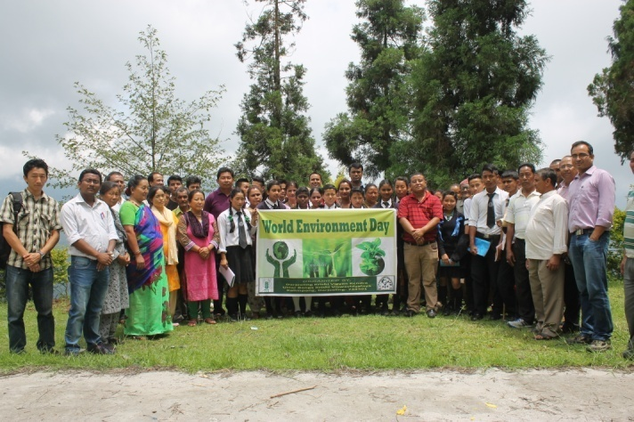 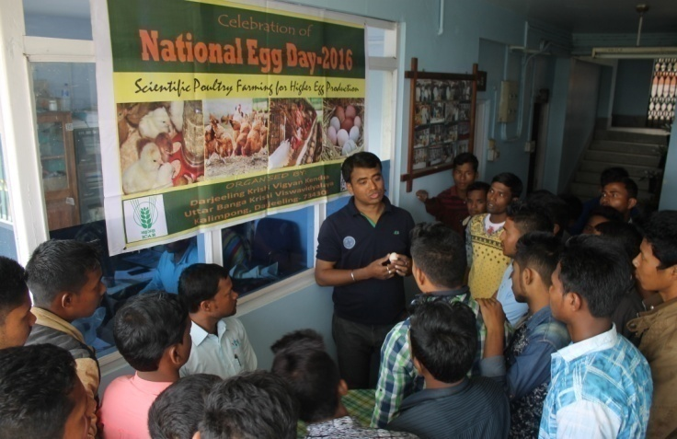

World Environment Day National Egg Day

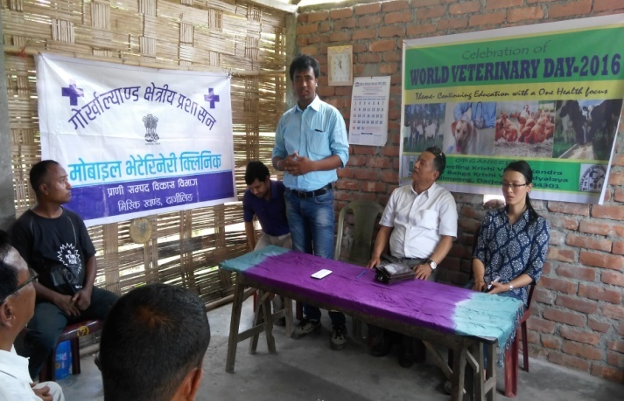 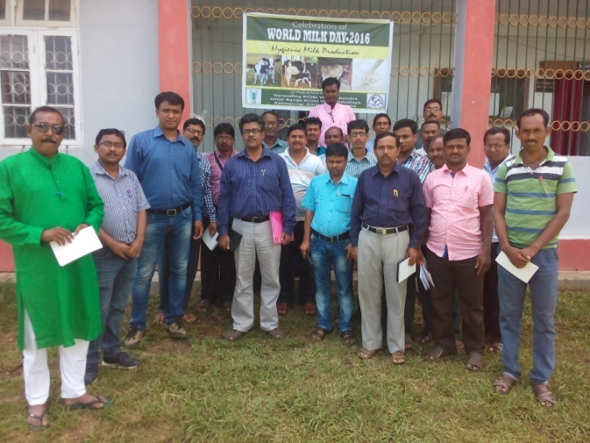

World Veterinary Day World Milk Day

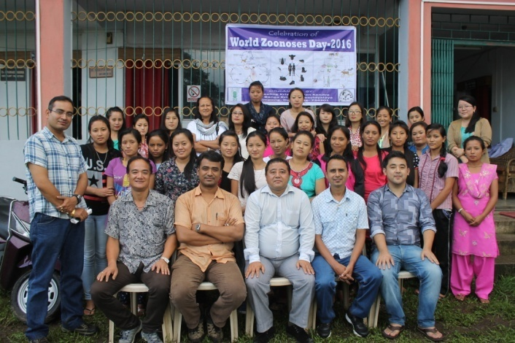 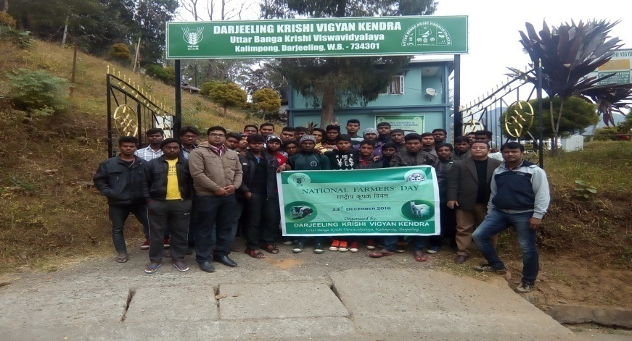

World Zoonosis Day National Farmers Day

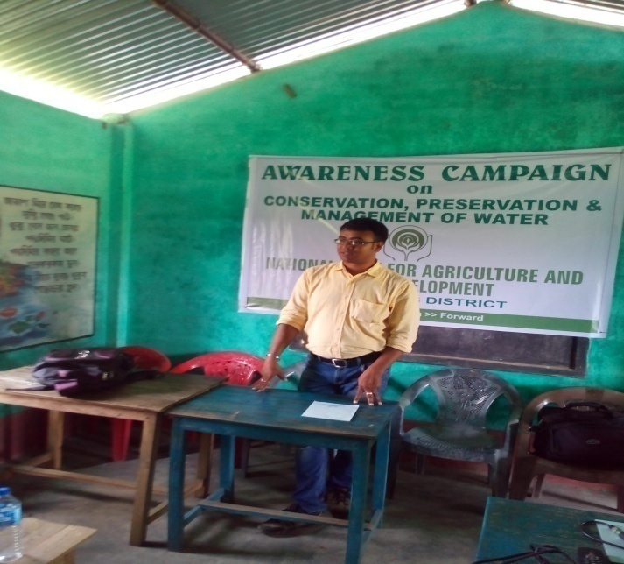 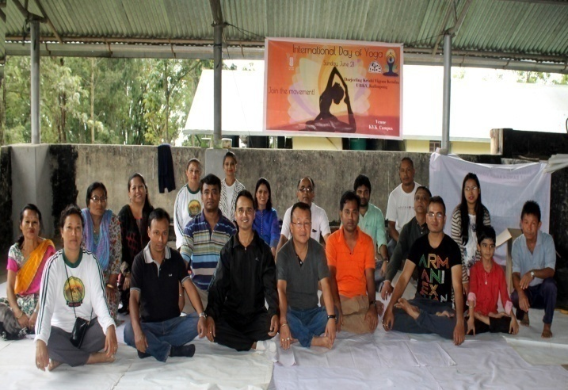

Awareness Programme on Water Conservation International Yoga Day

B. Other Extension activities

|  |  |
| --- | --- |
| Nature of Extension Activity | No. of activities |
|
| Newspaper coverage | 27 |
| Radio talks | 1 |
| TV talks | 3 |
| Popular articles | 2 |
| Extension Literature | 2 |
| Other, if any |  |

**3.5 Production and supply of Technological products**

Village seed

|  |  |  |  |  |
| --- | --- | --- | --- | --- |
| Crop | variety | Quantity of seed  (q) | Value  (Rs) | Provided to number of farmers |
|  |  |  |  |  |
|  |  |  |  |  |
|  |  |  |  |  |
|  |  |  |  |  |
| Total |  |  |  |  |

# KVK farm

|  |  |  |  |  |
| --- | --- | --- | --- | --- |
| Crop | variety | Quantity of seed  (q) | Value  (Rs) | Provided to number of farmers |
|  |  |  |  |  |
|  |  |  |  |  |

# Production of planting materials by the KVKs

|  |  |  |  |  |
| --- | --- | --- | --- | --- |
| Crop | Variety | No. of planting materials | Value  (Rs) | Provided to number of farmers |
| **Vegetable seedlings** |  | | | |
| Cauliflower |  |  |  |  |
| Cabbage |  |  |  |  |
| Tomato |  |  |  |  |
| Brinjal |  |  |  |  |
| Chilli |  |  |  |  |
| Onion |  |  |  |  |
| Gerbera |  | 204 | 932 | 5 |
| **Fruits** |  |  |  |  |
| Mango |  |  |  |  |
| Guava |  |  |  |  |
| Lime |  |  |  |  |
| Papaya |  |  |  |  |
| Banana |  |  |  |  |
| Orange Seedling | Darjeeling Mandarin | 2000 Nos | 44000 | 50 |
| Ornamental plants |  |  |  |  |
| Medicinal and Aromatic |  |  |  |  |
| Plantation |  |  |  |  |
| Large Cardamom Sapling | Bharlangay | 6000 No.s | 57000 | 25 |
| Turmeric | Local | 1.0 | 6000 | 5 |
| Ginger | Gorubathaney | 15 | 60000 | 50 |
| Potato | Jalandhar | 13.05 | 16965 | 30 |
| Elephant yams |  |  |  |  |
| Fodder crop saplings |  |  |  |  |
| Forest Species |  |  |  |  |
| Others, pl.specify |  |  |  |  |
| Total |  |  |  |  |

**Production of Bio-Products**

|  |  |  |  |
| --- | --- | --- | --- |
| Name of product | Quantity | Value (Rs.) | No. of Farmers |
| Kg |
| Bio Fertilisers |  |  |  |
| Bio-pesticide |  |  |  |
| Bio-fungicide |  |  |  |
| Bio Agents |  |  |  |
| Others |  |  |  |
| Total |  |  |  |

# Production of livestock materials

|  |  |  |  |  |
| --- | --- | --- | --- | --- |
| Particulars of Live stock | Name of the breed | Number | Value (Rs.) | No. of Farmers |
| Dairy animals |  |  |  |  |
| Cows |  |  |  |  |
| Buffaloes |  |  |  |  |
| Calves |  |  |  |  |
| Others (Pl. specify) |  |  |  |  |
| Poultry |  |  |  |  |
| Broilers |  |  |  |  |
| Layers |  |  |  |  |
| Duals (broiler and layer) |  |  |  |  |
| Japanese Quail |  |  |  |  |
| Turkey |  |  |  |  |
| Emu |  |  |  |  |
| Ducks |  |  |  |  |
| Others (Pl. specify) |  |  |  |  |
| Piggery |  |  |  |  |
| Piglet |  |  |  |  |
| Others (Pl. specify) |  |  |  |  |
| Fisheries |  |  |  |  |
| Indian carp |  |  |  |  |
| Exotic carp |  |  |  |  |
| Others (Pl. specify) |  |  |  |  |
| Grand Total |  |  |  |  |

**3.6. (A) Literature Developed/Published (with full title, author & reference)**

|  |  |  |  |  |
| --- | --- | --- | --- | --- |
| Item | Title | Authors name | Number | Circulation |
| Research paper | 1. Interactive ICT tools for goat management. 2. Knowledge level and adoption of scientific kid health management among goat owners under field conditions. 3. Productive and reproduction performance of dairy animal in Karnal district of Haryana. 4. Contract goat farming: an emerging model for livelihood generation among resource poor farmers of western Odisha. 5. Adoption level of recommended buffalo husbandry practices by dairy farmers in Uttar Pradesh. | Roy Rakesh and Tiwari Rupasi(2016).  Roy Rakesh, Tiwari Rupasi, Bharti PK and DuttTriveni (2017).  ManjushaJyoti, **Roy Rakesh,** Kumar Vijay and Gupta Jancy (2016).  ChinmayaSahoo, Rupasi Tiwari,**Rakesh Roy**,Bharti P.K.and TriveniDutt(2016)  SachanRanjana, Sankhala Gopal, Roy Rakesh and ManjushaJyoti (2016). | 1. *Journal of communication studies.* **34**(1): 42-49. 2. *Indian Journal of Animal Science.* **87**(1):78-79. 3. *Indian Veterinary Journal.* **93**(6):38-40 4. *Indian Journal of Animal Science.* **86** (5):609–611 5. *Indian Journal of Dairy Science***69**(5): 613-617 |  |
| Seminar/conference/ symposia papers | Effect of mobile radiation in hill agriculture | Subrata Manna  Kaushik Saha |  |  |
| Books |  |  |  |  |
| Bulletins |  |  |  |  |
| News letter |  |  |  |  |
| Popular Articles |  |  |  |  |
| Book Chapter | Trichogramma: An Egg Parasitoid in Insect-Pest Management | *Tarak Nath Goswami, Anil, Tarak Brambha Maji, Pranab Barma, and Shree Niwas Ray* |  |  |
| Coccinellids in Insect Pest Management: Problems and Prospects | *Pranab Barma, Suprakash Pal, and Tarak Nath Goswami* |  |  |
| Extension Pamphlets/ literature | Importance of Breast feeding | Akriti Pradhan  Subrata Manna |  |  |
| Technical reports |  |  |  |  |
| Electronic Publication (CD/DVD etc) | Cultivation of Oyster Mushroom | Akriti Pradhan  Subrata Manna  Basu Deo Kharga |  |  |
| TOTAL |  |  |  |  |

N.B. Please enclose a copy of each. In case of literature prepared in local language please indicate the title in English

**(B) Details of HRD programmes undergone by KVK personnel:**

|  |  |  |  |  |  |
| --- | --- | --- | --- | --- | --- |
| S. No. | Name of programme | Name of course | Name of KVK personnel and designation | Date and Duration | Organized by |
| 1. | Gender budgeting for main streaming women in agriculture | Gender budgeting for main streaming women in agriculture | Akriti Pradhan,  SMS Home Science | 6-11th June 2016 | MANAGE |
| 2. | Training of Trainers of KVK trainers at NIRD | Training of Trainers of KVK trainers at NIRD | Dr. Rakesh Roy  Dr. Pranab Barma  Mr. Subrata Manna | 10-12 November 2016 | ASCI |
| 3. | Short Course | Empowerment of farm women through livestock and poultry intervention | Dr. Rakesh Roy | 21-30 November 2016 | ICAR-CIWA, Bhubaneswar |
| 4. | National Conference on Enhancing Nutritional Security through climate smart farming practices | National Conference on Enhancing Nutritional Security through climate smart farming practices | Dr. M W Moktan  Dr. Rakesh Roy  Dr. Pranab Barma  Miss Akriti Pradhan  Mrs. Snehlata Lama  Mr. Subrata Manna  Dr. Basu Deo Kharga | 17-18th March 2017 | COBACAS |
| 5. | HRD & Review Workshop for KVK staff under UBKV |  | Dr. M W Moktan  Miss Akriti Pradhan  Mr. Subrata Manna  Mr. Akash Deep Thapa | 20-21st March 2017 | UBKV |
| 6. | Sensitization Workshop | “Technology Application in Animal and Fishery Sciences” | Dr. Rakesh Roy | 16-17th March | ICAR-ATARI, Zone II |

3.7. Success stories/Case studies, if any (two or three pages write-up on each case with suitable action photographs)

3.8. Give details of innovative methodology or innovative technology of Transfer of Technology developed and used during the year

3.9 Give details of indigenous technology practiced by the farmers in the KVK operational area which can be considered for technology development (in detail with suitable photographs)

|  |  |  |  |
| --- | --- | --- | --- |
| **S. No.** | **Crop / Enterprise** | **ITK Practiced** | **Purpose of ITK** |
| **1** | Rice | Brooming of rice plants when there is leaf folder incidence in the field. | To control leaf folder larvae, |
| **2** | Livestock | Feeding of Ganja (*Cannabis indica*) Juice. | To treat indigestion, diarrhea and dysentery. |
| **3** | Management of soil acidity | Application of wood ash in soil. | To increase in soil acidity. |
| **4** | Soybean | Preparation of fermented Soybean (Kinema). | Used as protein substitute. |
| **5** | Rayo Sag (mustard) | Preparation of dry fermented vegetable for cooking soup, achar etc. | It is also appetizer and for emergency cooking. |
| **6** | Livestock | Leaves of Tetaypati, (*Artemisia vulgaris* L.) are crushed and extract is applied externally on skin to treat itching. Fresh leaves are cleaned, ground and the sap extracted. | It is used as nasal drop to stop nose bleeding. |

3.10 Indicate the specific training need analysis tools/methodology followed by KVKs

3.11. a. Details of equipment available in Soil and Water Testing Laboratory

|  |  |  |
| --- | --- | --- |
| Sl. No | Name of the Equipment | Qty. |
| 1. | Spectrophotometer | 1 |
| 2. | Flame Photometer | 1 |
| 3. | PH Meter | 1 |
| 4. | Conductivity bridge | 1 |
| 5. | Physical balance | 1 |
| 6. | Chemical balance | 1 |
| 7. | Digestion unit | 1 |
| 8. | Kjeldhal Distillation set | 2 |
| 9. | Mechanical shaker | 1 |
| 10. | Refrigerator | 1 |
| 11. | Hot air oven | 1 |
| 12. | Hot plate | 1 |
| 13. | Grinder | 1 |
| 14. | Water distillation unit (double) | 1 |
| 15. | Chemical and Glass wares |  |
| 16. | Soxlet Apparatus (Big &Small) | 2 |
| 17. | Laboratory set up |  |
| 18. | Soil and plant sample processing and storage facility |  |
| Total | | 17 |

3.11.b. Details of samples analyzed so far :

|  |  |  |  |  |
| --- | --- | --- | --- | --- |
| Details | No. of Samples | No. of Farmers | No. of Villages | Amount realized |
| -- | -- | -- | -- | -- |
| Total |  |  |  |  |

3.12. Activities of rain water harvesting structure and micro irrigation system

|  |  |  |  |  |
| --- | --- | --- | --- | --- |
| No of training programme | No of demonstrations | No of plant material produced | Visit by the farmers | Visit by the officials |
| -- | -- | -- | -- | -- |

3.13 Technology week celebration

|  |  |  |  |
| --- | --- | --- | --- |
| Type of activities | No. of activities | Number of participants | Related crop/livestock technology |
| Training | 5 | 122 | Orange, Ginger, Goatery, Poultry, Piggery |
| Demonstration | 15 | 500 | Agricultural and Livelihood |
| Exhibition | 1 | 162 | All agricultural, Horticultural and Animal exhibits |

3.14. RAWE programme - is KVK involved?

|  |  |
| --- | --- |
| No of student/ARS trained | No of days stayed |
| 10 | 21 |

3.15. List of VIP visitors (MP/MLA/DM/VC/Zila Sabhadipati/Other Head of Organization/Foreigners)

|  |  |  |
| --- | --- | --- |
| Date | Name of the person | Purpose of visit |
| 21/02/2017 | MLA, Kalimpong | Mela Inauguration |
|  | VC, UBKV | For monitoring |
| 15-16 December 2016 | Director, NICRA | NICRA zonal workshop |
| 15-16 December 2016 | ZPD, ICAR, Zone II | NICRA zonal workshop |

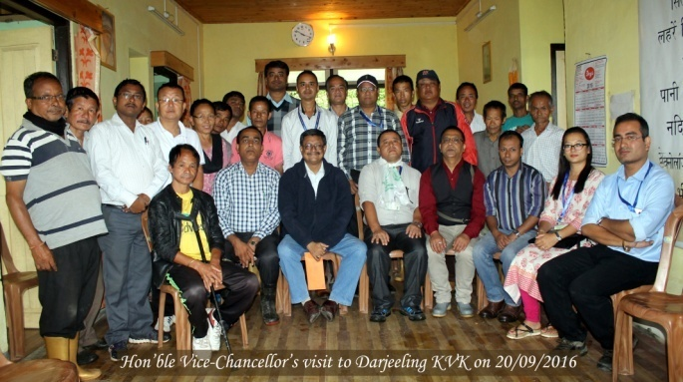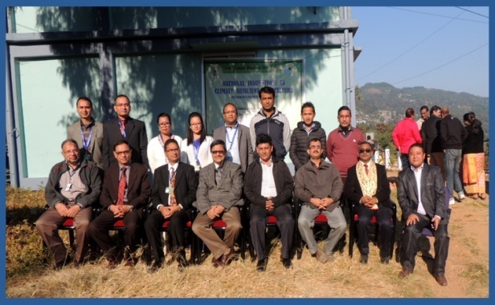

4.0 IMPACT

* 1. Impact of KVK activities (Not to be restricted for reporting period).

|  |  |  |  |  |
| --- | --- | --- | --- | --- |
| Name of specific technology/skill transferred | No. of participants | % of adoption | Change in income (Rs.) | |
| Before (Rs./Unit) | After (Rs./Unit) |
| Off season production of vegetable crops under low cost polyhouse | 2 | 100 | 2000 | 3500 |
|  |  |  |  |  |

NB: Should be based on actual study, questionnaire/group discussion etc. with ex-participants

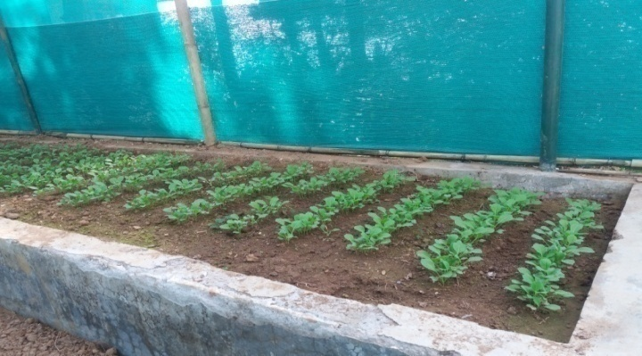

4.2 Cases of large scale adoption

(Please furnish detailed information for each case)

|  |  |
| --- | --- |
| Horizontal spread of technologies | |
| Technology | Horizontal spread |
| Nutritional management of Darjeeling Mandarin | The technology is horizontally spreading in the village where it was demonstrated |
|  |  |

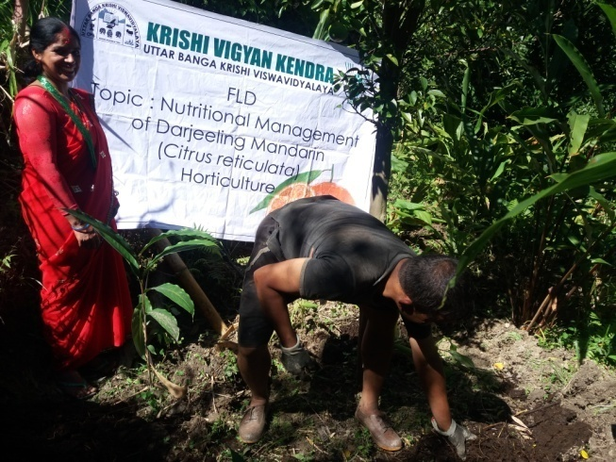 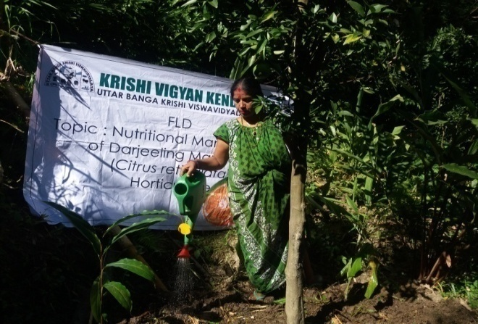

4.3 Details of impact analysis of KVK activities carried out during the reporting period

4.4 Details of innovations recorded by the KVK

|  |  |
| --- | --- |
| Thematic area | -- |
| Name of the Innovation | -- |
| Details of Innovator | -- |
| Back ground of innovation | -- |
| Technology details | -- |
| Practical utility of innovation | -- |

4.5 Details of entrepreneurship development

|  |  |
| --- | --- |
| **Entrepreneurship development** | |
| Name of the enterprise | -- |
| Name & complete address of the entrepreneur | -- |
| Intervention of KVK with quantitative data support: | -- |
| Time line of the entrepreneurship development | -- |
| Technical Components of the Enterprise | -- |
| Status of entrepreneur before and after the enterprise | -- |
| Present working condition of enterprise in terms of raw materials availability, labour availability, consumer preference, marketing the product etc. ( Economic viability of the enterprise): | -- |
| Horizontal spread of enterprise | -- |

4.6 Any other initiative taken by the KVK

5.0 LINKAGES

5.1 Functional linkage with different organizations

|  |  |
| --- | --- |
| **Name of organization** | **Nature of linkage** |
| State Agriculture Dept., Govt. of West Bengal | Training |
| Regional Research Station (Hill Zone), Uttar Banga Krishi Viswavidyalaya, Kalimpong |
| Dept. of Animal Recourses Development, Govt. of West Bengal |
| Sasastra Seema Bal (SSB), Siliguri Frontier |
| Regional Station, Indian Agricultural Research Institute, Kalimpong |
| Regional Research Station (Hill Zone), Uttar Banga Krishi Viswavidyalaya, Kalimpong | Demonstration |
| State Agriculture Dept., Govt. of West Bengal |
| Regional Research Station (Hill Zone), Uttar Banga Krishi Viswavidyalaya, Kalimpong | Joint Survey |
| State Agriculture Dept., Govt. of West Bengal |
| State Agriculture Dept., Govt. of West Bengal | Technical Support |
| Regional Research Station (Hill Zone), Uttar Banga Krishi Viswavidyalaya, Kalimpong |
| Dept. of Animal Recourses Development, Govt. of West Bengal |
| Spices Board, Kalimpong, Govt. of India |
| Regional Station, Indian Agricultural Research Institute, Kalimpong |

5.2. List of special programmes undertaken during 2016-17 by the KVK, which have been financed by ATMA/ Central Govt/ State Govt./NABARD/NHM/NFDB/Other Agencies **(information of previous years should not be provided)**

a) Programmes for infrastructure development

|  |  |  |  |  |
| --- | --- | --- | --- | --- |
| Name of the programme/scheme | Purpose of programme | Date/ Month of initiation | Funding agency | Amount (Rs.) |
| Repairing and maintenance of Building | Repairing | March 17 | ICAR | 400000 |
| Repairing and maintenance of Farm Road | Repairing | March 17 | ICAR | 200000 |
| Support to IFS | IFS | March 17 | ICAR | 490000 |
| Repairing and maintenance of Electric work | Repairing | March 17 | ICAR | 200000 |

(b) Programme for other activities (training, FLD,OFT, Mela, Exhibition etc.)

|  |  |  |  |  |
| --- | --- | --- | --- | --- |
| Total |  |  |  |  |
| Name of the programme/scheme | Purpose of programme | Date/ Month of initiation | Funding agency | Amount (Rs.) |
|  |  |  |  |  |
|  |  |  |  |  |

1. PERFORMANCE OF INFRASTRUCTURE IN KVK

6.1 Performance of demonstration units (other than instructional farm)

|  |  |  |  |  |  |  |  |  |  |
| --- | --- | --- | --- | --- | --- | --- | --- | --- | --- |
| Sl. No. | Name of demo Unit | Year of estt. | Area(Sq.mt) | Details of production | | | Amount (Rs.) | | Remarks |
| Variety/breed | Produce | Qty. | Cost of inputs | Gross income |
| 1. |  |  |  |  |  |  |  |  |  |
| 2. |  |  |  |  |  |  |  |  |  |
| 3. |  |  |  |  |  |  |  |  |  |
| 4. |  |  |  |  | | | | |  |
| 5. |  |  |  |  |  |  |  |  |  |
| 6. |  |  |  |  |  |  |  |  |  |
| 7. |  |  |  |  |  |  |  |  |  |
|  | Total |  |  |  |  |  |  |  |  |

6.2 Performance of instructional farm (Crops)

|  |  |  |  |  |  |  |  |  |  |
| --- | --- | --- | --- | --- | --- | --- | --- | --- | --- |
| Name  Of the crop | Date of sowing | Date of harvest | Area (ha) | Details of production | | | Amount (Rs.) | | Remarks |
|  |  | Variety | Type of Produce | Qty.(q) | Cost of inputs | Gross income |
| Potato |  | 29/05/2016 |  | Jalandhar | Tuber | 13.05 |  | 16965 |  |
| Gerbera |  |  |  |  | Cutflower | 204 |  | 932 |  |
| Orange Seedling |  |  |  | Darjeeling Mandarin |  | 2000 Nos |  | 44000 |  |
| Large Cardamom Sapling |  |  |  | Bharlangay |  | 6000 No.s |  | 57000 |  |
| Ginger |  |  |  | Gorubathaney |  | 15 |  | 60000 |  |
| Turmeric |  |  |  | Local |  | 1.0 |  | 6000 |  |
| Large Cardamom |  |  |  | Bharlangay |  | .01 |  | 8000 |  |

* 1. Performance of Production Units (bio-agents / bio pesticides/ bio fertilizers etc.,)

|  |  |  |  |  |  |
| --- | --- | --- | --- | --- | --- |
| Sl.  No. | Name of the Product | Qty (Kg) | Amount (Rs.) | | Remarks |
| Cost of inputs | Gross income |
| 1. | -- | -- | -- | -- | -- |
|  |  |  |  |  |  |

* 1. Performance of instructional farm (livestock and fisheries production)

|  |  |  |  |  |  |  |  |
| --- | --- | --- | --- | --- | --- | --- | --- |
| Sl.  No | Name  of the animal / bird / aquatics | Details of production | | | Amount (Rs.) | | Remarks |
| Breed | Type of Produce | Qty. | Cost of inputs | Gross income |
| 1. | -- | -- | -- | -- | -- | -- | -- |
| 2. |  |  |  |  |  |  |  |
| 3. |  |  |  |  |  |  |  |

6.5 Utilization of hostel facilities

Accommodation available (No. of beds) : 30

|  |  |  |  |
| --- | --- | --- | --- |
| Months | No. of trainees stayed | Trainee days  (days stayed) | Reason for short fall (if any) |
| April 16 | 15 | 3 | -- |
| July 16 | 20 | 3 | -- |
| Aug 16 | 18 | 3 | -- |
| Oct 16 | 21 | 2 | -- |
| Dec 16 | 30 | 10 | -- |
| Jan 17 | 30 | 10 | -- |
| Total : | 134 | 31 | -- |

(For whole of the year)

6.6 Utilization of staff quarters

Whether staff quarters has been completed: Yes

No. of staff quarters: 6

Date of completion: 2009

Occupancy details: All Quarters Occupied except Senior Scientist & Farm manager’s Quarters

|  |  |  |  |  |  |  |
| --- | --- | --- | --- | --- | --- | --- |
| Months | Q I | QII | Q III | QIV | Q V | QVI |
|  |  | | | | | |
|  |
|  |
|  |

1. FINANCIAL PERFORMANCE

7.1 Details of KVK Bank accounts

|  |  |  |  |
| --- | --- | --- | --- |
| **Bank account** | **Name of the bank** | **Location** | **Account Number** |
| Darjeeling KVK | State Bank of India | Kalimpong | 11283931150 |
| Darjeeling KVK | Bank of India | Kalimpong | 429310110000033 |

* 1. Utilization of funds under FLD on Oilseed *(Rs. In Lakhs)*

|  |  |  |  |  |  |
| --- | --- | --- | --- | --- | --- |
| Item | Released by ICAR | | Expenditure | | Unspent balance as on - |
| Kharif | Rabi | Kharif | Rabi |
| Mustard |  | 90000 |  | 89327 | 770 |
|  |  |  |  |  |  |
|  |  |  |  |  |  |
|  |  |  |  |  |  |

7.3 Utilization of funds under FLD on Pulses *(Rs. In Lakhs)*

|  |  |  |  |  |  |
| --- | --- | --- | --- | --- | --- |
| Item | Released by ICAR | | Expenditure | | Unspent balance as on 1st April 2013 |
| Kharif | Rabi | Kharif | Rabi |
| Blackgram | 150000 |  | 149515 |  | 485 |
| Greengram | 150000 |  | 149690 |  | 310 |

7.4 Utilization of funds under FLD on Maize *(Rs. In Lakh)*

|  |  |  |  |  |  |
| --- | --- | --- | --- | --- | --- |
| Item | Released by ICAR | | Expenditure | | Unspent balance as on 1st April 2012 |
| Kharif | Rabi | Kharif | Rabi |
|  |  |  |  |  |  |
| TOTAL |  |  |  |  |  |

7.5 Utilization of KVK funds during the year 2016-17 (Not audited)

|  |  |  |  |  |
| --- | --- | --- | --- | --- |
| S.  No. | Particulars | Sanctioned | Released | Expenditure |
| A. Recurring Contingencies | | | | |
| 1 | Pay & Allowances | 91.25 | 91.25 | 90.61275 |
| 2 | Traveling allowances | 1.50 | 1.50 | 1.50 |
| 3 | Contingencies | | | |
| *A* | Stationaries, Telephone, Postage and other office charges | 4.40 | 4.40 | 4.39950 |
| *B* | POL, Reapair of vehicle, Tractor & Equipment |
| *C* | Training of farmers | 1.80 | 1.80 | 1.79540 |
| *D* | Training materials( Posters, chart, Demonstration materials including chemnical etc require for conducting the training |
| *E* | Training of Extension functionaries |
| *F* | Training of rural youths |
| *G* | Front Line Demonstration (minimum of 100 demonstration in a year) | 1.20 | 1.20 | 1.1943 |
| *H* | On Farm Testing (Only based, location specific & newely generated information in the major production of the year) | 0.60 | 0.60 | 0.60 |
| *I* | Maintenance of Building (Repairing and maintenance of Building 4.0, Support to IFS 4.90, Repairing and maintenance of farm Road 2.00, Repairing and maintenance of electrical work, sanitation and water supply 2.00, Contractual salary0.75) | 13.65 | 13.65 | 13.65 |
| *J* | TSP | 6.00 | 6.00 | 5.98250 |
| TOTAL (A) | |  |  |  |
| B. Non-Recurring Contingencies | | | | |
| 1 | Office furniture and furnishing | 2.00 | 2.00 | 2.00 |
| 2 |  |  |  |  |
| TOTAL (B) | |  |  |  |
| C. REVOLVING FUND | |  |  |  |
| GRAND TOTAL (A+B+C) | |  |  |  |

7.6. Status of revolving fund (Rs. in lakh) for last three years

|  |  |  |  |  |
| --- | --- | --- | --- | --- |
| Year | Opening balance as on 1st April | Income during the year | Expenditure during the year | Net balance in hand as on 1st April of each year (Kind + cash) |
| 2014-15 | 235652 | 228661 | 47472 | 416841 |
| 2015-16 | 416841 | 1724056 | 1637151.52 | 503745.48 |
| 2016-17 | 503745.48 | 211967 | 278520 | 437192.48 |

7.6.

1. Number of SHGs formed by KVKs : NIL
2. Association of KVKs with SHGs formed by other organizations indicating the area of SHG activities.

MLLDB

World Vision

CADC

DRDC

Krishak Kalyan Sangathan

* 1. Details of marketing channels created for the SHGs

NA

* 1. Special programme on Food and Nutrition :

1. Training and awareness on preparation of Weaning food for children
2. Preparation of low cost supplementary foods for pregnant and lactating mothers
3. Celebration of International Breast Feeding Week.
4. Awareness programme for primary school children on nutrition health & sanitation
5. Health checkup and nutrition programme for farm tribal women

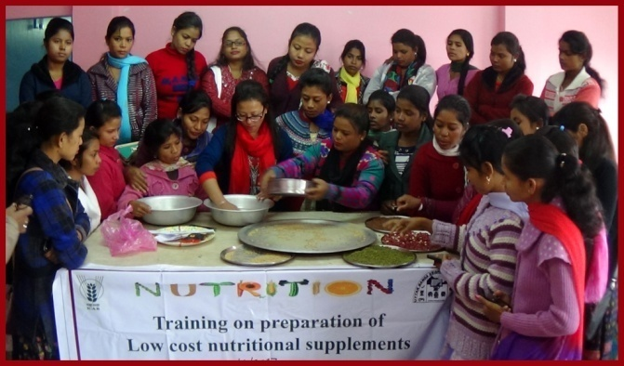 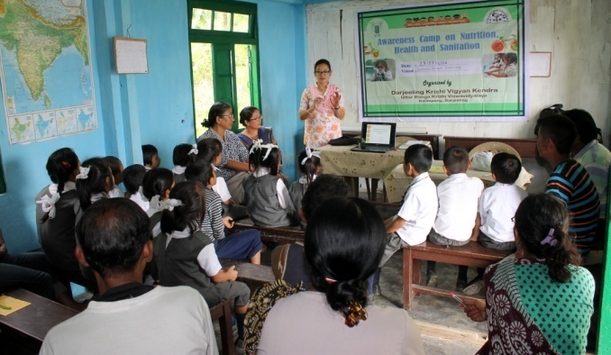

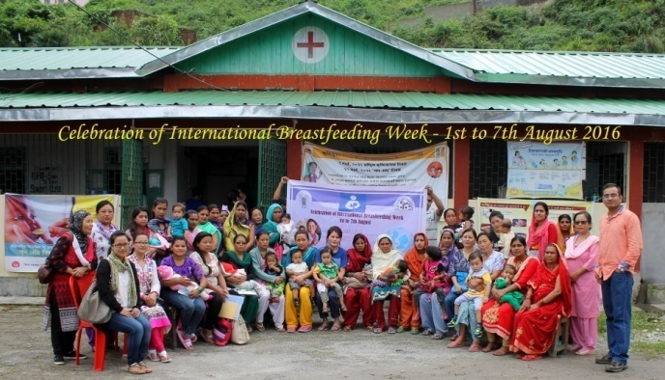 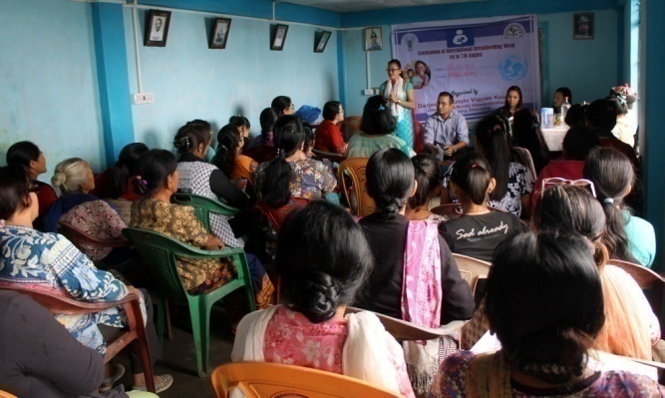

* 1. Joint activity carried out with line departments and ATMA

|  |  |  |  |  |  |
| --- | --- | --- | --- | --- | --- |
| Name of activity | Number of activity | Season | With line department | With ATMA | Both |
| Exposure Visit | 15 | Not specified |  | 15 |  |
|  |  |  |  |  |  |
|  |  |  |  |  |  |

**8. Initiative taken towards organic farming by the KVK (area brought under organic farming, crops cultivated through organic means and other relevant information)**

**9. Other information**

9.1. Prevalent diseases in Livestock/Crops/Fishery

|  |  |  |  |  |
| --- | --- | --- | --- | --- |
| Name of the disease | Crop/animal | Date of outbreak | Number of death/ % commodity loss | Number of animals vaccinated |
|  |  |  |  |  |

9.2. Nehru Yuva Kendra (NYK) Training :NA

|  |  |  |  |  |  |
| --- | --- | --- | --- | --- | --- |
| Title of the training programme | Period | | No. of the participant | | Amount of Fund Received (Rs) |
|  | From | To | M | F |  |
| -- | -- | -- | -- | -- | -- |
|  |  |  |  |  |  |

9.3. PPV & FR Sensitization training Programme

|  |  |  |  |  |
| --- | --- | --- | --- | --- |
| Date of organizing the programme | Resource Person | No. of participants | Registration (crop wise) | |
|  |  |  | Name of crop | No. of registration |
| -- | -- | -- | -- | -- |

|  |  |  |  |  |  |  |  |  |
| --- | --- | --- | --- | --- | --- | --- | --- | --- |
| 9.4.a SMS PORTAL   Date of start of functioning of SMS portal | | | | | | | | |
| No. of messages | No. of calls | No. of farmers covered | Types of messages (No.) | | | | | |
| Crop | Livestock | Weather | Marketing | Awareness | Other |
| 381 | - | 288468 | 10 | 361 | - | - | 10 | - |

9.4.b Information in uploading KVK Portal by KVKs during 2016-17

|  |  |  |  |  |
| --- | --- | --- | --- | --- |
| *Sr. No.* | *Name of item/ events/ component* | *Uploading status (Yes/No)* | *No. uploaded* | *Remarks, if any* |
| 1 | KVK Profile | Yes |  |  |
| 2 | Employee details | Yes |  |  |
| 3 | Post | Yes |  |  |
| 4 | Finance | Yes |  |  |
| 5 | Soil Health Card | No |  |  |
| 6 | Appliance | Yes |  |  |
| 7 | Crops |  |  |  |
| 8 | Resources |  |  |  |
| 9 | Fish |  |  |  |
| 10 | Past events | Yes |  |  |
| 11 | Future/ upcoming events | No |  |  |
| 12 | Facilities available at KVKs | Yes |  |  |
| 13 | Package and practices | Yes |  |  |
| 14 | Crop |  |  |  |
| 15 | Livestock |  |  |  |
| 16 | Fishery |  |  |  |
| 17 | Horticulture |  |  |  |
| 18 | CFLD on Pulses | Yes |  |  |
| 19 | 2016-17 |  |  |  |
| 20 | 2015-16 |  |  |  |
| 21 | CFLD Oilseeds | | |  |
| 22 | 2016-17 |  |  |  |
| 23 | 2015-16 |  |  |  |

9.5 Observation of Swacha Bharat Programme

|  |  |
| --- | --- |
| Date of Observation | Activities undertaken |
|
| 24/10/16  25/10/16  26/10/16  27/10/16  28/10/16 | Imparted knowledge about the cleanliness, recycling of kitchen wastes, vermi-compost preparation. |

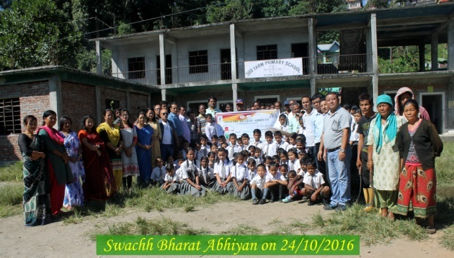 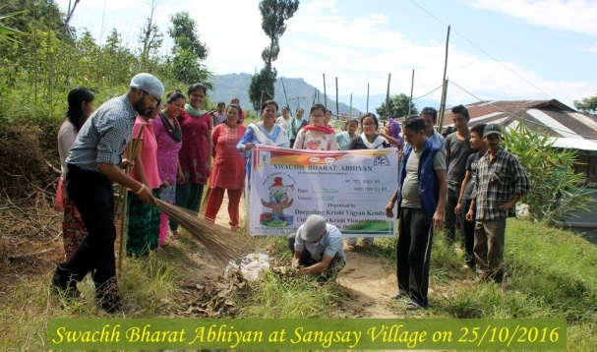

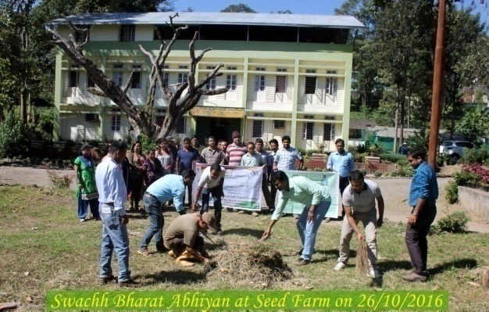 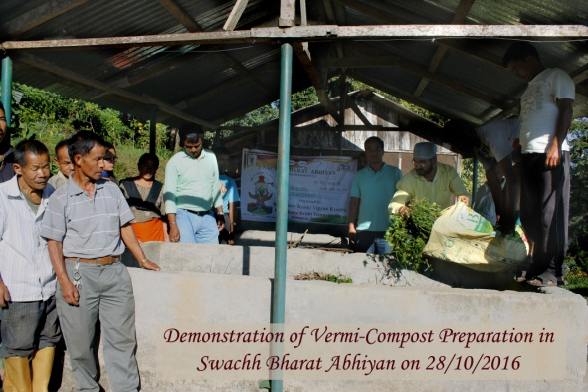

9.6 Observation of National Science day

|  |  |
| --- | --- |
| Date of Observation | Activities undertaken |
|
| -- | -- |

9. 7.Programme with Sashratra Seema Bal (SSB)

|  |  |  |
| --- | --- | --- |
| Title of Programme | Date | No. of participants |
| Entrepreneurship development of through Goatery | 08/01/17 | 30 |
| Entrepreneurship development of through Piggery | 15/01/17 | 30 |

9.8 Agriculture Knowledge in rural school:

|  |  |  |  |
| --- | --- | --- | --- |
| Name and address of school | Date of visit to school | Areas covered | Teaching aids used |
| Gangotri HS School, Kpg | 10/03/2017 | Agriculture | A/V aid |
|  |  |  |  |

9.9. Details of Kharif and Rabi Sammelan (Information should be provided in two separate tables – one for Kharif and another for Rabi Sammelan)

|  |  |  |  |  |  |  |
| --- | --- | --- | --- | --- | --- | --- |
| Name of the state | Name of district/KVK | Date on which conducted | Number of participants | | Name of public representative | Details of Technology Demonstrated and other programmes organized |
| Farmers | Others |
| WB | Darjeeling | 22-23 Dec 2016 | 190 | 145 | ADA Mirik | Training, Exhibition, Film Show and Demonstration |
|  |  | 21-23 Feb 2017 | 227 | 163 | MLA Kaimpong | Training, Exhibition, Film Show and Demonstration |

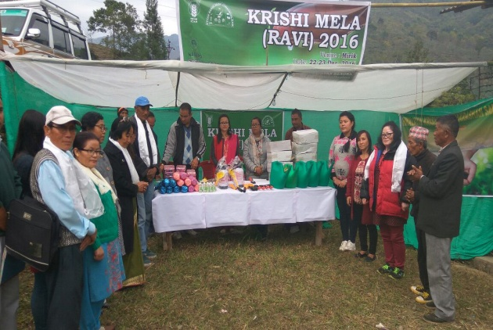 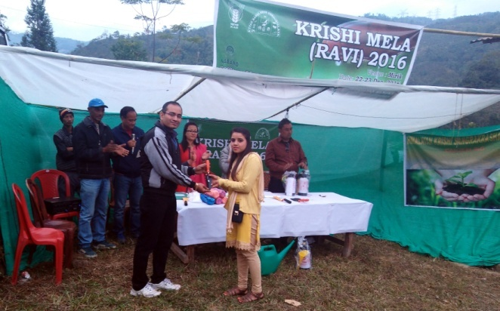

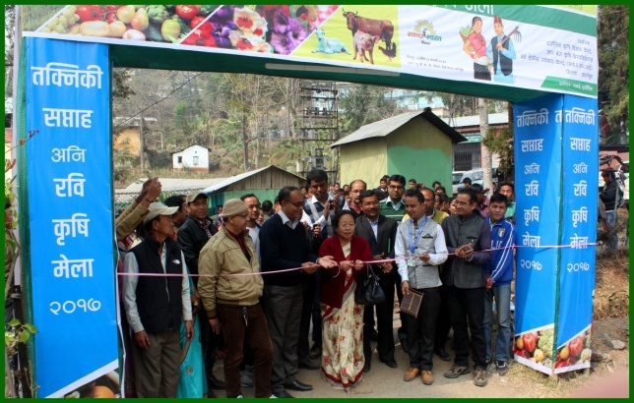 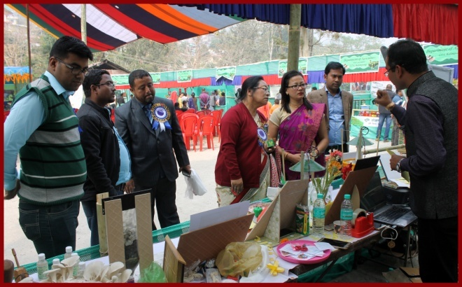

9.10. Details of Pradhan Mantri Fasal Bima Yojana programme organized

|  |  |  |  |  |  |  |
| --- | --- | --- | --- | --- | --- | --- |
| Name of the state | Name of district/KVK | Date on which conducted | Number of participants | | Name of public representative | Details of awareness created and other programmes organized |
| Farmers | Others |
| WB | Darjeeling | 05/07/2016  11/01/2017 | 42 | 16 | Not attended | In Darjeeling district Maize and Paddy is covered under PMFBY  Awareness camp were conducted for this programme. |

9.11. Contingent crop planning

|  |  |  |  |  |  |
| --- | --- | --- | --- | --- | --- |
| Name of the state | Name of district/ KVK | Thematic area | Number of programmes organized | Number of Farmers contacted | A brief about contingent plan executed by the KVK |
| -- | -- | -- | -- | -- | -- |

9.12. Report on Citizens’ Client Charter (attending the requests seeking guidance on agricultural

technology and technology products)

|  |  |  |  |  |  |
| --- | --- | --- | --- | --- | --- |
| Sl. No. | Services/ Transaction | Process | Service Standard | No. of such services attended by KVKs and ATICs during the year | No. of such services pending with KVK/ATIC beyond 30 days |
| 1. | Guidance on Agricultural technology and technology products | Personal contact by the Service Sectors with the responsible person of KVK/ATIC | -- | -- | -- |

9.13. Community Radio Station : NA

Date of establishment:

Amount of fund received year wise :

Source of fund:

Achievements:

| Sr. no | Community Radio Stations (CRS) | No of programmes in the year | Total broadcast hrs in a month | Please specify details of the broadcasts |
| --- | --- | --- | --- | --- |
| A.  B. | Agricultural broadcasts   * Talks/interviews/discussions with experts, PG students/ and farmers on Agricultural technologies * Agro-climatic conditions, weather and marketing advisory * Phone–in programme of interface with experts * Phone-in programme with interface of progressive/innovative farmers * Success stories of progressive farmers * Success stories in FLD/OFT/ Trainings /Extension activities * Women in agriculture programme * Discussions on current issues in agriculture and allied sectors. * KVK happenings * Agricultural University professors. * Any other(please specify)   Community development broadcasts  Please specify the programmes like rural development, educational, health, environment, public service broadcasts, sports etc. |  |  |  |

9.14 No. of Progressive/Innovative/Lead farmer identified (category wise) :

Agriculture : 3

Horticulture:5

Animal Husbandry: 5

9.15 HRD programmes organized by the KVK

|  |  |  |  |  |
| --- | --- | --- | --- | --- |
| Training programme/ Seminar/ Symposia/ Workshop etc attended | Duration | Name of the  participants | Designation | Organizer of the training Programme |
| NICRA Workshop | 2 |  |  |  |
|  |  |  |  |  |

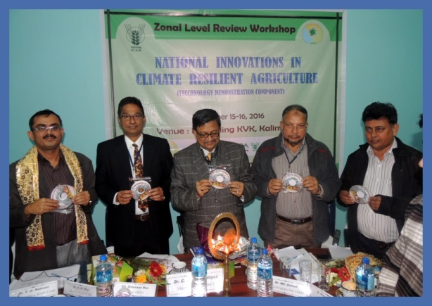 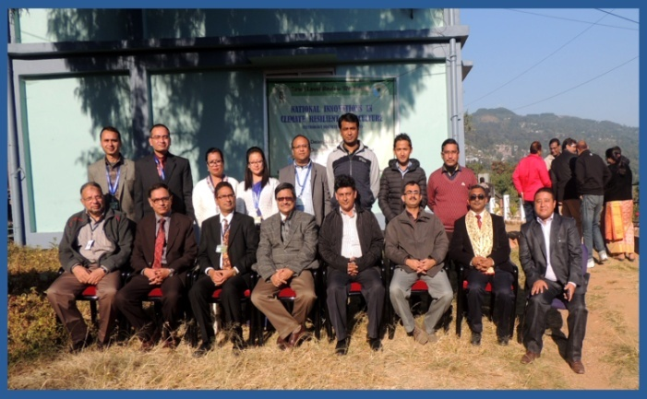

9.16. Revenue generation:

| SL.No. | Name of Head | Income(Rs.) | Sponsoring agency |
| --- | --- | --- | --- |
| 1. | Hostel Feed | 60000 | SSB, Kishanganj |
| 2. | Rent of Conference hall | 20000 | SSB, Kishanganj |
| 3. | Institutional Charges | 56000 | SSB, Kishanganj |

9.17. Resource Generation:

|  |  |  |  |  |  |
| --- | --- | --- | --- | --- | --- |
| SL.No. | Name of the programme | Purpose of the programme | Sources of fund | Amount  (Rs. lakhs) | Infrastructure created |
| -- | -- | -- | -- | **--** | **--** |

9. 18. Performance of Automatic Weather Station in KVK

|  |  |  |
| --- | --- | --- |
| Date of establishment | Source of funding i.e. IMD/ICAR/Others (pl. specify) | Present status of functioning |
| NA | -- | -- |
|  |  |  |

10. Details of TSP Project

|  |  |  |  |  |  |  |  |  |
| --- | --- | --- | --- | --- | --- | --- | --- | --- |
| Name of the village adopted under TSP | Block | Population of the village | | | ST Population of the village | | | Percentage of ST population to total population |
|  |  | M | F | T | M | F | T |  |
| Sangsay | Block II | 3215 | 2618 | 5833 | 1446 | 916 | 2362 | 40.5 |
| Bidyang | Block I | 2155 | 1916 | 4071 | 926 | 785 | 1711 | 42.1 |
| Chenga | Mirik | 2644 | 2168 | 4812 | 846 | 650 | 1496 | 31.1 |
| Sittong | Kurseong I | 2388 | 2138 | 4526 | 1098 | 940 | 2038 | 45.1 |

Physical achievements under TSP during 2016-17

|  |  |
| --- | --- |
| **Programmes** | **Physical achievements 2016-17** |
| Asset creation (Number; Sprayer, ridge maker, pump set, weeder etc.) | Secateuar 20 No.  Garden Tools – 20 No.  Budding & Grafting Kinife – 20  Knapsack sprayer – 2  Hand Sprayer – 20 No.  Watering Can – 20 No. (10L)  Watering Can – 20 No. (5L)  Water Tank – 1000L – 2 No.  Poly pipe – 10 Coil (1 Inch)  Salpaulin – 20 No. |
| On-farm trials (Number) | 1 |
| Frontline demonstrations (Number) | 2 |
| Farmers training (in lakh) |  |
| Extension personnel training (in lakh) |  |
| Participants in extension activities (in lakh) |  |
| Seed production (in tonnes) | 1.5 t |
| Planting material production (in lakh) | 2000 |
| Livestock strains and fingerlings production (in lakh) | 10 pig, 8 goat |
| Soil, water, plant, manures samples testing (in lakh) | 0 |
| Provision of mobile agro – advisory to farmers (in lakh) | 80000 |
| Others (Swachha Bharat Abhiyaan, Agriculture knowledge in rural school, Planting material distribution, Vaccination camp etc.) | 10 |

Fund received under TSP in 2016-17: 6.00 lakh

11. Progress Report OF NICRA KVK (Technology Demonstration component) 2016-17

(**Applicable for KVKs identified under NICRA)**

Natural Resource Management

|  |  |  |  |  |  |
| --- | --- | --- | --- | --- | --- |
| Name of intervention undertaken | Numbers under taken | No of units | Area (ha) | No of farmers covered / benefitted | Remarks |
|  |  |  |  |  |  |
|  |  |  |  |  |  |
|  |  |  |  |  |  |
|  |  |  |  |  |  |

Crop Management

|  |  |  |  |
| --- | --- | --- | --- |
| Name of intervention undertaken | Area (ha) | No of farmers covered / benefitted | Remarks |
|  |  |  |  |
|  |  |  |  |

Livestock and fisheries

|  |  |  |  |  |  |
| --- | --- | --- | --- | --- | --- |
| Name of intervention undertaken | Number of animal covered | Number of units | Area (ha) | No of farmers covered / benefitted | Remarks |
|  |  |  |  |  |  |

Institutional interventions

|  |  |  |  |  |
| --- | --- | --- | --- | --- |
| Name of intervention undertaken | No of units | Area (ha) | No of farmers covered / benefitted | Remarks |
|  |  |  |  |  |

Capacity building

|  |  |  |  |  |
| --- | --- | --- | --- | --- |
| Thematic area | No. of Courses | No. of beneficiaries | | |
| Males | Females | Total |
|  |  |  |  |  |
|  |  |  |  |  |

Extension activities

|  |  |  |  |  |
| --- | --- | --- | --- | --- |
| Thematic area | No. of activities | No. of beneficiaries | | |
| Males | Females | Total |
|  |  |  |  |  |
|  |  |  |  |  |

Detailed report should be provided in the circulated Performa

12. Information on NFDB Funded Capacity building programme during 2016-17

|  |  |  |  |  |  |  |
| --- | --- | --- | --- | --- | --- | --- |
| Sl. No. | Name of capacity building training programme | Duration (days) | Date of programme | Fund (Rs.) sanctioned by NFDB, Hyderabad | No. of Farmers  trained | Remarks, if any |
| 1 |  |  |  |  |  |  |
| 2 |  |  |  |  |  |  |
| Total |  |  |  |  |  |  |

13. National Initiative on Fodder Technology Demonstration (NIFTD)

(**Applicable for KVKs identified under NIFTD)**

|  |  |  |  |  |  |  |  |  |  |  |
| --- | --- | --- | --- | --- | --- | --- | --- | --- | --- | --- |
| Name of the fodder crop | Date of sowing | Area (ha) | No. of farmers involved | Demonstration Yield (q/ha) | | | Check Yield | | | % increase |
|  |  |  |  | H | L | A | H | L | A |  |
| -- | -- | -- | -- | -- | -- | -- | -- | -- | -- | -- |
|  |  |  |  |  |  |  |  |  |  |  |

Economic of Demonstration

|  |  |  |  |  |  |  |
| --- | --- | --- | --- | --- | --- | --- |
| Name of the fodder crop | Demonstration Cost/Rs/ha | | | Check Cost (Rs/ha) | | |
|  | Gross cost | Gross return | BC ratio | Gross cost | Gross return | BC ratio |
| -- | -- | -- | -- | -- | -- | -- |

14. Awards/Recognition received by the KVK

|  |  |  |  |  |  |
| --- | --- | --- | --- | --- | --- |
| Sl. No. | Name of the Award | Year | Conferring Authority | Amount | Purpose |
| --- | -- | --- | -- | --- | -- |
|  |  |  |  |  |  |
|  |  |  |  |  |  |

Award received by Farmers from the KVK district

|  |  |  |  |  |  |  |
| --- | --- | --- | --- | --- | --- | --- |
| Sl. No. | Name of the Award | Name of the Farmer | Year | Conferring Authority | Amount | Purpose |
| 1 | Best farmer | Yogendra Kharga | 2017 | UBKV | Felicitation |  |
| 2 | Best Florist | Arun Kr. Chettri | 2017 | UBKV | Felicitation |  |
|  |  |  |  |  |  |  |

15. Any significant achievement of the KVK with facts and figures as well as quality photograph

**Livestock Business Farming in hills: A sustainable employment for youth**

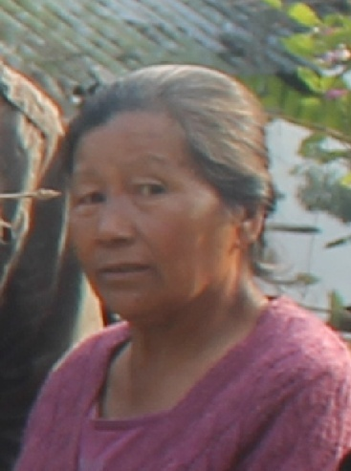

Premkit Simick Lepcha, an enthusiastic tribal lady also an ex-army at the age of more than 60 years had shown a way of livestock business farming in the low hills. In her service life she had serve the nation with her dedication, sincerity and hard work. After her retirement she always had a zeal to do somethings which itself will be an example. She had started trying out backyard livestock farming. Now, she is one of the leading livestock farmers in the region. She is living in one of the remote village in the district where there was no approach road few years back.

She is one of the successful pig breeders in the area. She had a breeder stock of three Hampshire and two Duroc pig. She had more than 250 numbers of poultry birds comprising Vanaraja, Australop, cross breed of Vanaraja and Autralop and desi poultry birds. She also had 4 Siri type dairy cattle.

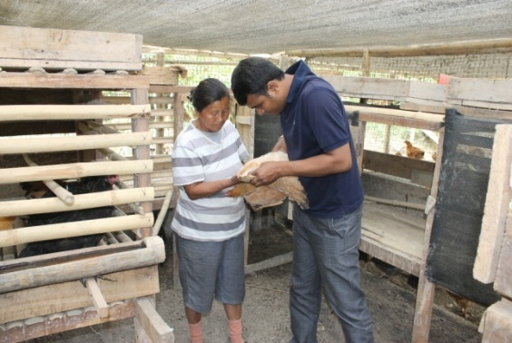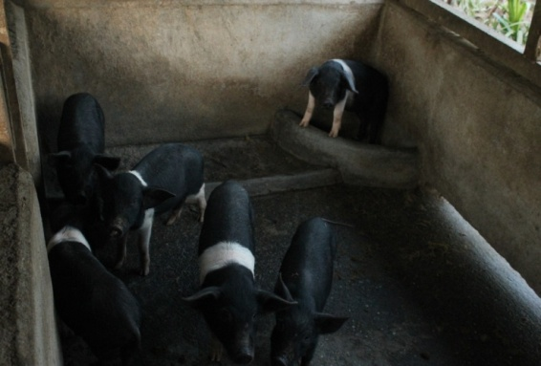Inspiteof poor connectivity to the town she is in regular contact with Krishi Vigyan Kendra for the scientific techniques of livestock farming. Krishi Vigyan Kendra, Kalimpong always use to provide her scientific knowledge which enhanced the production performance of her livestock. She is deworming in her livestock on regular basis. She always supplements iron to her piglet to check mortality due to piglet anaemia. She vaccinate her pig against swine fever; poultry against Ranikhet disease and Gumboro and cattle against foot and mouth disease, haemorrhagic septicaemia and black quarter by which she reduces the disease incidence in her livestock and check morbidity and mortality. Thereby reduces the economic losses due to livestock diseases.

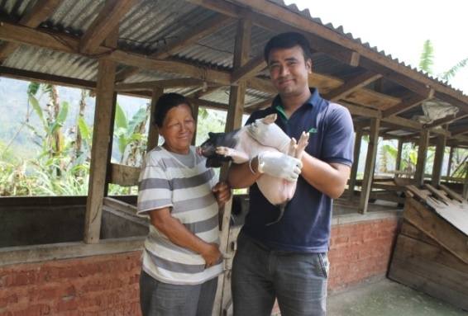She had a significant income from different livestock species. She sells piglet as well as pig for meat purpose. She sells poultry egg and live chicken for meat purpose. Egg and meat of Vanaraja, Australop, cross breed of Vanaraja and Autralop and desi poultry birds always have a high demand in the market. Selling of milk is also a significant source of income to her total income. Due to poor connectivity to the town she had to sell her product in comparatively low rate, even though she had an annual income of more than 3 lakhs from different livestock species.

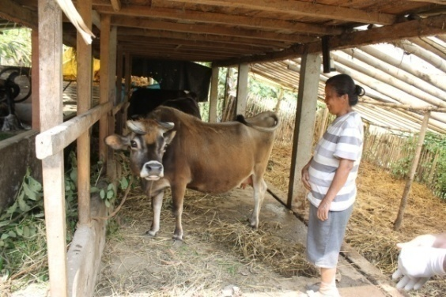She use to inspire the youth in livestock farming by donating piglets to those who are in need of employment and use migrate to big cities of their livelihood. Now, she is a role model for many and a source of inspiration of young generation. She used to tell if at the age of more than 60 years she can earn from livestock farming then why youth couldn’t earn from it. She always used to tell that nobody should lose hope and never give up.

16. List of 5000 farmers with mobile number and Aadhar card number (only soft copy to be enclosed)

Collection of data is going on.

17. Number of commodity based organizations/ farmers’ cooperative society formed during last one year

(Details of the group/society may be indicated)

NIL

18. Any other programme organized by KVK not covered above

Organized Training programme under ASCI as Training partner for NSDC on Broiler Poultry Farm Worker and Bee Keeping.

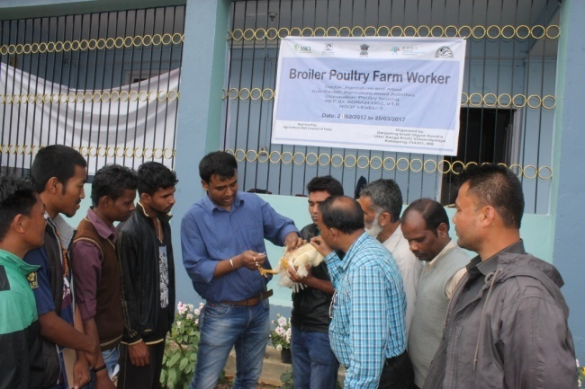 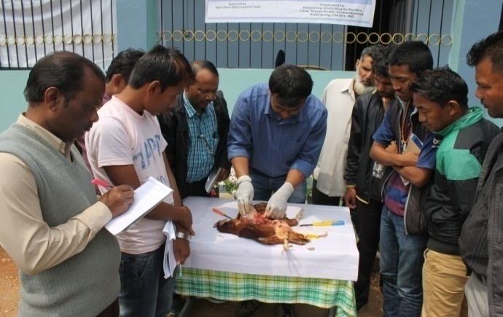

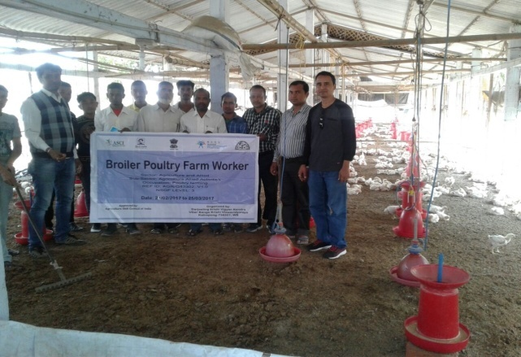 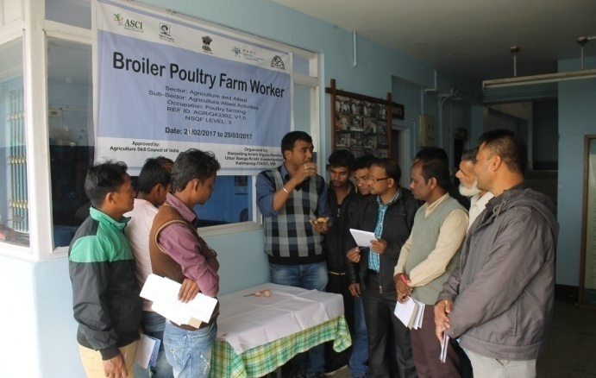

Training on Broiler Poultry Farm Worker

Making of Video film on **Integrated farming system** for hill region and **Clean milk production and its processing** by Doordarshan, Jalpaiguri on our progressive farmer.

